**WORKSHEET 1**

**Read the text and answer the questions**

The Amazon Tribes: Their Cultures and Traditions

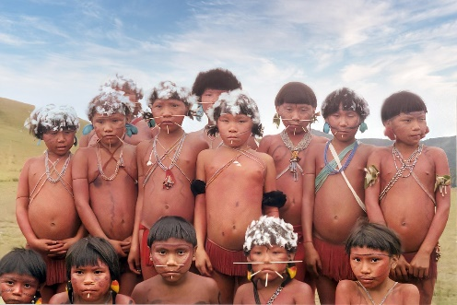 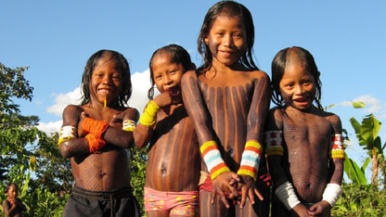

The Amazon rainforest is home to many different tribes. These tribes have their own unique languages, cultures and traditions. They live in the forest and rely on it for everything they need.

One of the tribes in the Amazon is called the Yanomami. They are one of the largest tribes in the region and live in Brazil and Venezuela. The Yanomami people live in large communal houses called Υanos. They hunt, fish and gather food from the forest. They also grow crops like bananas, yams and sweet potatoes.

Another tribe in the Amazon is the Kayapo. They live in the Brazilian state of Pará. The Kayapo people are known for their elaborate body paint and headdresses made from feathers. They also make beautiful woven baskets and jewelry from seeds and nuts found in the forest.

The Ashaninka tribe is another group that lives in the Amazon. They live in Peru and Brazil and are known for their knowledge of medicinal plants. They use plants from the forest to treat illnesses and injuries.

The Amazon rainforest is an important home for these tribes and many others. It is important to protect the forest and its inhabitants so that they can continue to live their traditional way of life.

**Questions:**

1. What is the Amazon rainforest home to?

A. Only one tribe.

B. Many different tribes.

C. Only animals and plants.

D. No one.

2. What is unique about the Yanomami tribe?

A. They live in large communal houses called yanos.

B. They are known for their elaborate body paint and headdresses.

C. They are experts in medicinal plants.

D. They grow crops like bananas, yams and sweet potatoes.

3. What is the Kayapo tribe known for?

A. Their knowledge of medicinal plants.

B. Their elaborate body paint and headdresses made from feathers.

C. Their large communal houses called yanos.

D. Their ability to hunt, fish and gather food from the forest.

4. What is the Ashaninka tribe known for?

A. Their elaborate body paint and headdresses made from feathers.

B. Their ability to hunt, fish and gather food from the forest.

C. Their knowledge of medicinal plants.

D. Their ability to grow crops.

5. Why is it important to protect the Amazon rainforest?

A. It is a home for many different tribes.

B. It is a source of medicinal plants.

C. It is a source of food.

D. It is a place for tourists to visit.

6. Where do the Yanomami people live?

A. Brazil and Venezuela.

B. Peru and Brazil.

C. The Brazilian state of Pará.

D. None of the above.

7. What do the Kayapo people make from seeds and nuts found in the forest?

A. Elaborate body paint and headdresses.

B. Woven baskets and jewelry.

C. Communal houses called yanos.

D. Crops like bananas, yams and sweet potatoes.