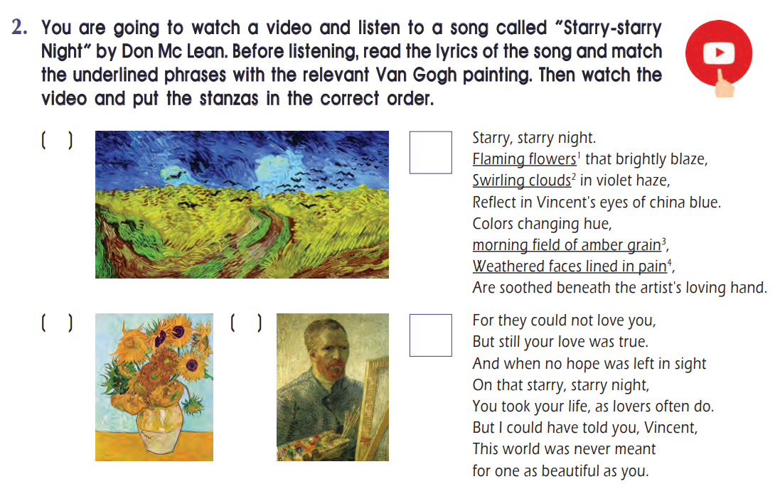

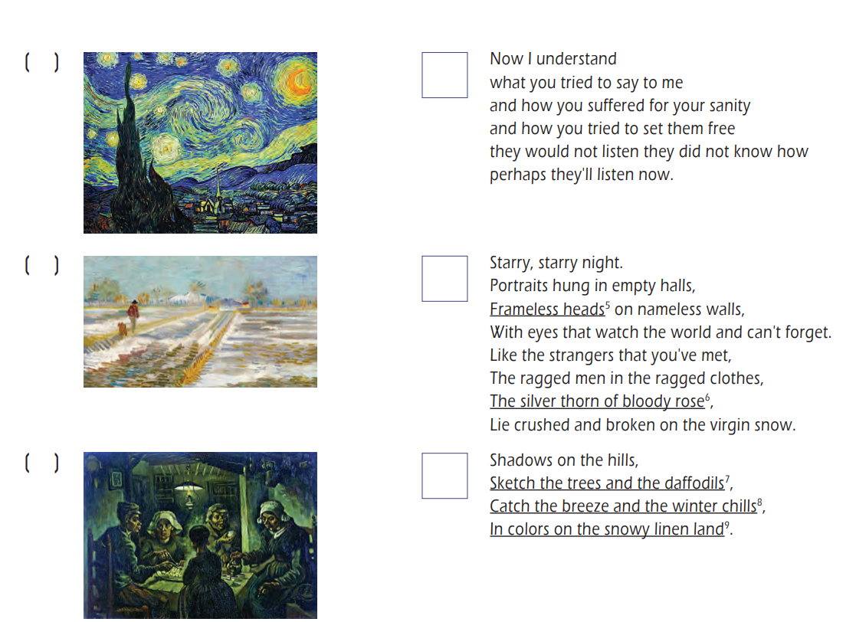

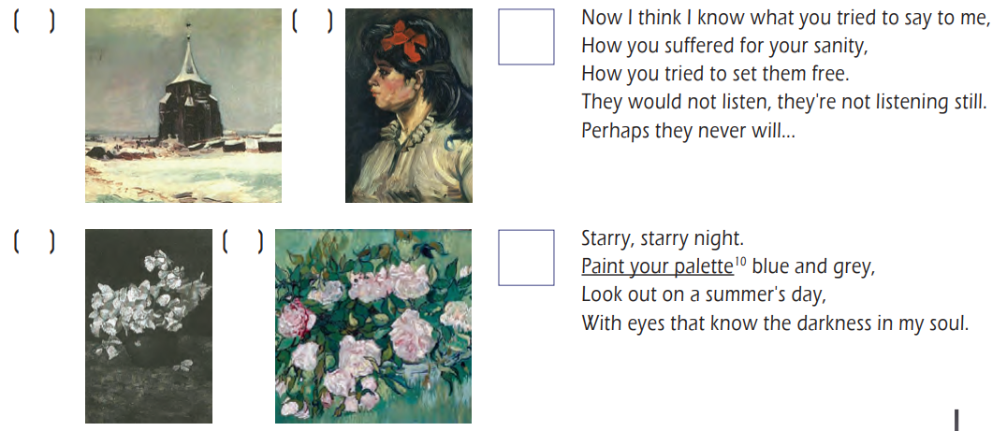

Απαντήσεις

- Wheatfield with crows ________
- Sunflowers ________
- Self -portrait as a painter ________
- Starry night ________
- Landscape with snow ________
- The potato eaters ________
- The old cemetery tower at Nuenen in the snow ________
- Portrait of a lady with red hair band ________
- Bowl with daffodils ________
- Still life – pink roses ________

1st stanza: ___________________________________________________________________
2nd stanza: ___________________________________________________________________
3rd stanza: ___________________________________________________________________
4th stanza: ___________________________________________________________________
5th stanza: ___________________________________________________________________
6th stanza: ___________________________________________________________________
7th stanza: ___________________________________________________________________

