**UNIT 9-The Merchant of Venice**

**Glossary**

|  |  |  |
| --- | --- | --- |
| **Lexical item** | **Synonym/Definition** | **Greek translation** |
| **playwright** | a person who writes plays | θεατρικός συγγραφέας |
| **play** | a dramatic work for the stage | θεατρικό έργο |
| **plot** | 1. the main events of a play, novel, film  2. a plan made in secret by a group of people to do something illegal or harmful | 1. πλοκή έργου 2. δολοπλοκία |
| **climax** | the most intense, exciting, or important point of something; the culmination | το αποκορύφωμα |
| **merchant** | a person involved in trade or commerce | έμπορος |
| **merchandise** | goods to be bought and sold | εμπόρευμα |
| **money/wealth tied up** | invested or reserved capital so that it is not immediately available for use | περιουσία δεσμευμένη |
| **to pursue** | seek to form an intimate relationship with | ακολουθώ, εδώ: διεκδικώ |
| **to be entitled to** | to be given a legal right or a just claim to receive or do something. | δικαιούμαι |
| **usurer** | a person who lends money at unreasonably high rates of interest | τοκογλύφος |
| **Jew** | a member of the people and cultural community whose traditional religion is Judaism | Εβραίος |
| **to lend money with interest** | to grant money at a particular rate of profit when returned | δανείζω χρήματα με τόκο |
| **loan** | a sum of money that is expected to be paid back with interest | δάνειο |
| **to borrow money** | to be granted money on the condition that it will be returned | δανείζομαι |
| **repayment** | paying back a loan | αποπληρωμή |
| **to forfeit** | to lose or be deprived of (property or a right or privilege) as a penalty for wrongdoing | στερούμαι, χάνω το δικαίωμα |
| **forfeit** | financial penalty | τίμημα, ενέχυρο |
| **collateral** | guaranty | εγγύηση, εχέγγυο |
| **bond** | here: an agreement with legal force | εδώ: δέσμευση συμβολαίου |
| **grudge** | grievance, resentment | παράπονο, μνησικακία |
| **to take an oath** | to make a solemn promise | παίρνω όρκο |
| **to shed blood** | to make blood flow from the body | να χυθεί αίμα |
| **heiress (female)** | a woman who is legally entitled to the property or rank of another on that person's death **(male: heir)** | κληρονόμος (γυναίκα) |
| **casket** | a small ornamental box or chest for holding jewels, letters, etc. | κουτί, λάρνακα |
| **lead** | bluish-grey metal | μόλυβδος |
| **will** | a legal document containing instructions as to what should be done with one's money and property after one's death | διαθήκη |
| **to elope** | to run away secretly in order to get married | το σκάω, «κλέβομαι» |
| **to disgrace** | to bring shame or discredit on smb | ατιμάζω |
| **to hinder** | to obstruct, to prevent smb from accomplishing sth | εμποδίζω |
| **losses** | an amount of money lost | απώλειες |
| **gains** | an increase in wealth | κέρδη |
| **to thwart** | to prevent (someone) from accomplishing something | εμποδίζω |
| **Hath not a Jew eyes?** | Hasn’t got a Jew eyes? | Δεν έχει μάτια ένας Εβραίος; |
| **to be subject to** | To cause or force someone or something to undergo (a particular experience or form of treatment, typically an unwelcome or unpleasant one) | υπόκειμαι σε |
| **to prick** | to pierce slightly with a sharp object | τρυπώ |
| **humility** | humbleness, here: punishment | εδώ: τιμωρία, ταπείνωση |
| **sufferance** | the suffering or undergoing of something bad or unpleasant | μαρτύριο |
| **villainy** | wicked or criminal behaviour | φαυλότητα |



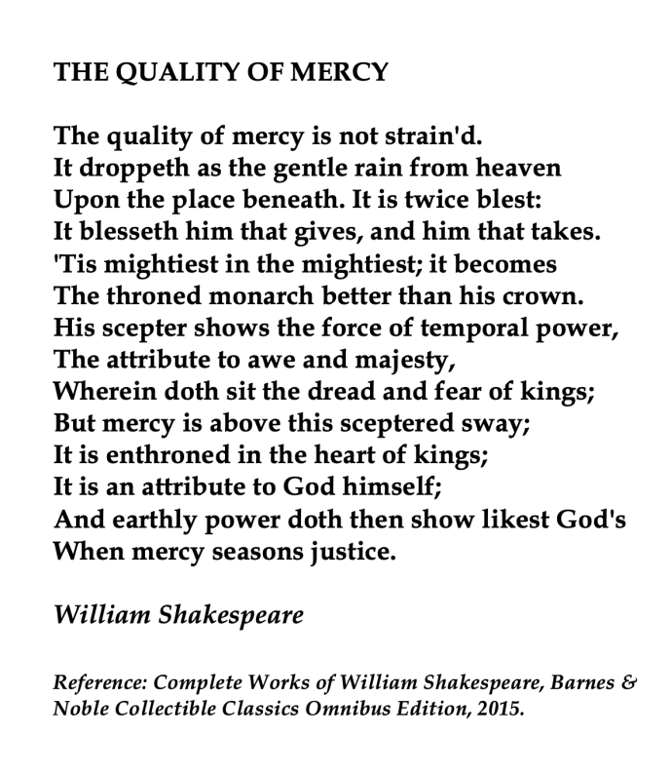



**Choose a phrase and find out what it means**

**Grammar pp. 100-105, Conditional Sentences**

***Watch the following videos and find the examples of conditional sentences in Shylock’s soliloquy:***

**English Conditional Sentences**: <https://youtu.be/FH3ThwR99LM>

**When to use Zero+First Conditional Sentences**: <https://youtu.be/ZYdIhPgIDkg>

**Mixed Conditionals:** <https://youtu.be/FuWk4lTt3UE>

**Different ways of saying ‘if”:** <https://youtu.be/eCpB4QK6Y3k>

**How to use inverted conditionals:** <https://youtu.be/RmQH6B9P8r8>

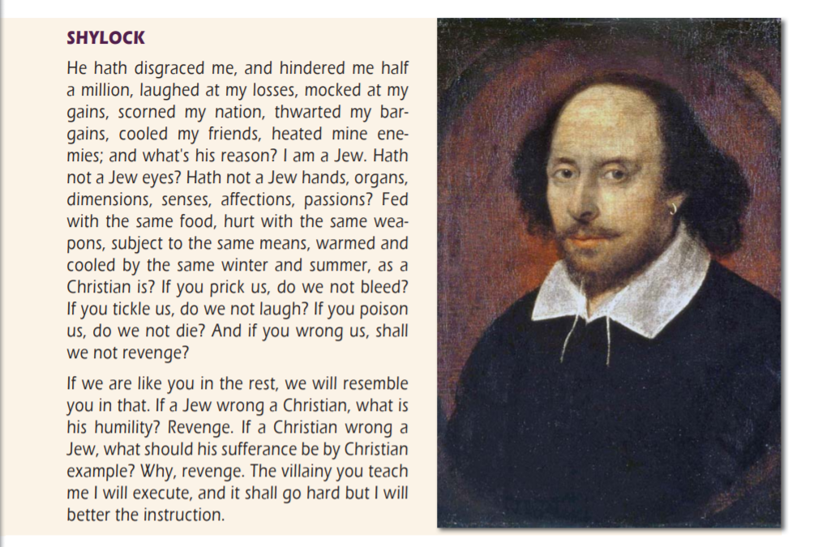

Source: Αγγλικά 2 Γενικού Λυκείου, Unit 9 The Merchant of Venice, p.144

**Writing a Review**

***Choose a book or film that you like and write a review. Follow the plan below:***

* ***Introduction:***Mention the title and author of the book. If you're reviewing a film, mention the director or actors.
* ***Body:***Paragraph: 1. a. Summarize the plot in a few sentences.  
   b. Mention the setting: the place and time of the plot.  
  Paragraph: 2. a. Write about the main characters. Focus on your favourite one.  
   b. Write your opinion about the content/message of the book/film.
* ***Conclusion:***1. Comment on the book or film. Use the following questions to help you:  
  a. Let others know whether or not you liked the book/film.  
  b. Why do you like it? Why don't you like it?  
  b. Is the author's style good or bad, is the book / film interesting or boring etc.  
  c. Do you want to recommend the book/film?

**Tip: *don’t forget to edit your writing and include a catchy title*.**

**Useful Expressions:**

**Title, Author / Director, Actors**

The film is directed by  
The film is produced by..  
It is starred by...  
The book is written by ...

**Setting**

The action takes place in ... (setting)  
The action of the film is set in ...  
The story takes place in...

**Characters and Plot**

The main characters are ...  
The story is about ....  
The novel tells the story of ...  
In the course of the novel the action develops dramatically.  
The novel / film begins with...  
The novel has an unexpected ending.  
The end of ... is ...

**Reaction**

I am impressed by  
I think ....  
The book is terribly / beautifully written  
The film is terrible / exciting.  
What surprised me is ...  
What I liked is.../ What I didn't like is...  
I liked/didn't like the film / novel because ...