**ΘΕΜΑ 1. ΚΑΤΑΝΟΗΣΗ ΓΡΑΠΤΟΥ ΛΟΓΟΥ**

**Read the text and decide if each statement (1-10) is True (A) or False (B).**

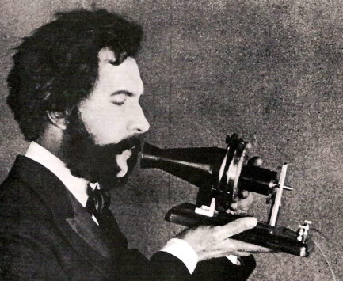On March 10 1876, in Boston, Massachusetts, Alexander Graham Bell invented the telephone. Speaking through the machine to his assistant Thomas A. Watson, who was in the next room, Bell said these famous first words: “Mr. Watson come here, I want to see you”. “Telephone” comes from the Greek word “tele”, meaning “from far away”, and “phone”, meaning “voice” or “voice sound”.

Generally, a telephone is any machine that carries sound over distance. People have used smoke signals, mirrors, jungle drums, pigeons to get a message from one point to another. But a real telephone could not be invented until the electrical age began. The electrical rules needed to build a telephone were known in 1831, but the idea of sending speech electrically was thought of in 1854. It wasn't until 22 years later, in 1876, that the idea became a fact. Bell's success with the telephone came as a direct result of his attempts to improve the telegraph. This had been the traditional means of communication for some 50 years but, with its Morse code, it was limited to receiving and sending one message at a time. The telephone is a shared achievement among many inventors, but Bell's knowledge of the nature of sound made it easy for him to think of the possibility of sending many messages at the same time.

(Words: 222)

|  |  |  |  |
| --- | --- | --- | --- |
| **Statements** | | **A** | **B** |
| **TRUE** | **FALSE** |
|  | The text talks about the family life of Alexander Graham Bell. |  |  |
|  | A lab assistant would be interested in reading this text. |  |  |
|  | The telephone was invented in 1876. |  |  |
|  | The word telephone in Greek means voice from far away. |  |  |
|  | People have always wanted to find a way to talk to pigeons. |  |  |
|  | The idea of sending speech electrically was thought of in 1831. |  |  |
|  | The invention of the telephone came as a result of Bell’s attempts to improve the telegraph. |  |  |
|  | The traditional means of communication before the telephone was the telegraph. |  |  |
|  | Bell succeeded in inventing the telephone because he knew a lot about music. |  |  |
|  | The telephone is the achievement of one inventor only. |  |  |

**ΘΕΜΑ 2α. ΛΕΞΙΚΟΓΡΑΜΜΑΤΙΚΗ**

**Match each of the phrases below (11-20) with a word from the box that has a similar meaning (A-J). Use each word only once.**

|  |  |  |  |  |  |  |  |  |  |
| --- | --- | --- | --- | --- | --- | --- | --- | --- | --- |
| **A.** | invent | **B.** | experiment | **C.** | assistant | **D.** | communicate | **E.** | message |
| **F.** | attempt | **G.** | result | **H.** | traditional | **I.** | machine | **J.** | inventor |

|  |  |
| --- | --- |
| **11.** | To try to do something, especially something difficult. |
| **12.** | A short piece of information that you give to a person when you cannot speak to them directly. |
| **13.** | Someone who helps someone else to do a job. |
| **14.** | To design or create something which has never been made before. |
| **15.** | A scientific test you do in order to learn something or to discover whether something is true. |
| **16.** | To share information with others by speaking, writing, moving your body or using other signals. |
| **17.** | A piece of equipment that uses power to do a particular type of work. |
| **18.** | Following the customs or ways of behaving that have continued in a group of people or society for a long time without changing. |
| **19.** | Someone who designs and makes new things. |
| **20.** | Information that you get from an exam, a scientific experiment or a medical test. |