**ΝΕΑ** ΤΡΑΠΕΖΑ ΘΕΜΑΤΩΝ ΔΙΑΒΑΘΜΙΣΜΕΝΗΣ ΔΥΣΚΟΛΙΑΣ



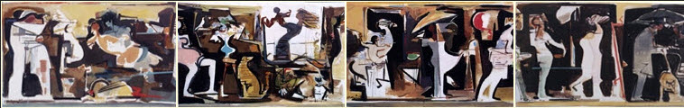

***Κώστας Κοντογιάννης****: “Ζωή” τετράπτυχη σύνθεση*

*ακρυλικά σε ύφασμα 105x(4x65)cm - έτος 2000*

**➤ 11637 / Δ** [****](https://drive.google.com/file/d/1CY381WN9LndEAHGP-SSXHP8TEqHb4TqC/view?usp=sharing)

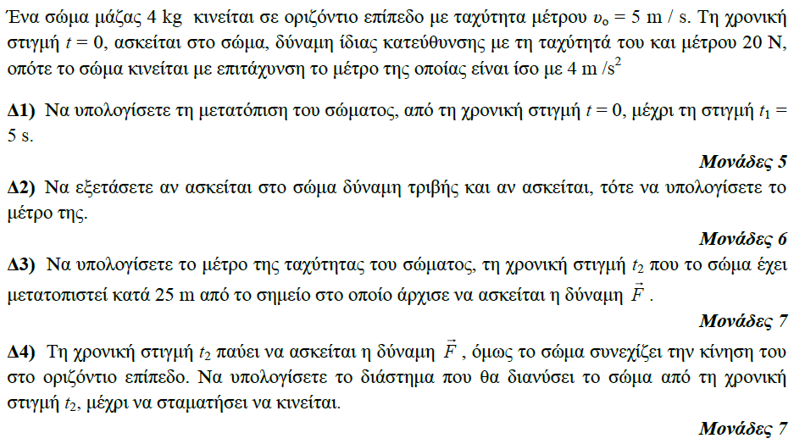

**➤ 11642 / Δ** [****](https://drive.google.com/file/d/1K4JjpDtq5g5Fh9xcwWyzxkWEtKZK05uc/view?usp=sharing)

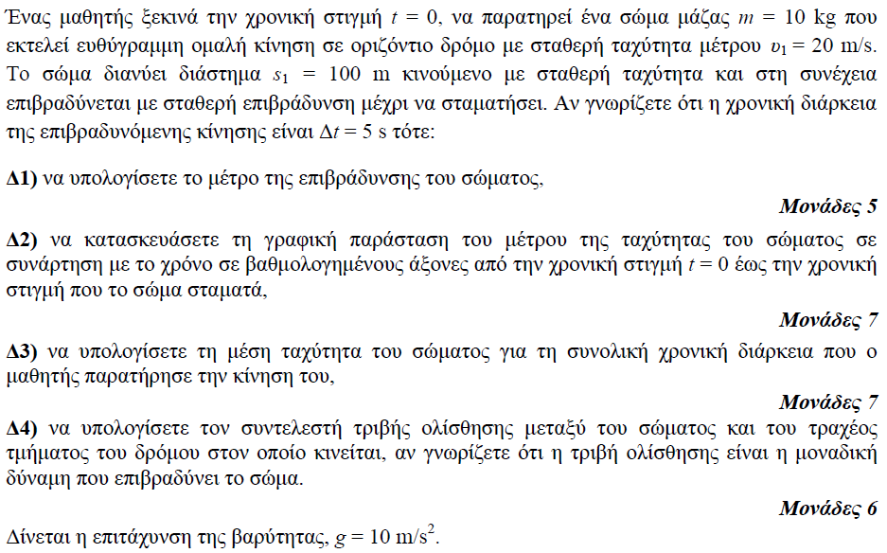

**➤ 11662 / Δ** [****](https://drive.google.com/file/d/1WnN5z_Sz6mO51cndK2VjdHvRY9SJFS0A/view?usp=sharing)

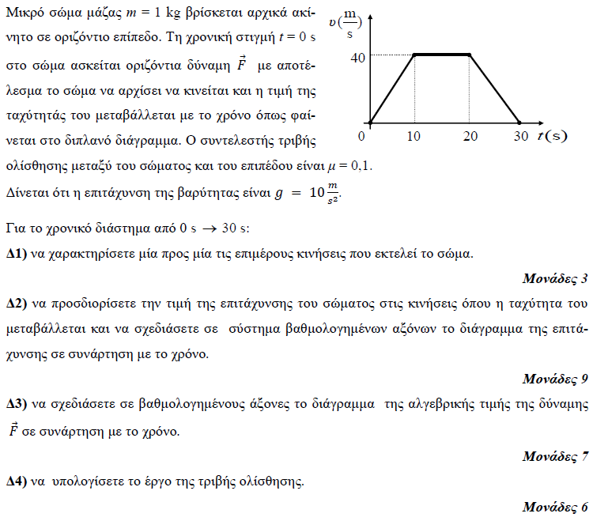

**➤ 11665 / Δ** [****](https://drive.google.com/file/d/1tSyGLfAFbpkT3uWqNoZ57Q4EHVsOQgss/view?usp=sharing)

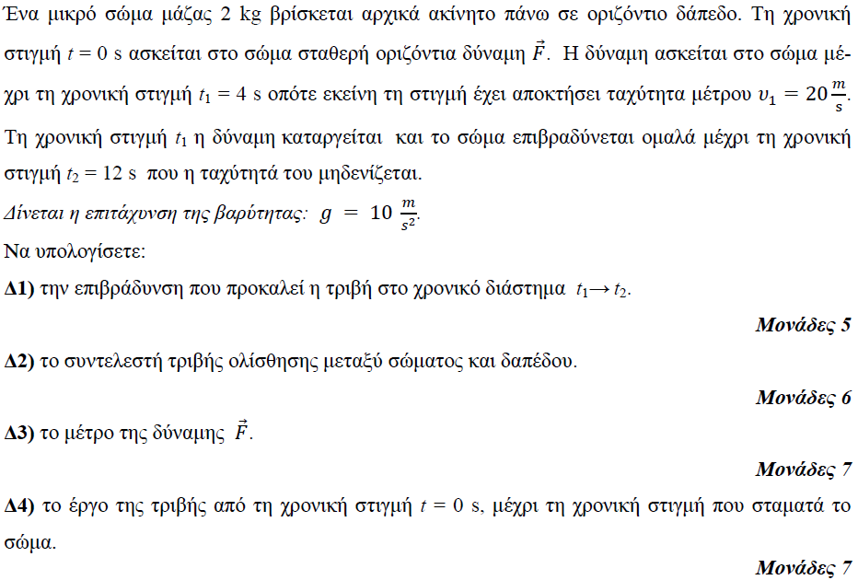

**➤ 11667 / Δ** [****](https://drive.google.com/file/d/1gV5RCWB_HZk4zKcZHQWTzWvDzixJTV7E/view?usp=sharing)

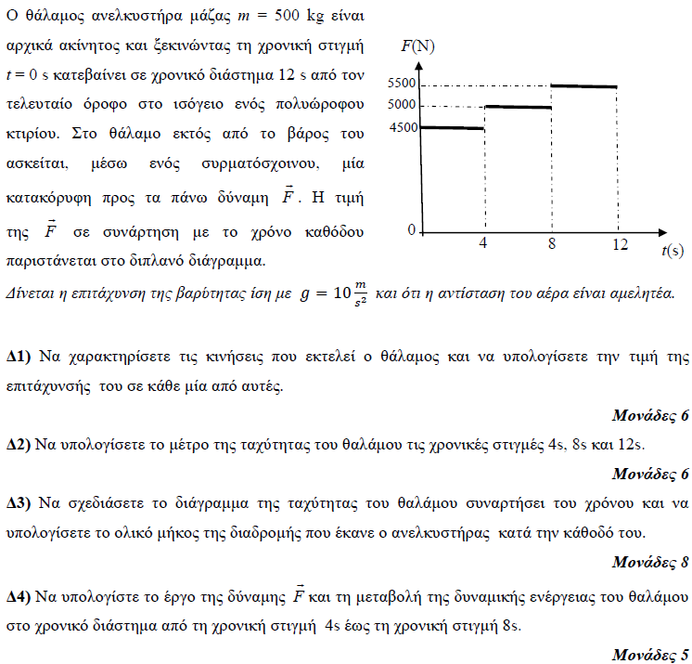

**➤ 11673 / Δ** [****](https://drive.google.com/file/d/16KrlWaXzftsQ6jzytiQ37t6VZd18g97n/view?usp=sharing)

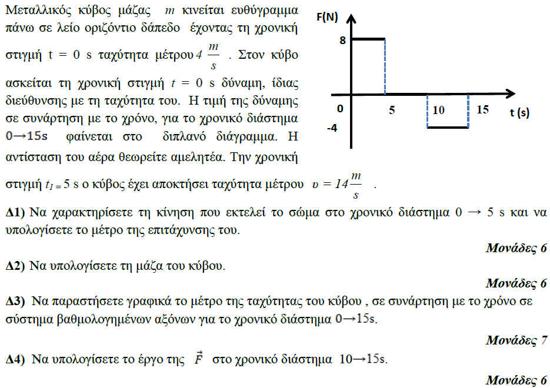

**➤ 11674 / Δ** [****](https://drive.google.com/file/d/1i9bouCi9mAEA_0_V3ekN6JwlI8z-xVYZ/view?usp=sharing)

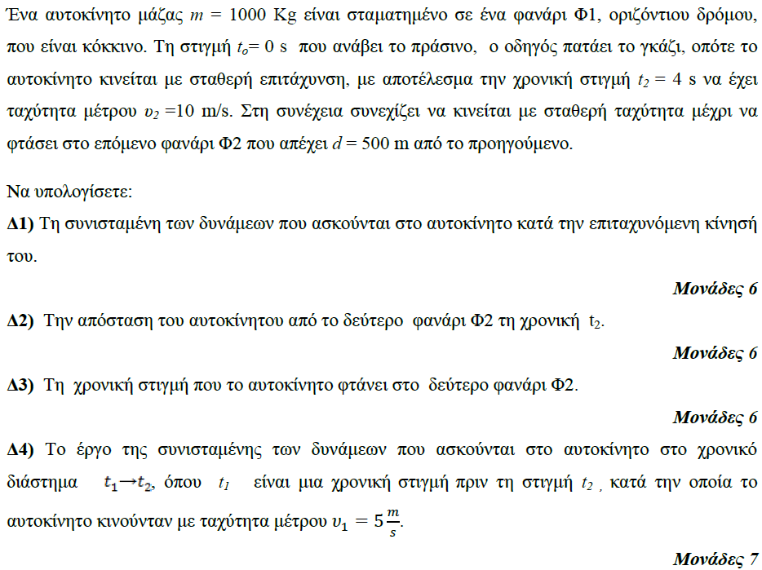

**➤ 11675 / Δ** [****](https://drive.google.com/file/d/1EgwJ_zF0edsOTN2wElyiTaEoUDq4wlLz/view?usp=sharing)

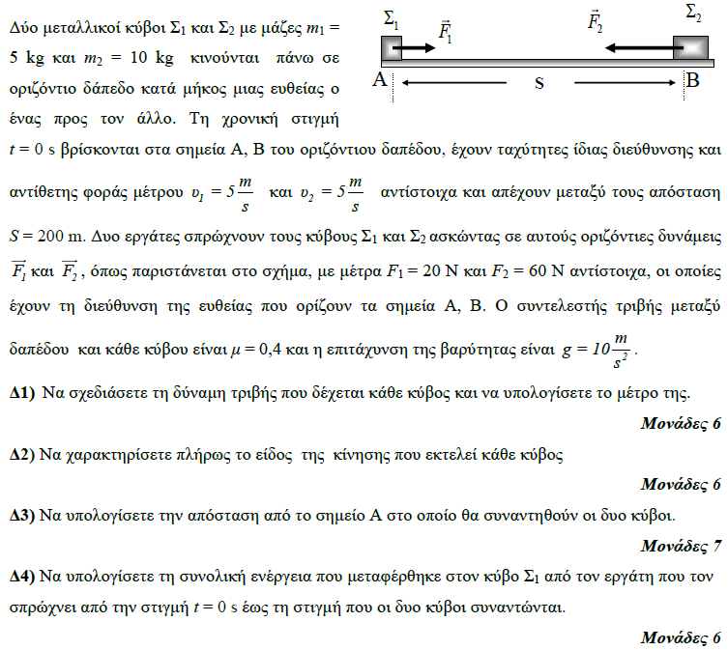

**➤ 11678 / Δ** [****](https://drive.google.com/file/d/1FWMAWdGw3xGXVi2oJnFSr6LBpMQMwOMg/view?usp=sharing)

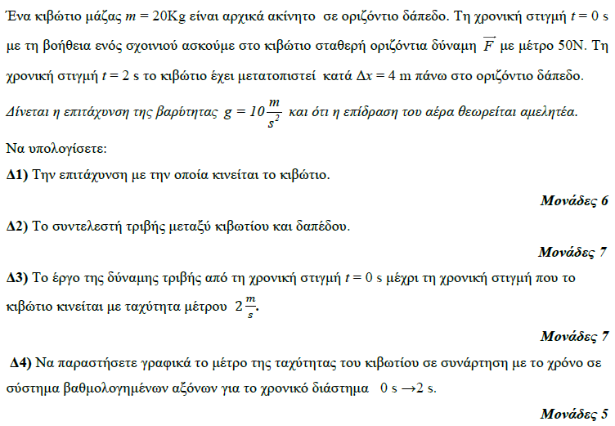

**➤ 11679 / Δ** [****](https://drive.google.com/file/d/1sfmpWfvDwWZQE4dvtUOxV4XApJOfV5EP/view?usp=sharing)

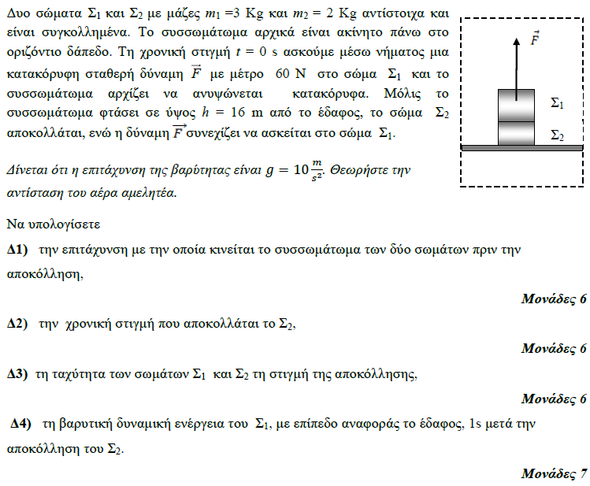

**➤ 11680 / Δ** [****](https://drive.google.com/file/d/1BwdekXQZD6utOecJqUPq5mgsT8SaV8Cm/view?usp=sharing)

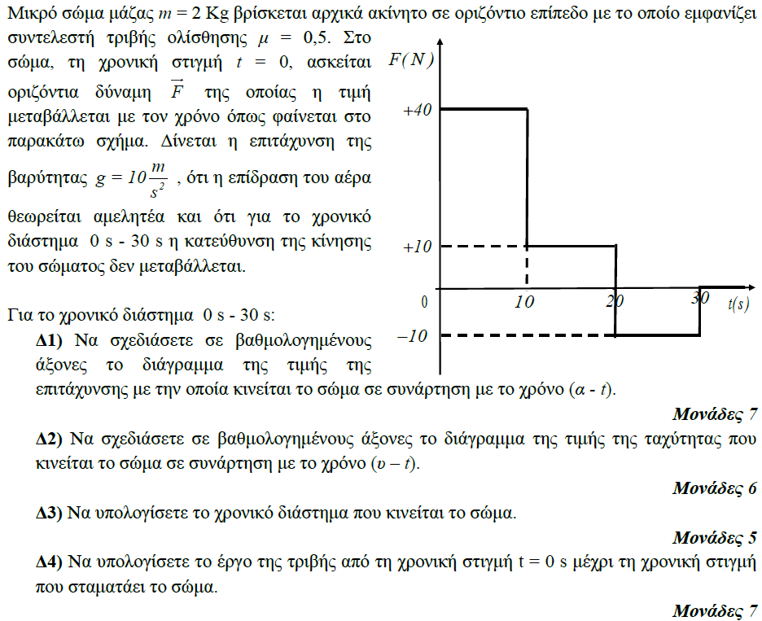

**➤ 11681 / Δ** [****](https://drive.google.com/file/d/1RKl0nr6kKk7BjiAh0WJ9AgFCkaHOXyr8/view?usp=sharing)

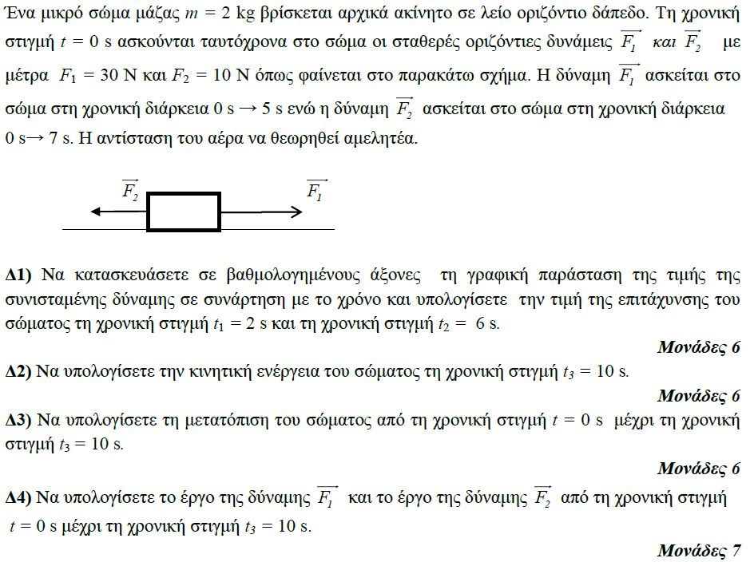

**➤ 11685 / Δ** [****](https://drive.google.com/file/d/11VNRVnKxHT5eAi4qF-XNmtRbOtQjdwzR/view?usp=sharing)

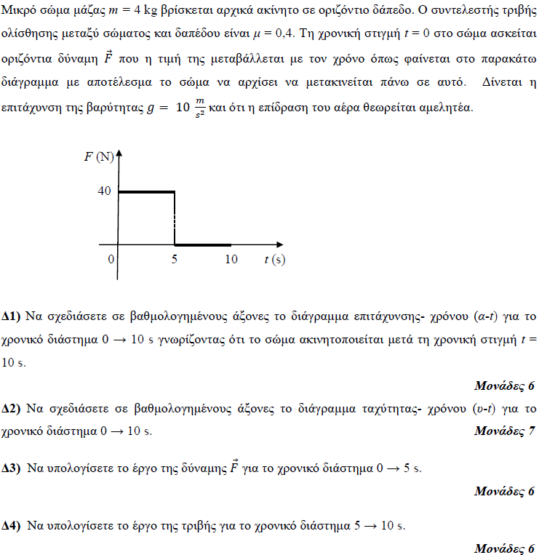

**➤ 11692 / Δ** [****](https://drive.google.com/file/d/1ZRywmvrqDGJeexPKFOSk4LrZfOO0zJEY/view?usp=sharing)

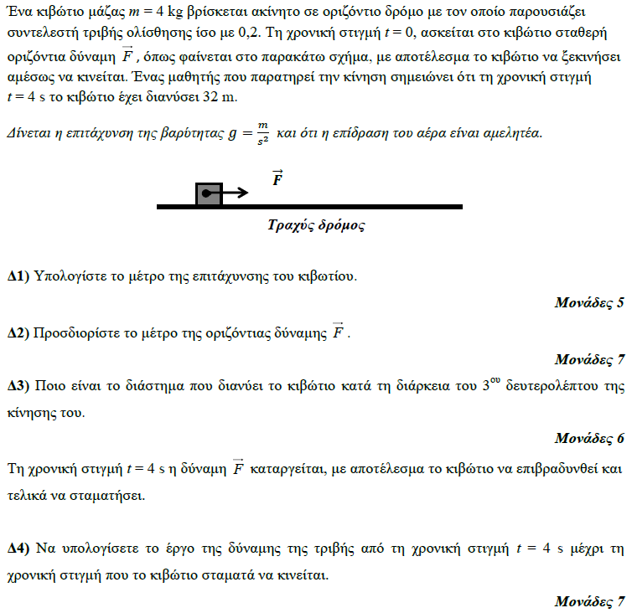

**➤ 11698 / Δ** [****](https://drive.google.com/file/d/1fwexOzvXQqQa9aOvn9gijSpA-g_4Jd5X/view?usp=sharing)

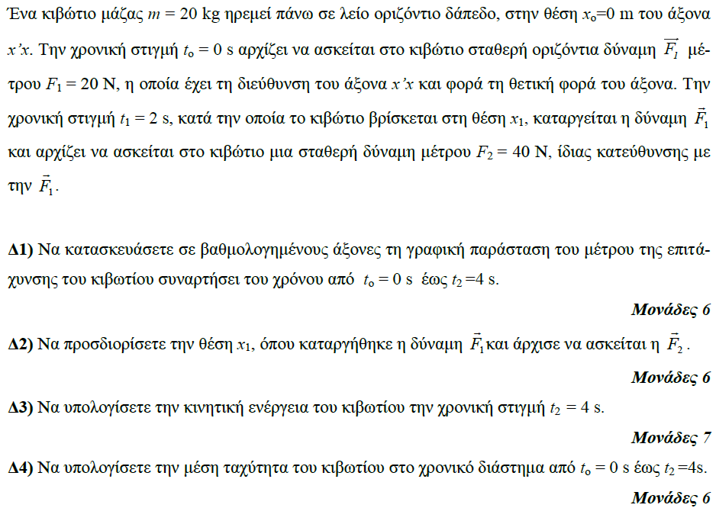

**➤ 12989 / Δ** [****](https://drive.google.com/file/d/1pvcCBQRJ0frX8q5PIJmpQvFtYnwXzSQa/view?usp=sharing)

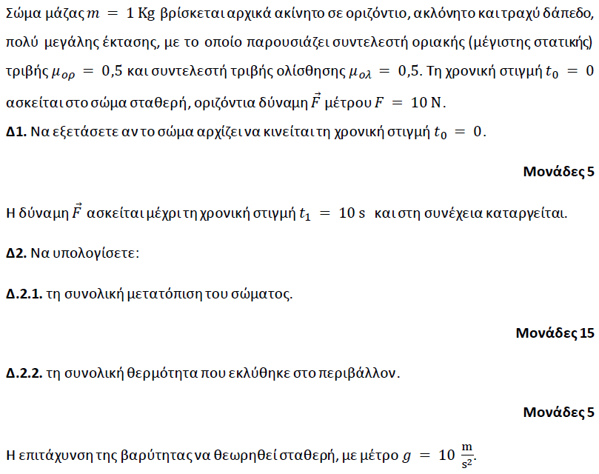

**➤ 12990 / Δ** [****](https://drive.google.com/file/d/1y0lUKtY7do-GvXTeBBnikNp1Rw_o171Z/view?usp=sharing)

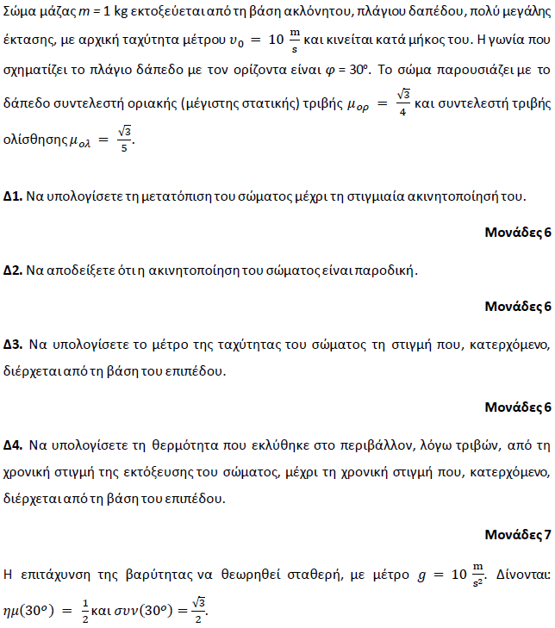

**➤ 12991 / Δ** [****](https://drive.google.com/file/d/191uBJIqjyA2XXfwr53jxc_o7R6jEuu-w/view?usp=sharing)

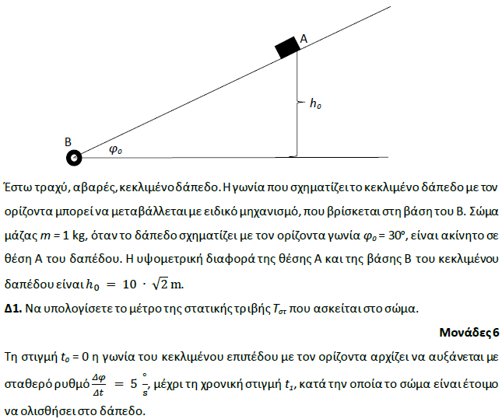

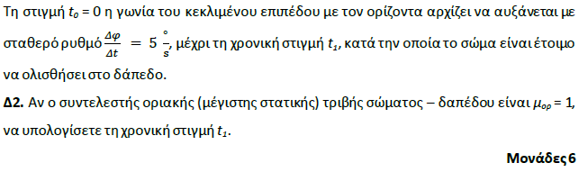

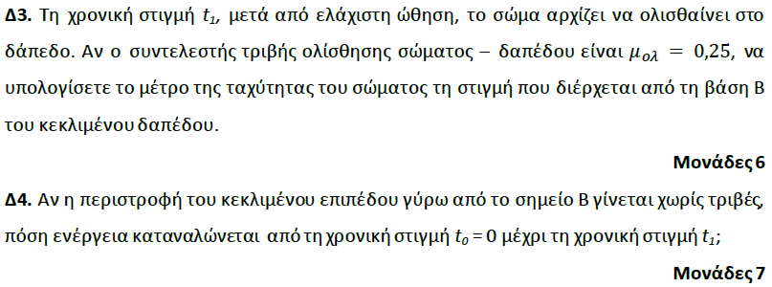

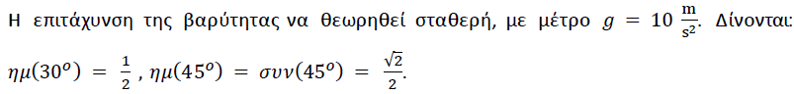

**➤ 13563 / Δ** [****](https://drive.google.com/file/d/16TpGI4nq1icMAaviL3xGvn0tQ2WNqAr4/view?usp=sharing)

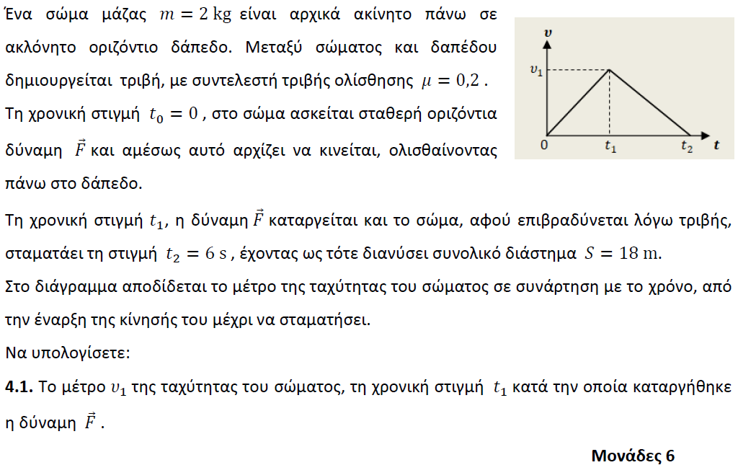

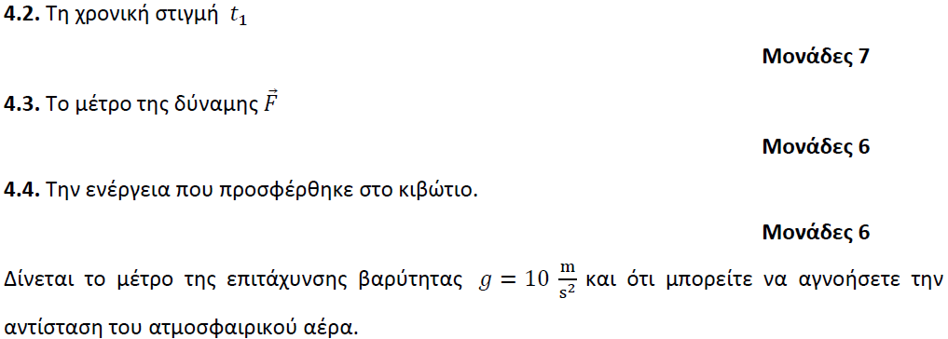

**➤ 13587 / Δ** [****](https://drive.google.com/file/d/1-1ii4CuFV4su-lgn8OBt6PNvjfyYxfmN/view?usp=sharing)

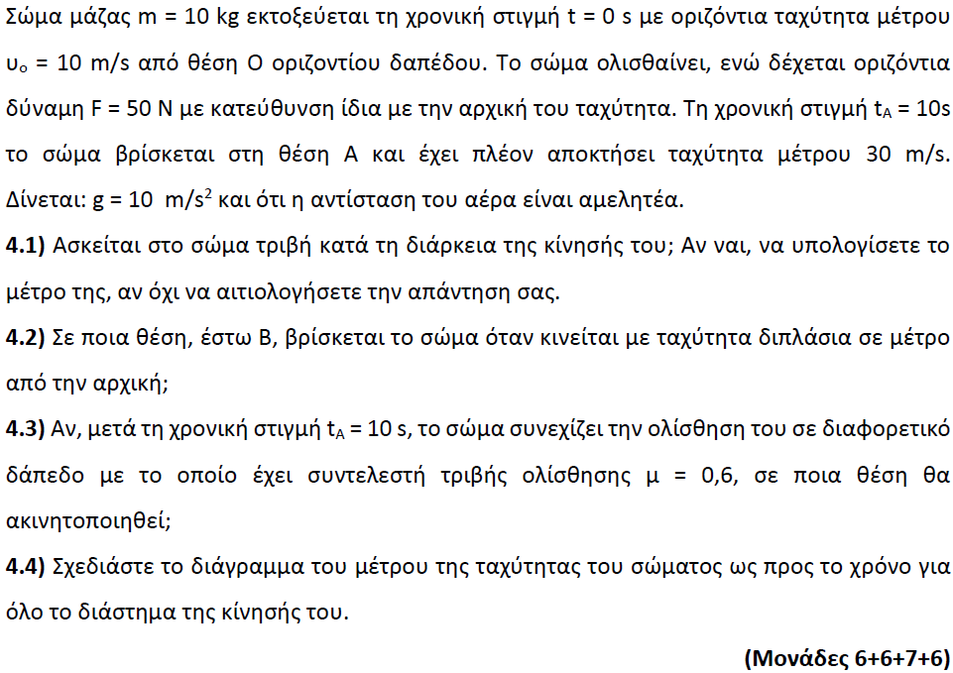

**➤ 13588 / Δ** [****](https://drive.google.com/file/d/12-JOSYKvNOyB6FGIP3FsD782SpcT4wSf/view?usp=sharing)

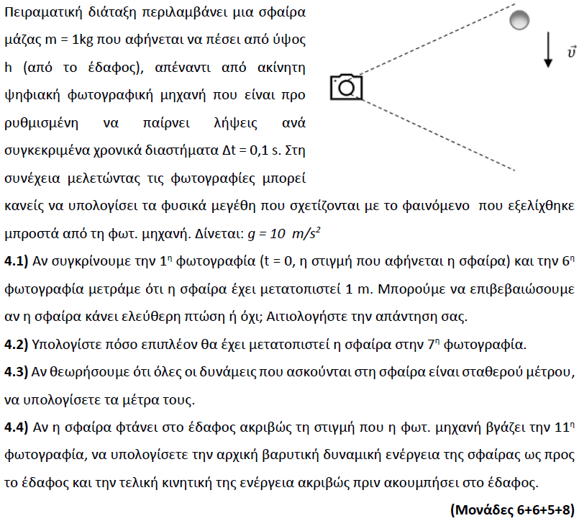

**➤ 13590 / Δ** [****](https://drive.google.com/file/d/1modHZgkLmOYR1oXHQZLzEZb8k-S9w3td/view?usp=sharing)

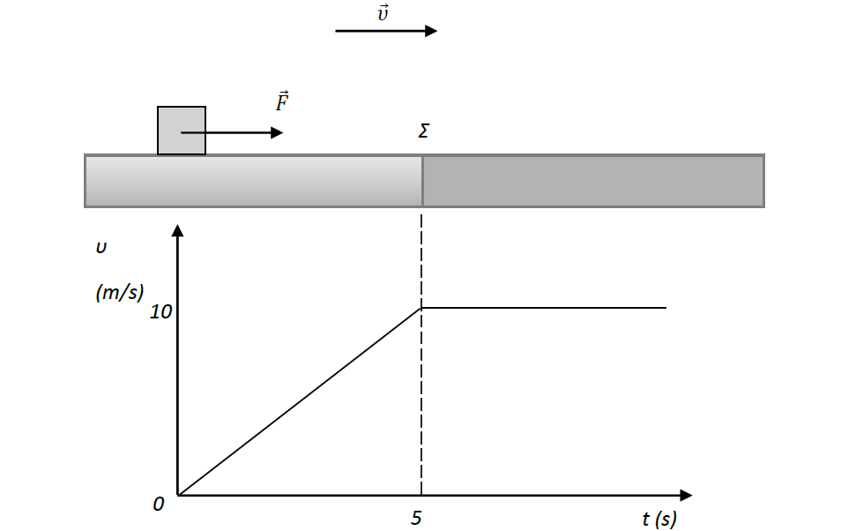

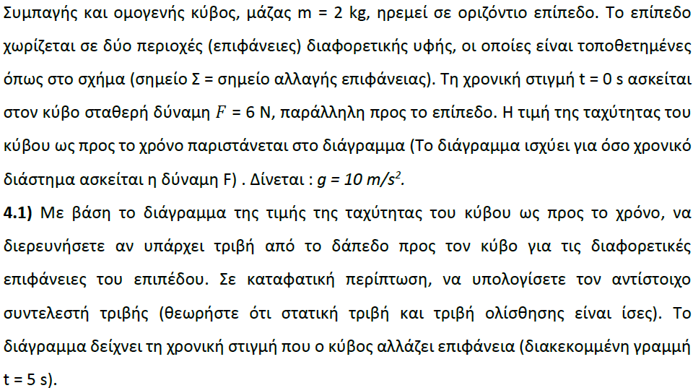

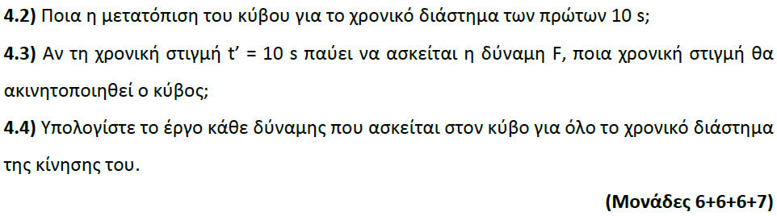

**➤ 13591 / Δ** [****](https://drive.google.com/file/d/1kPMsimE86JBGmmby0KPK-_nLqlgJJebp/view?usp=sharing)

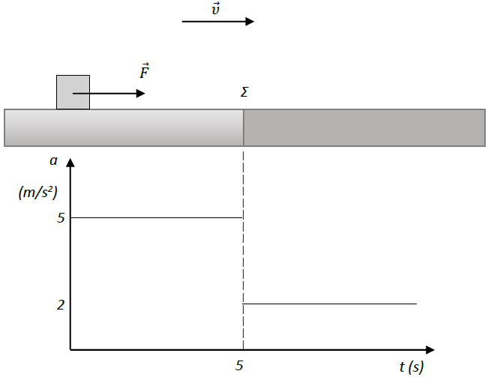

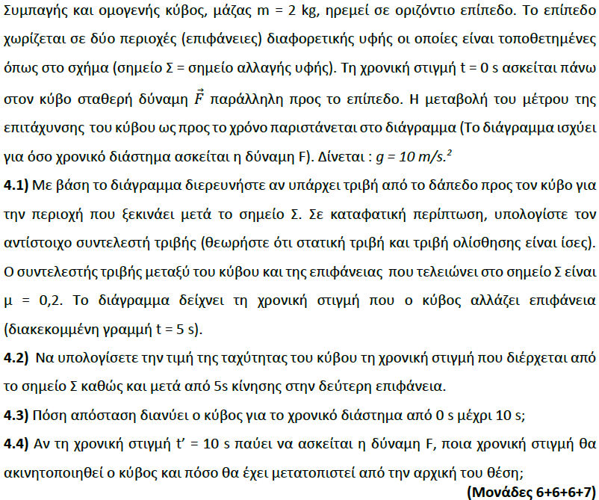

**➤ 13633 / Δ** [****](https://drive.google.com/file/d/1qjBVDLS0WU986OTvkE-LvT1xBWSheUmC/view?usp=sharing)

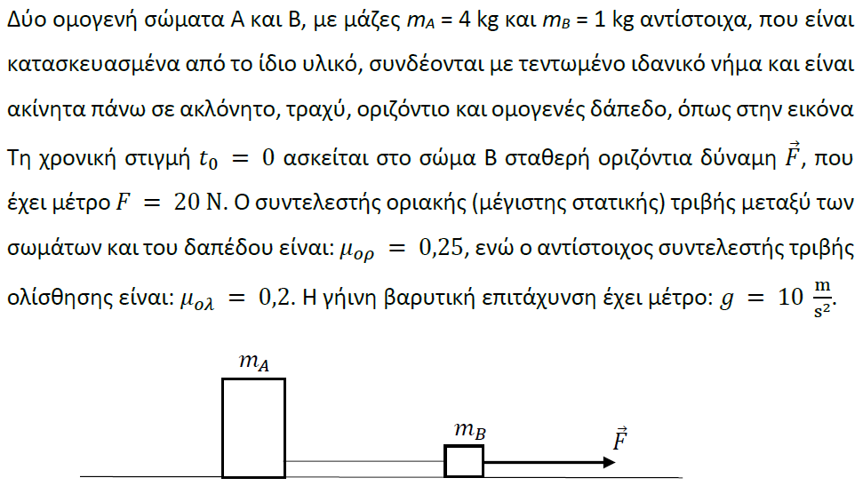

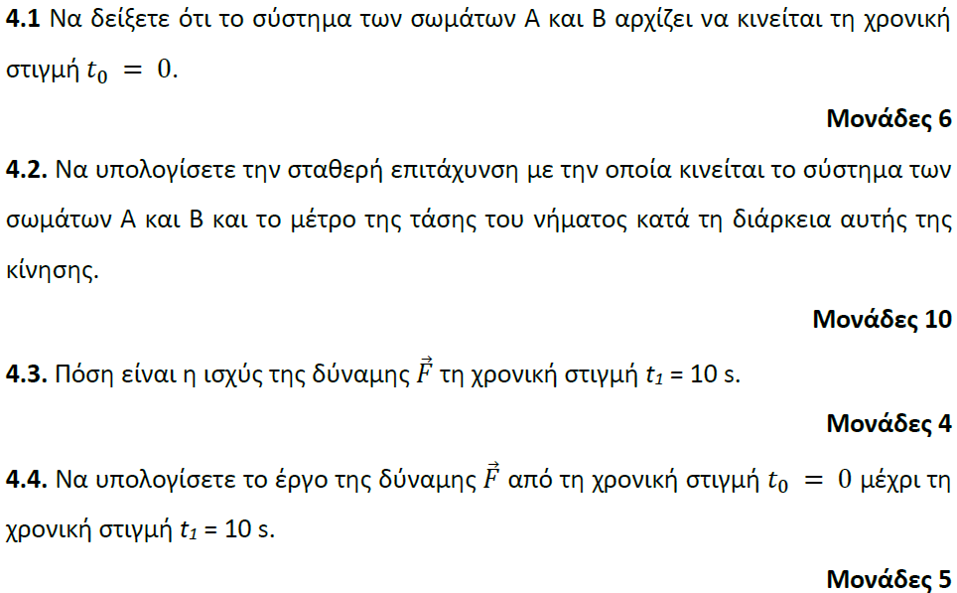

**➤ 13635 / Δ** [****](https://drive.google.com/file/d/1WtPKIsETjvc8903MKb_PxeLWZ8PcCuxx/view?usp=sharing)

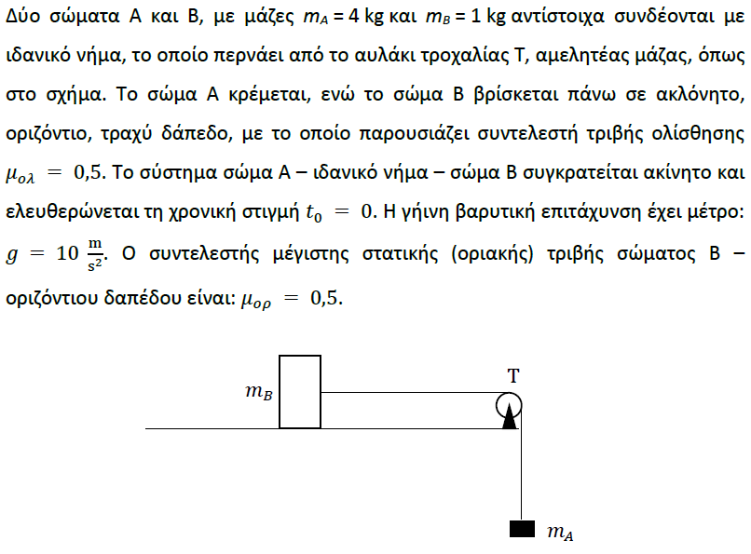

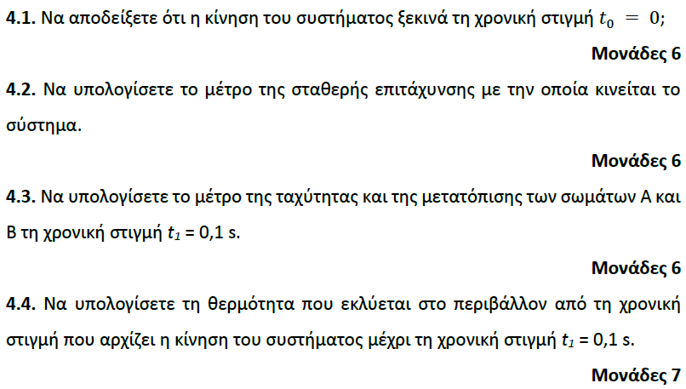

**➤ 13642 / Δ** [****](https://drive.google.com/file/d/1QXgOnYdtYNUkMGV6OKWRWPlxMaXxkEF_/view?usp=sharing)

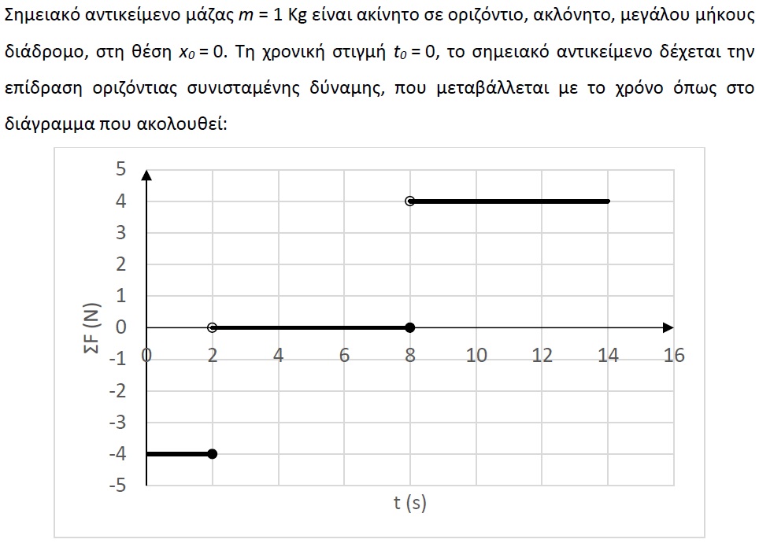

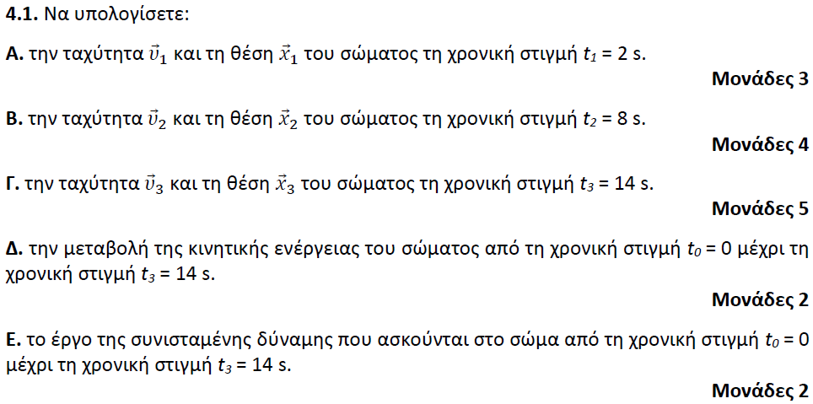

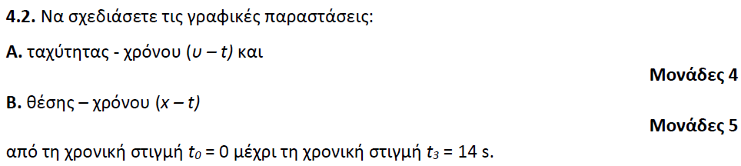

**➤ 13658 / Δ** [****](https://drive.google.com/file/d/1r72sN5AI6ggQ1iwQtqKkF1xSeb6butkF/view?usp=sharing)

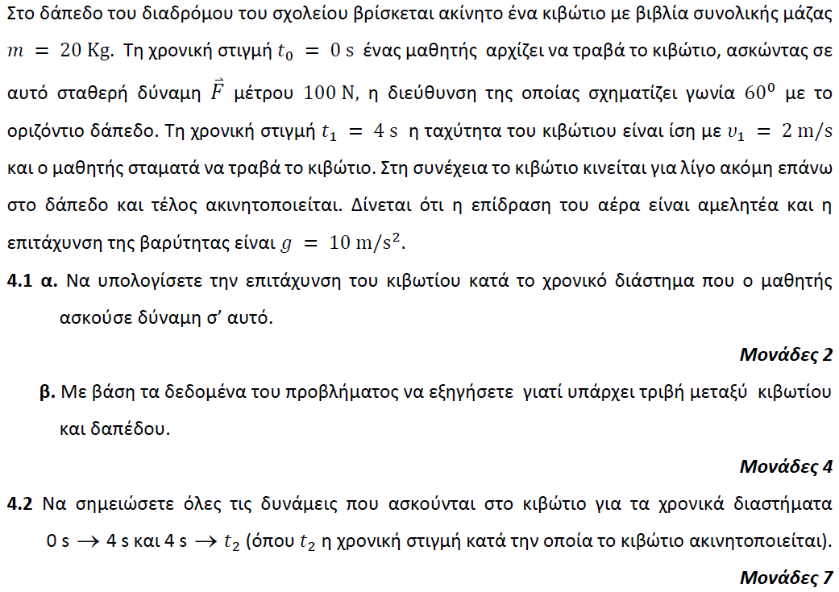

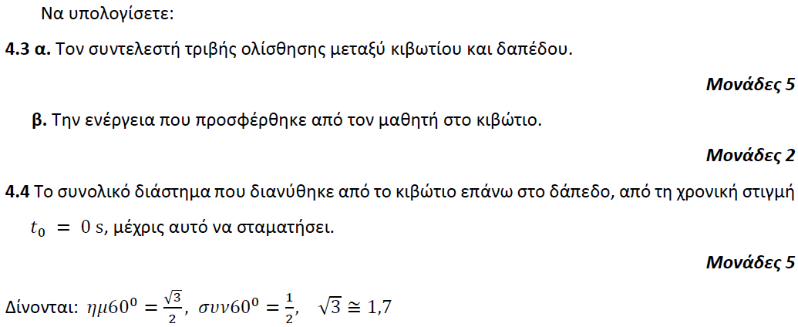

**➤ 13659 / Δ** [****](https://drive.google.com/file/d/1TXXCDK-B5yYCKzvJOTFO0feNsf1GWcAH/view?usp=sharing)

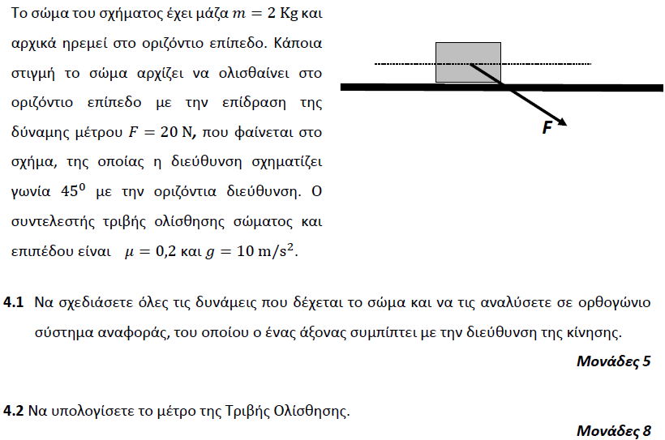

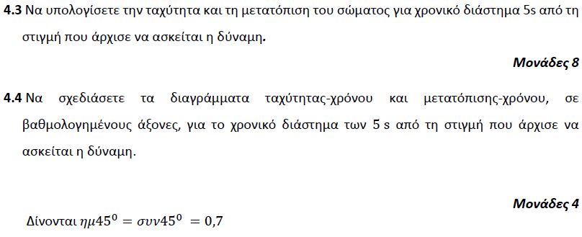

**➤ 13660 / Δ** [****](https://drive.google.com/file/d/1mT31mTOS2z1a2ASkcRjG7QoCMDUXnoaR/view?usp=sharing)

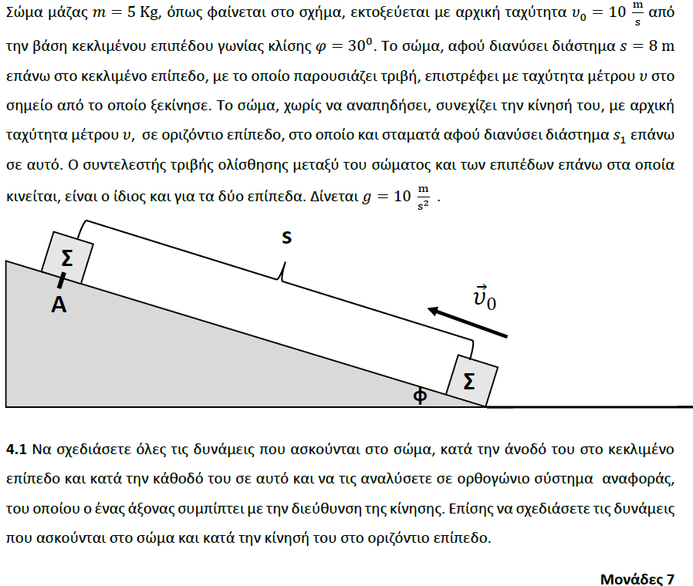

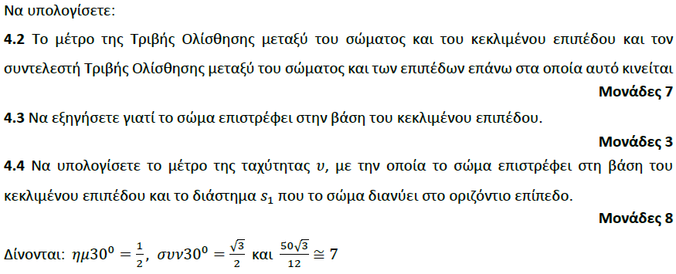

**➤ 13664 / Δ** [****](https://drive.google.com/file/d/1iD4fH_hIv-aaOBUYXYXi1Rnpls7CtGtv/view?usp=sharing)

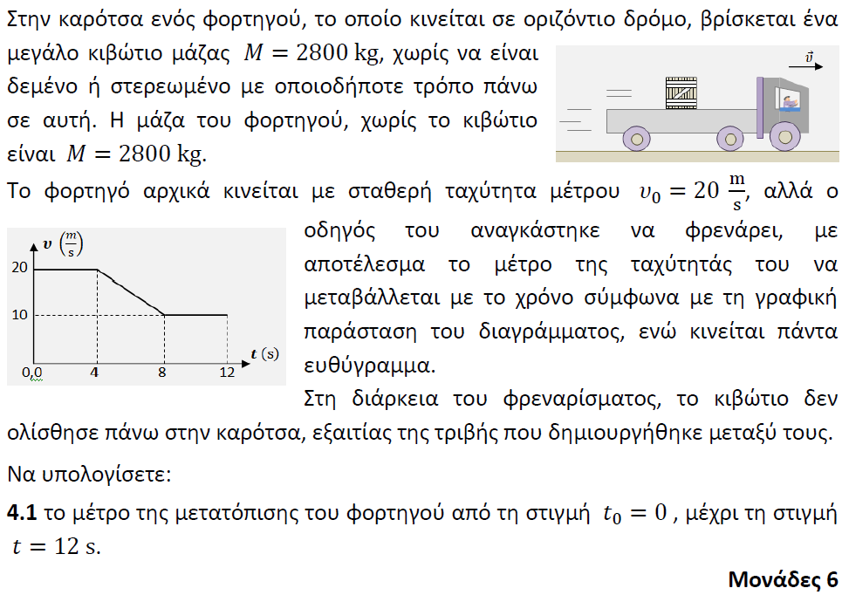

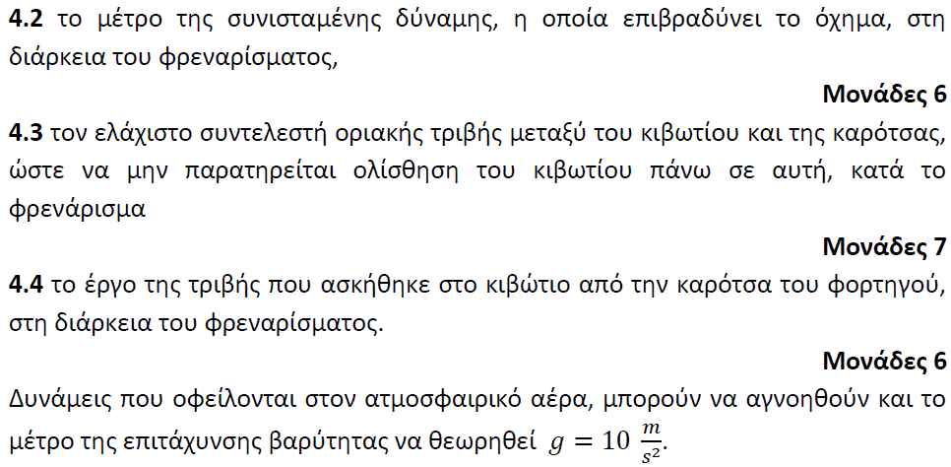

**➤ 13666 / Δ** [****](https://drive.google.com/file/d/1tWWms_D7chNpmBL9b73FLjyfFZ0h6iLq/view?usp=sharing)

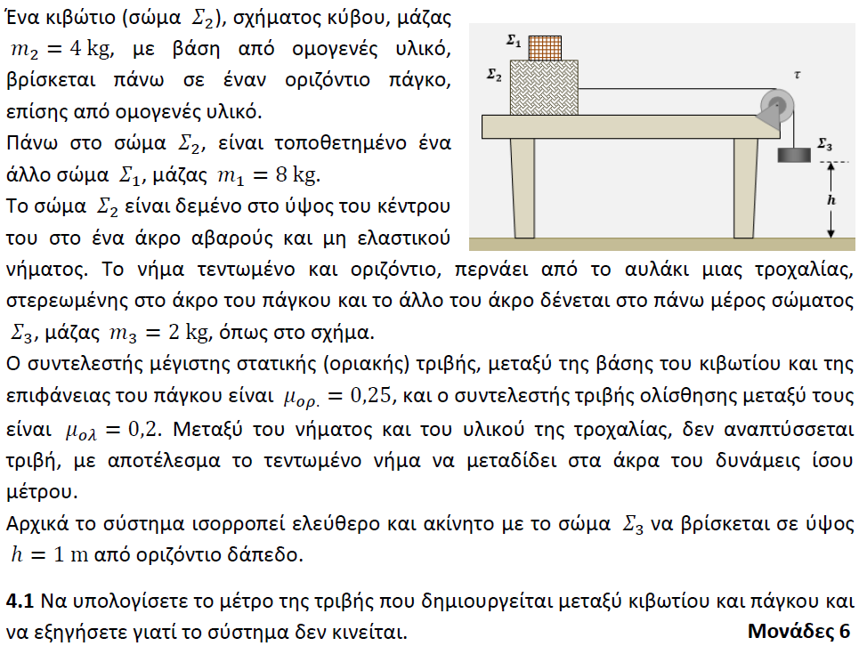

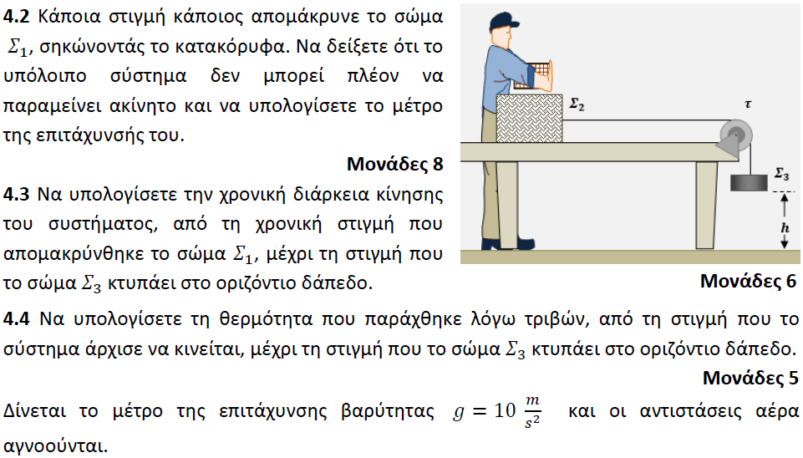

**➤ 13696 / Δ** [****](https://drive.google.com/file/d/1pK2oCtCCCl8UmFwkzfsQkFQd_ntqThT2/view?usp=sharing)

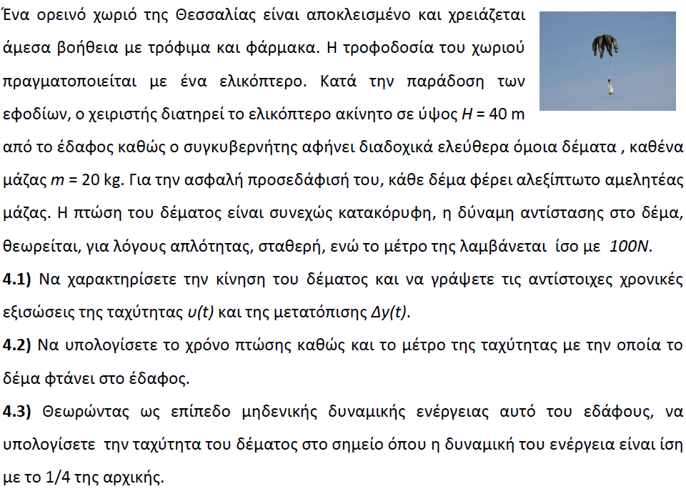

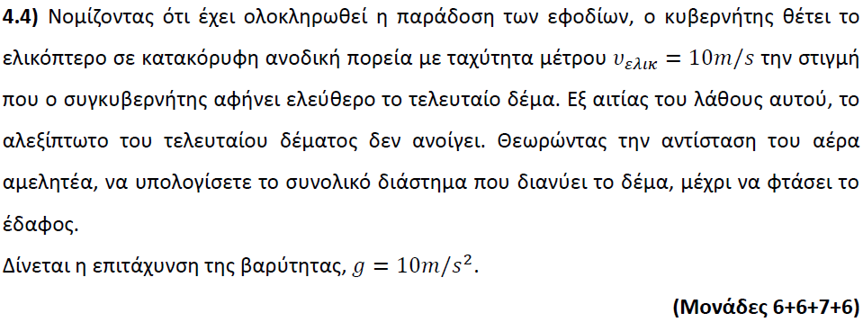

**➤ 13701 / Δ** [****](https://drive.google.com/file/d/1-sRIt2hQJOU_KD-Vl0uXTYRkKTmTCPyg/view?usp=sharing)

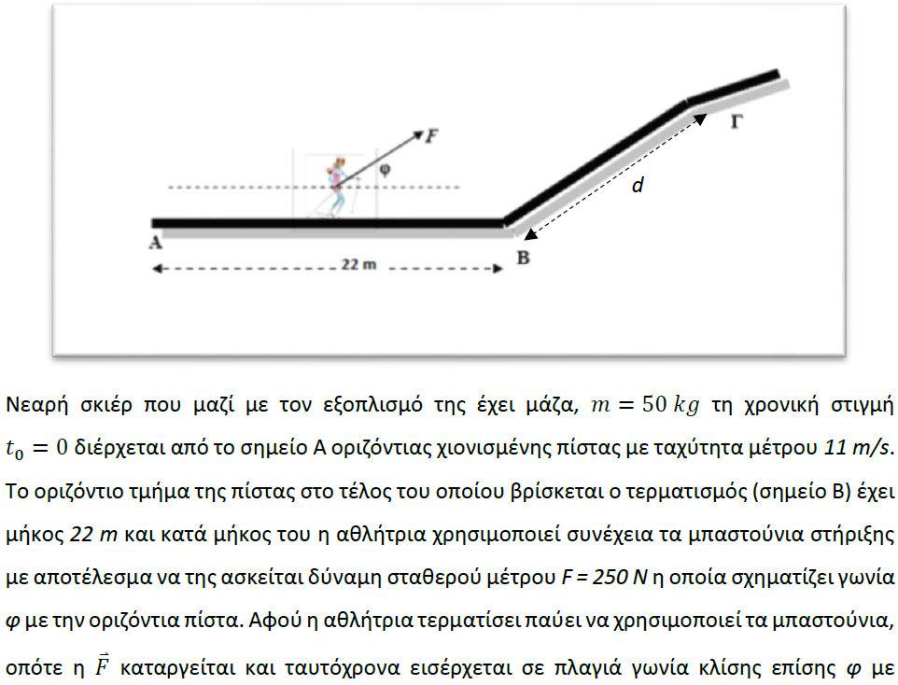

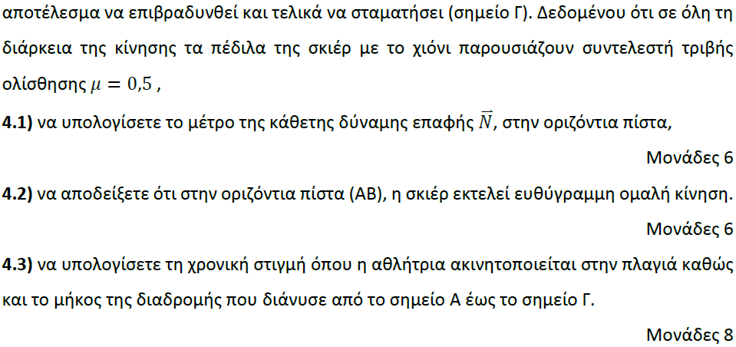

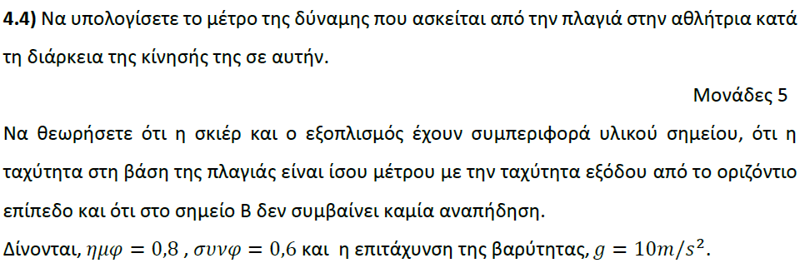

**➤ 13703 / Δ** [****](https://drive.google.com/file/d/1oEouBnedkKgAlb-N1AQUTVMgqpV2r8_n/view?usp=sharing)

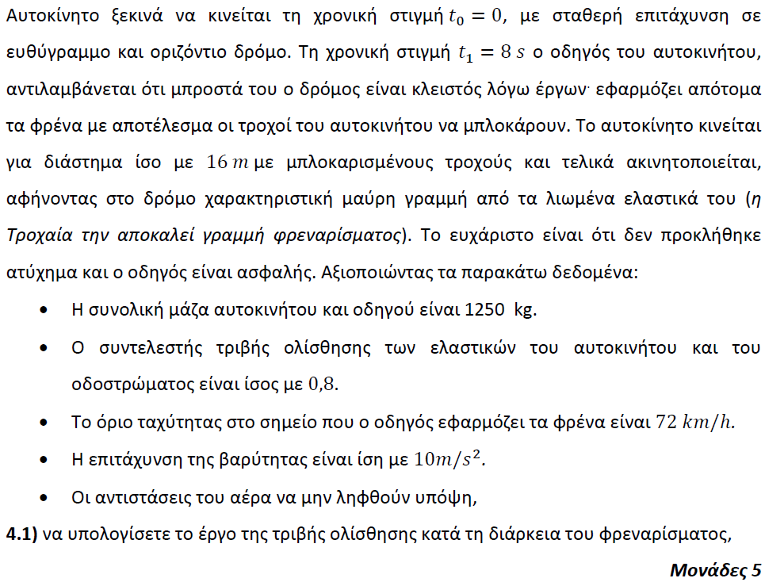

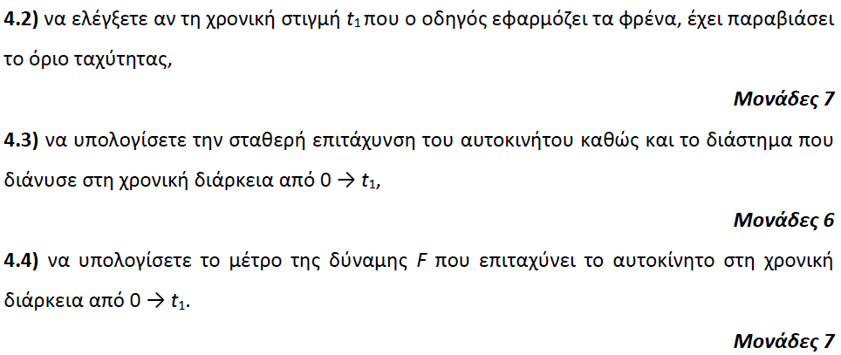

**➤ 13705 / Δ** [****](https://drive.google.com/file/d/1MNB-nNB8OCjDdSoFITQIjLcW-ArEw8Wc/view?usp=sharing)

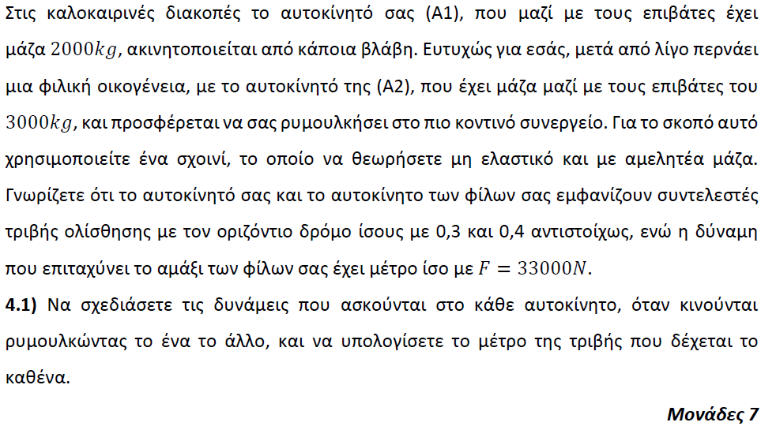

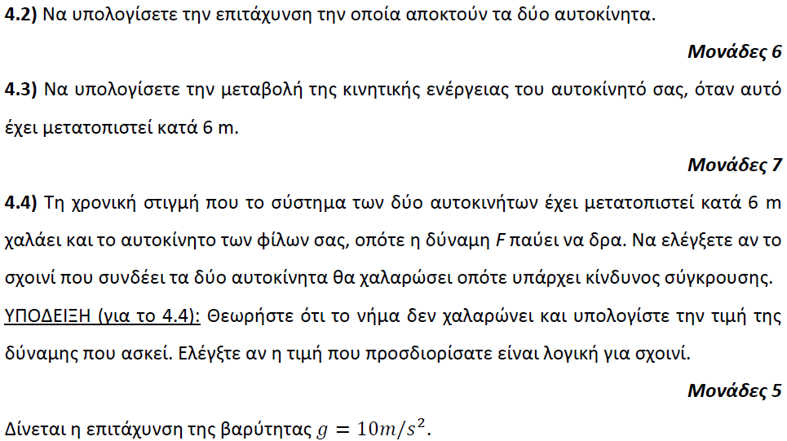

**➤ 13706 / Δ** [****](https://drive.google.com/file/d/1rPcrGqCkTxmnCEubg-lXZoXAM2Wyywcj/view?usp=sharing)

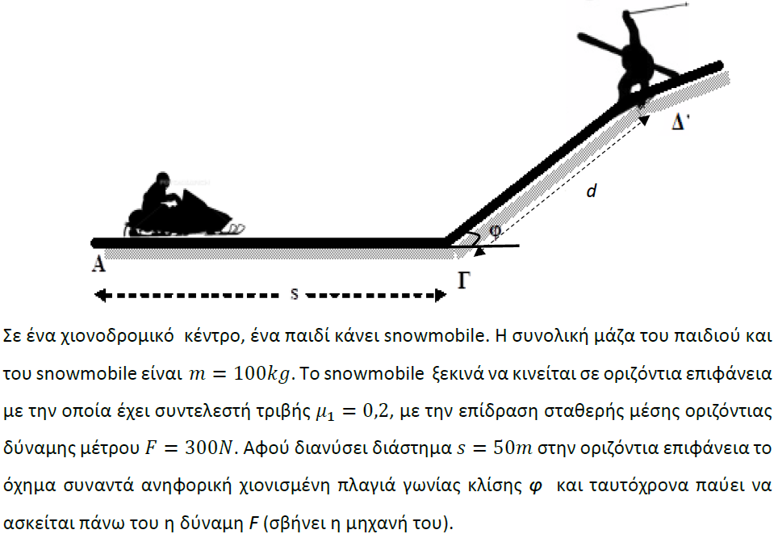

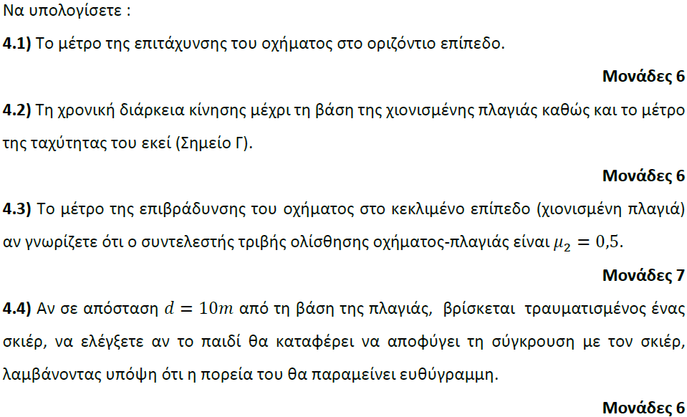

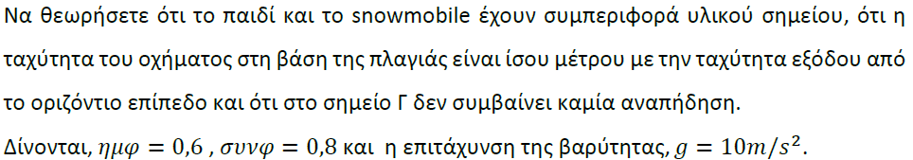

**➤ 13707 / Δ** [****](https://drive.google.com/file/d/1dSdmzLOU_Msm11gSuf_4rVI51svU2tSU/view?usp=sharing)

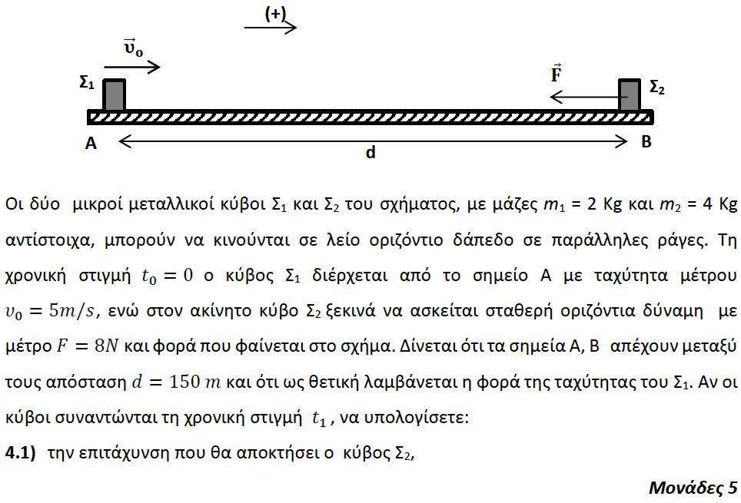

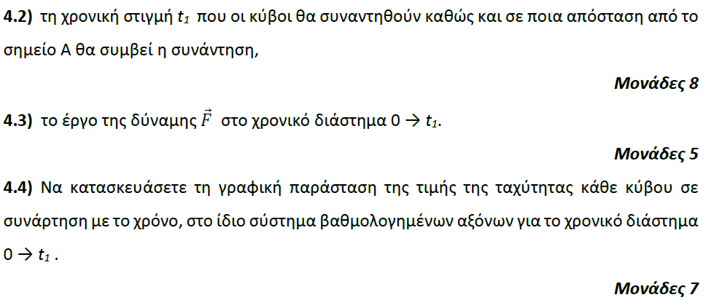

**➤ 13708 / Δ** [****](https://drive.google.com/file/d/1-gkdb4c6_r5OMGP38SAkqJovVMBqZGd0/view?usp=sharing)

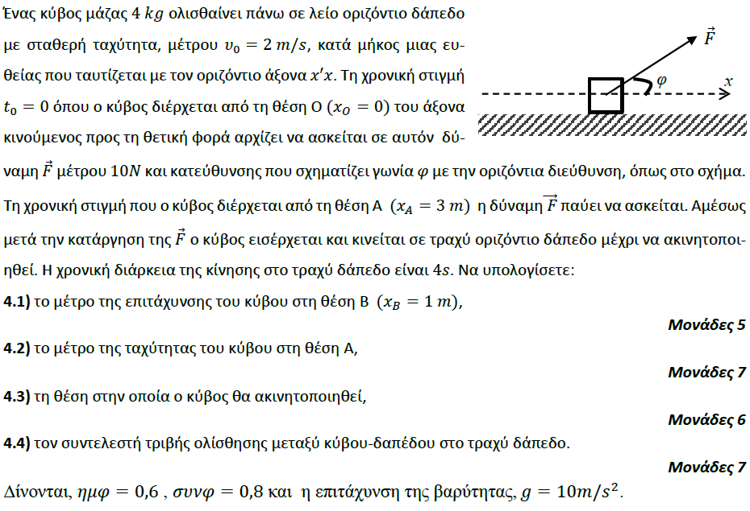

**➤ 13709 / Δ** [****](https://drive.google.com/file/d/1QrVQsRzILzWZNj1UMY2xhWoBQpBFQdph/view?usp=sharing)

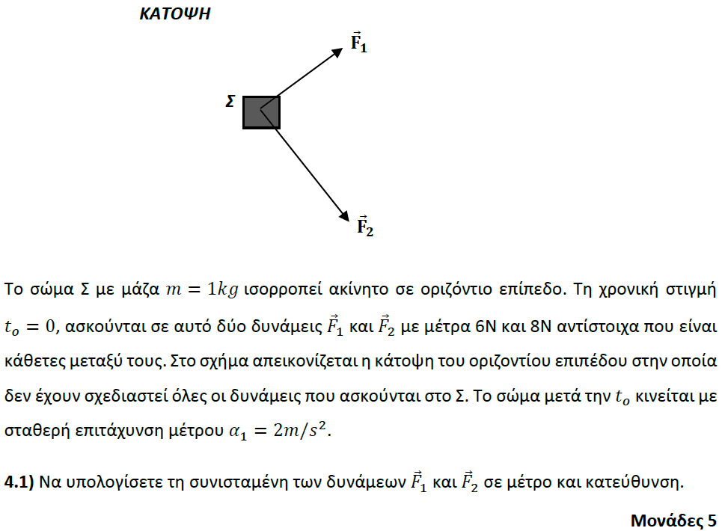

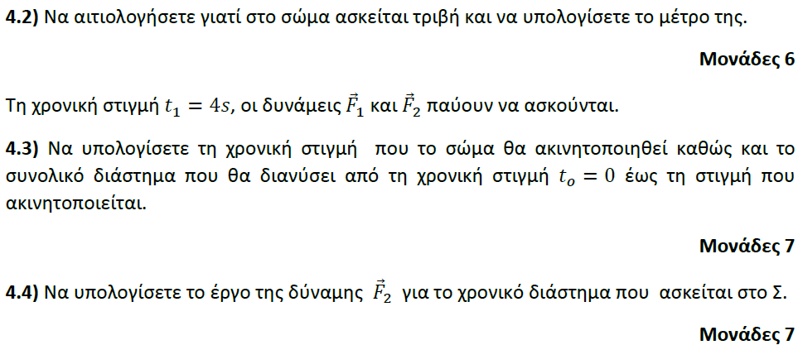

**➤ 13710 / Δ** [****](https://drive.google.com/file/d/1Lgli_Zp2TQpSgV7d-ngFzrfQNh3v8YP-/view?usp=sharing)

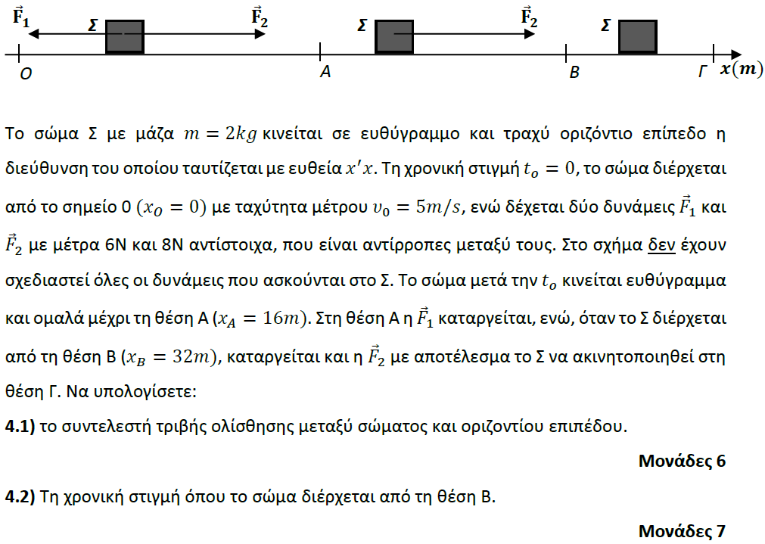

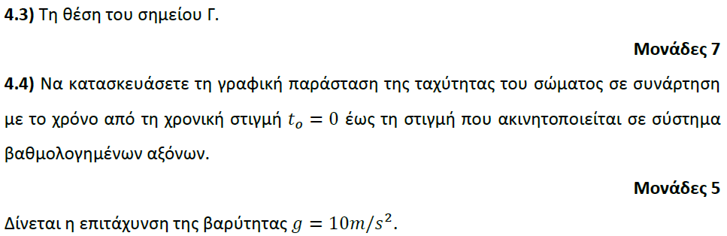

**➤ 13712 / Δ** [****](https://drive.google.com/file/d/1qXOII-gAckGPk-cL0Vj1WMuaj3aBeD1H/view?usp=sharing)

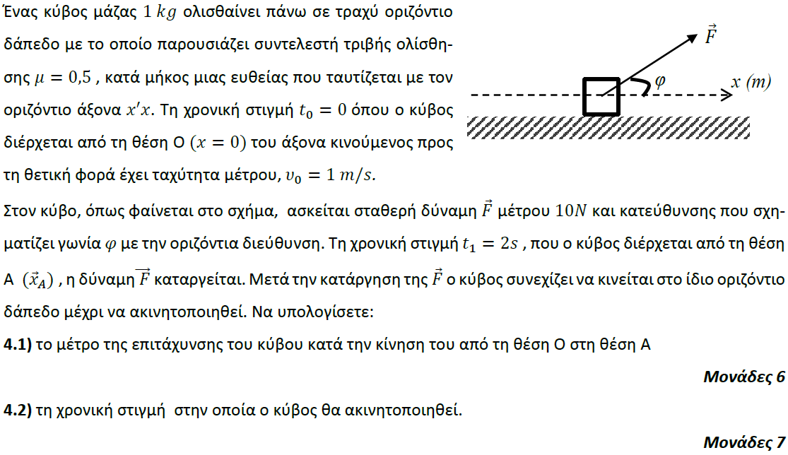

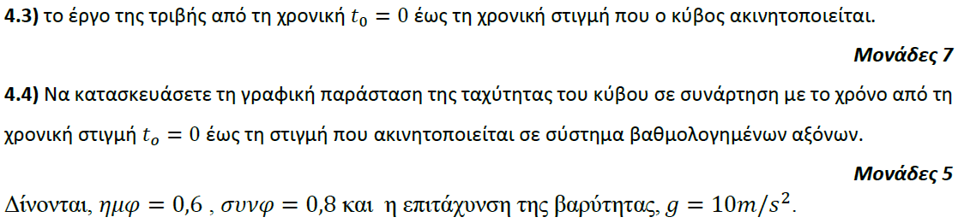

**➤ 13713 / Δ** [****](https://drive.google.com/file/d/13cXBcVYSqdGQb3INvWM33buuP-TdKeqt/view?usp=sharing)

