

**ΝΕΑ** ΤΡΑΠΕΖΑ ΘΕΜΑΤΩΝ **2022** ΔΙΑΒΑΘΜΙΣΜΕΝΗΣ ΔΥΣΚΟΛΙΑΣ



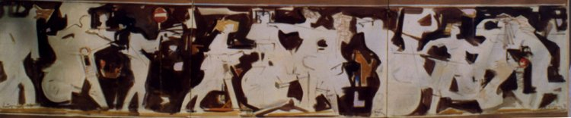

***Κώστας Κοντογιάννης****: “Σύνθεση με νέους και μηχανάκια”*

*ακρυλικά σε ύφασμα 70x300cm - έτος 2000*

**➤ 15885 / B2** [****](https://drive.google.com/file/d/1YivYyYds0AOAwc6ofw6-aSEdlQpe1yeK/view?usp=sharing)

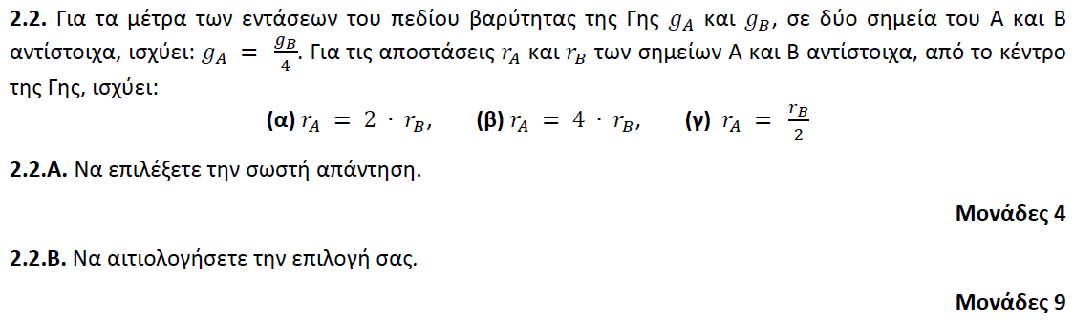

**➤ 15889 / B1** [****](https://drive.google.com/file/d/19Qz9XZk0XsV_DyOrWQyNbQ_OYzVUbiih/view?usp=sharing)

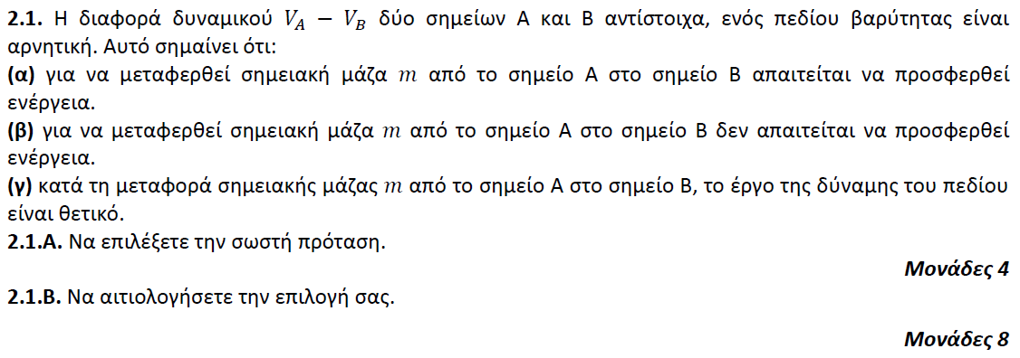

**➤ 15977 / B1** [****](https://drive.google.com/file/d/1e39A6pmnZJLq5ZQwk8G77PNChhPKXes5/view?usp=sharing)

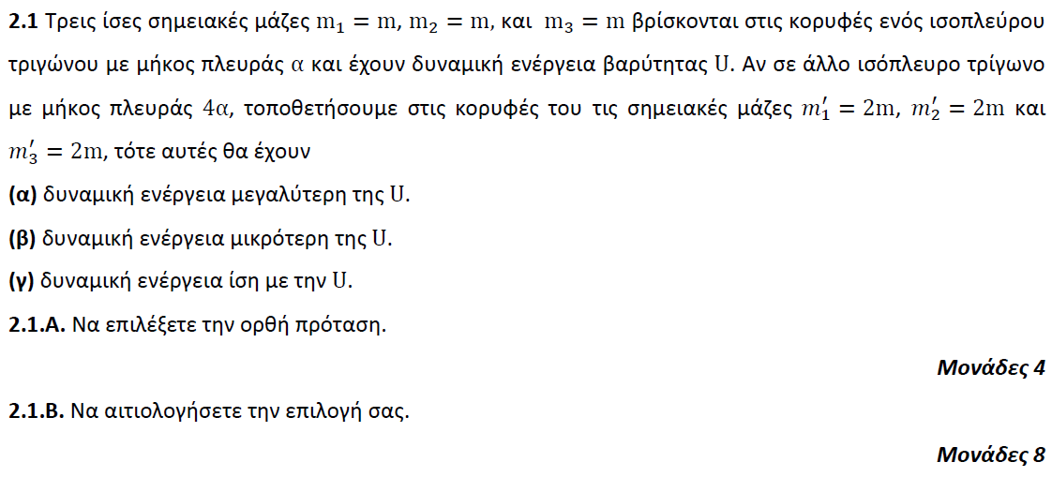

**➤ 15977 / B2** [****](https://drive.google.com/file/d/1e39A6pmnZJLq5ZQwk8G77PNChhPKXes5/view?usp=sharing)

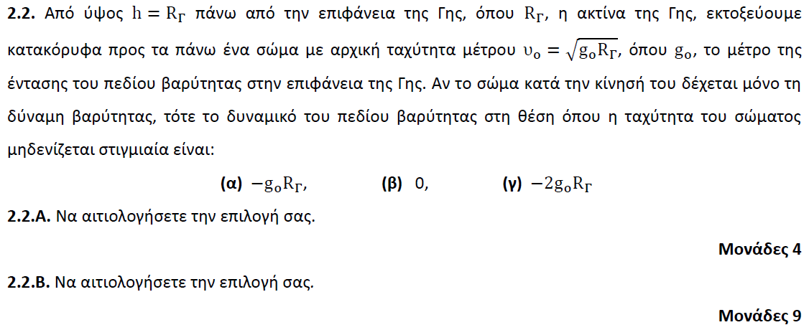

**➤ 15998 / B1** [****](https://drive.google.com/file/d/19gzpjsj-qAlJLRrwytxutnIymmC5DMSo/view?usp=sharing)

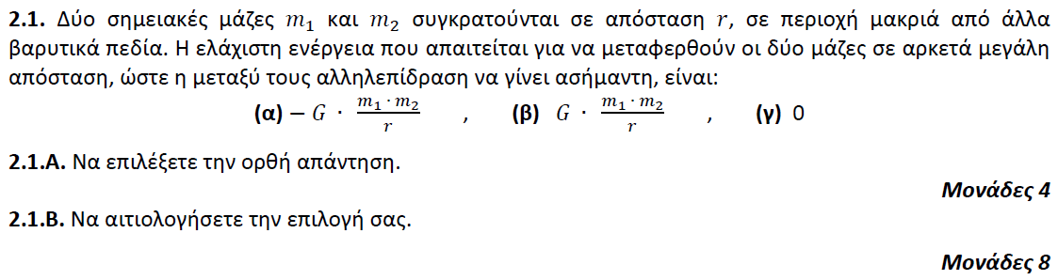

**➤ 16064 / B2** [****](https://drive.google.com/file/d/17F0jZqmJyJ_r0q9C7ZufJa8_hBfWkcxZ/view?usp=sharing)

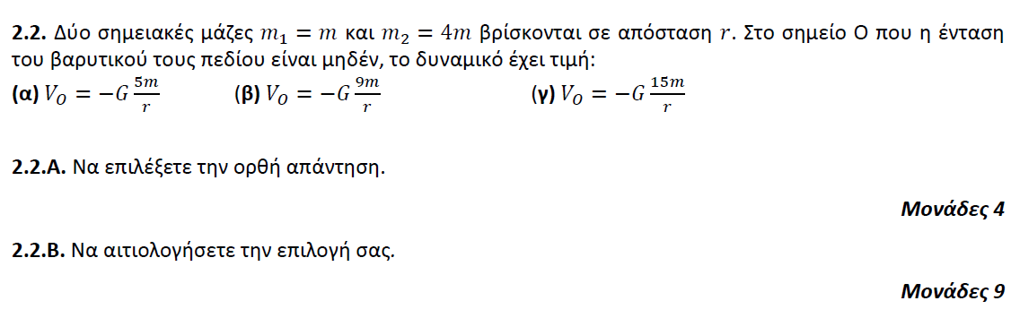

**➤ 16066 / B2** [****](https://drive.google.com/file/d/1g8kn-i6ttf5wqWpdiGR2nmDf_GF0cIeQ/view?usp=sharing)

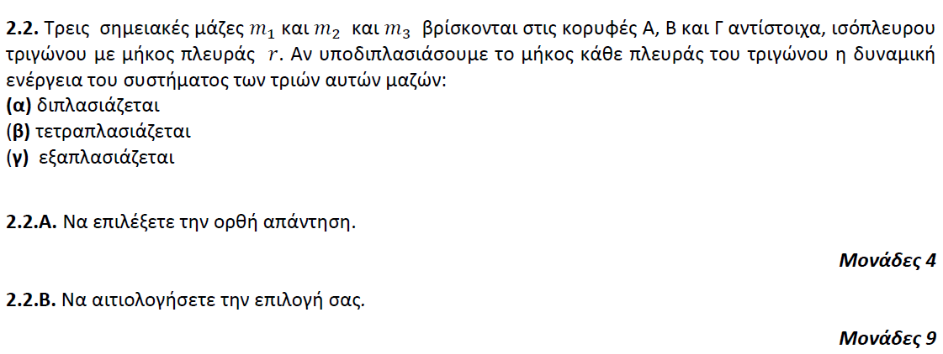

**➤ 16069 / B1** [****](https://drive.google.com/file/d/17y-m0BNMlBGG5jUKkJ6PhAuYvHktv5ub/view?usp=sharing)

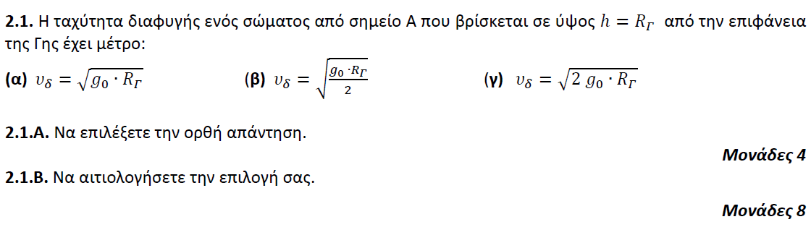

**➤ 16070 / B1** [****](https://drive.google.com/file/d/1wheGU0-xzDlSIgJEc-ytcwDY6Y2Upj6m/view?usp=sharing)

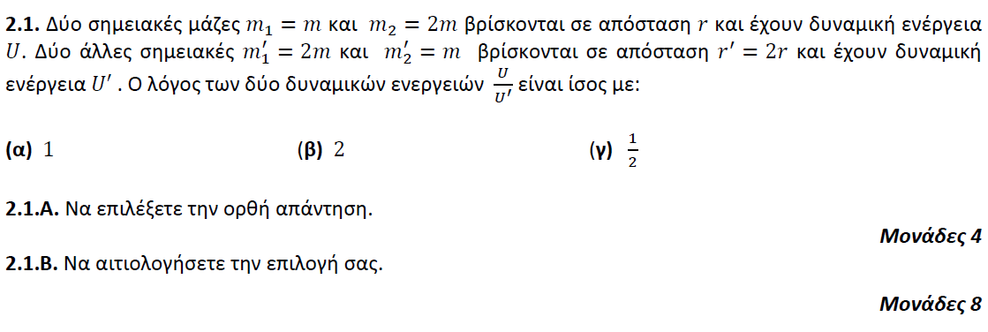

**➤ 16071 / B1** [****](https://drive.google.com/file/d/1D4e9i9w5X5enqqAbQuuuWivCf0NP1O4N/view?usp=sharing)

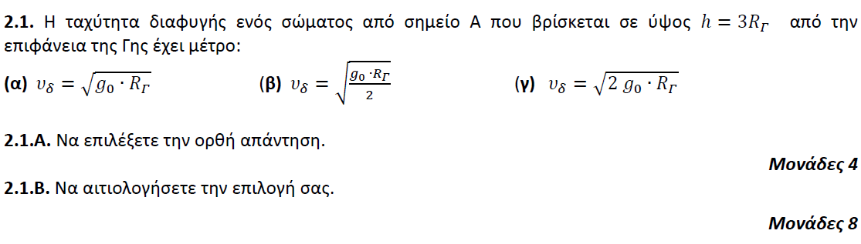

**➤ 16083 / B1 + Β2** [****](https://drive.google.com/file/d/1mrecKZlW4YQc5GwERG8VT9qXPIPArDQg/view?usp=sharing)

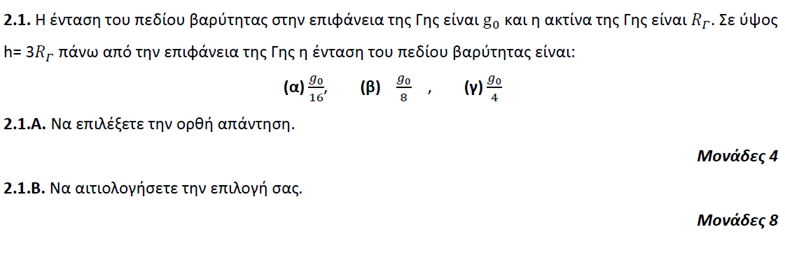

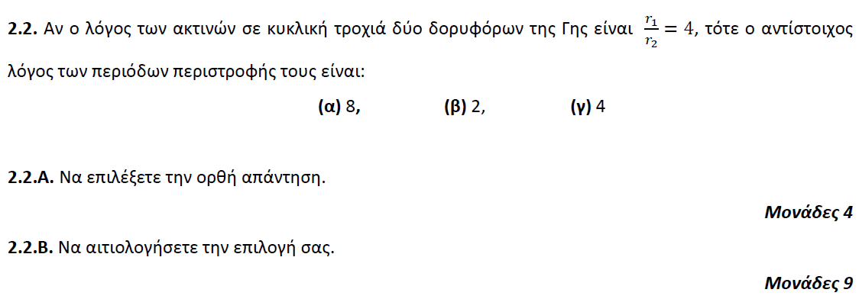

**➤ 16096 / B2** [****](https://drive.google.com/file/d/1lNVQi2siiDalOSCbhgq3VmL3lto8ay84/view?usp=sharing)

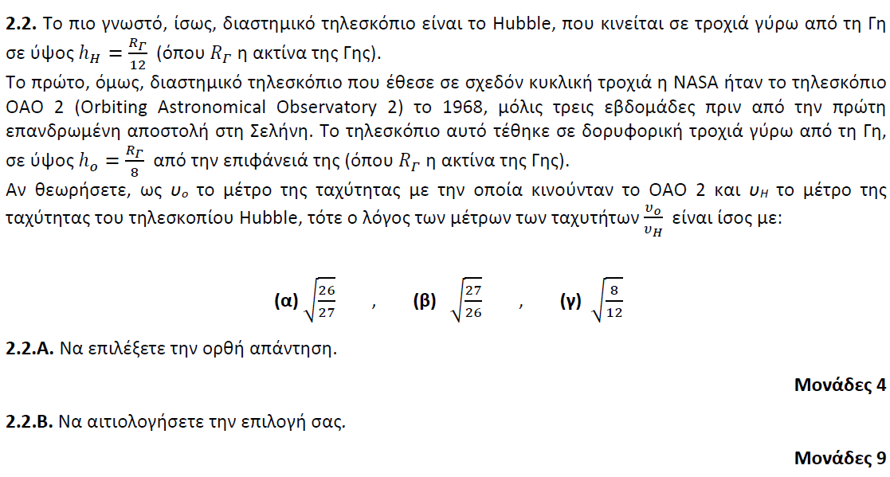

**➤ 16098 / B1** [****](https://drive.google.com/file/d/1KIV5jXXMWyzAIpLMPvc_wu3FEJmBTwQG/view?usp=sharing)

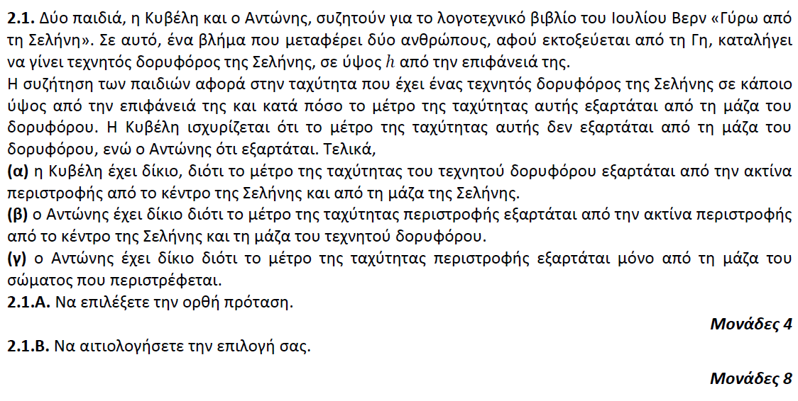

**➤ 16103 / B1** [****](https://drive.google.com/file/d/1jI1vOvKesNQK0SRBFXmY89xXDYTirbpI/view?usp=sharing)

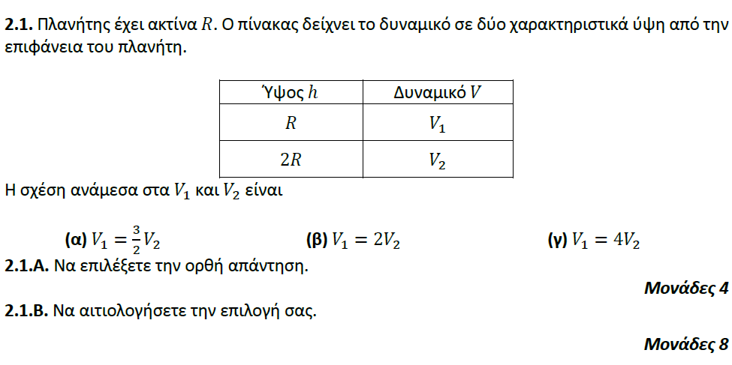

**➤ 16116 / B1** [****](https://drive.google.com/file/d/1ZkszV3BS6K9t-4DAsYNwE9dNZaxDAtNz/view?usp=sharing)

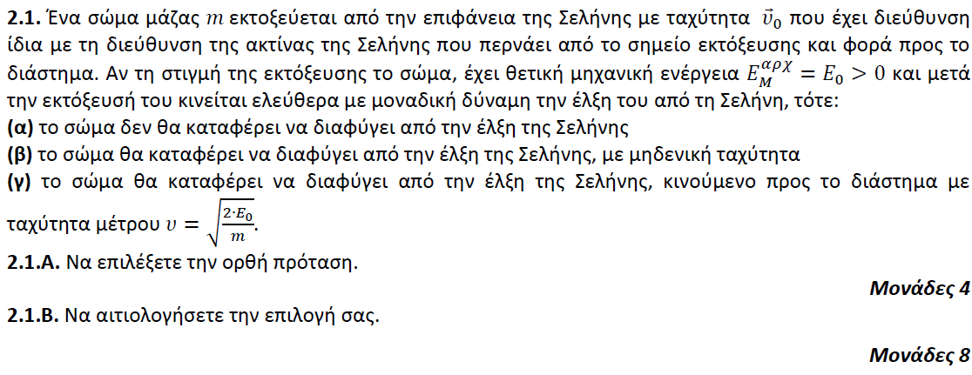

**➤ 16266 / B1** [****](https://drive.google.com/file/d/100Nk5CK31tiJGPlKEf_KYTf3lf44uBGp/view?usp=sharing)

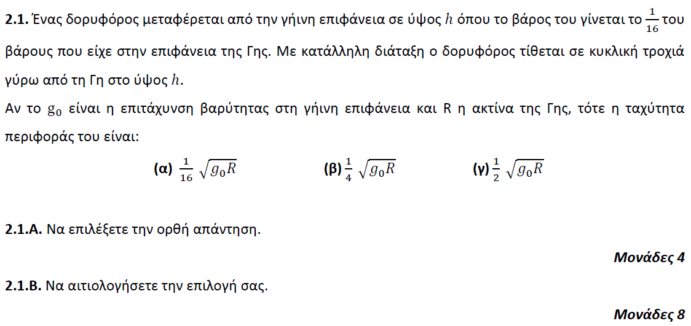

**➤ 16266 / B2** [****](https://drive.google.com/file/d/100Nk5CK31tiJGPlKEf_KYTf3lf44uBGp/view?usp=sharing)

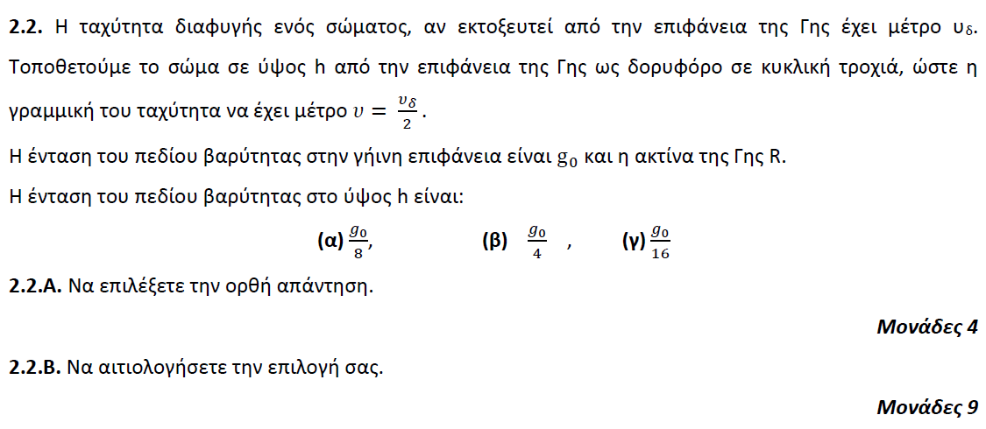

**➤ 16383 / B1** [****](https://drive.google.com/file/d/1Av84FOLCyIS0zkY12UsOmz-C9_cQR4jg/view?usp=sharing)

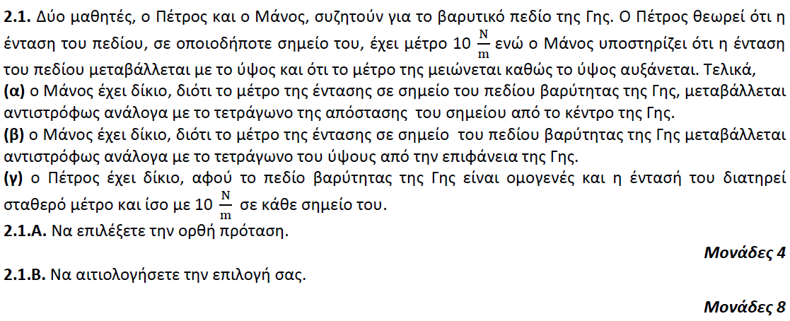

**➤ 16384 / B2** [****](https://drive.google.com/file/d/1INyuujE2W5ZAHJbcd3ASh7o29UBwplrS/view?usp=sharing)

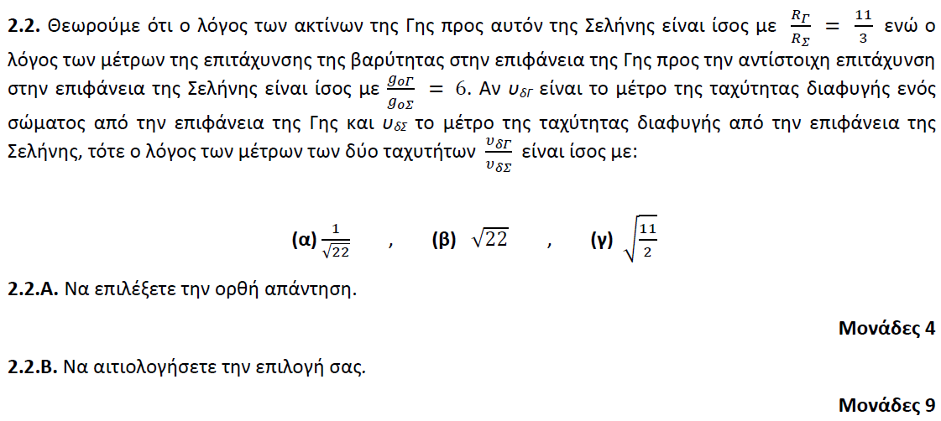

**➤ 16385 / B1+B2=ενιαίο** [****](https://drive.google.com/file/d/1mlnvG8-jeoDiLX3JVocyK3QUXO8mpL7z/view?usp=sharing)

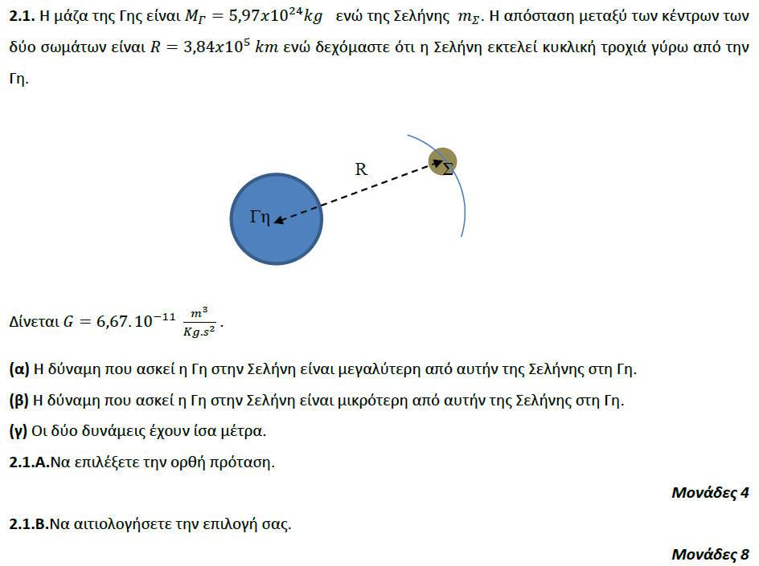

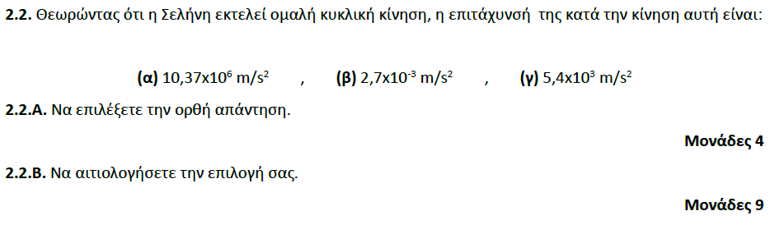

**➤ 16386 / B1+B2=ενιαίο** [****](https://drive.google.com/file/d/1zGJsCu1POmFFiY3M9tkQ8tdQx-fO8cyg/view?usp=sharing)

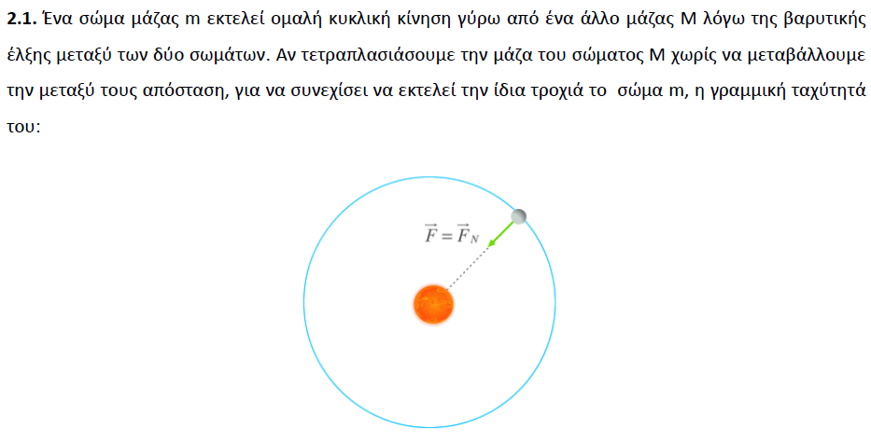

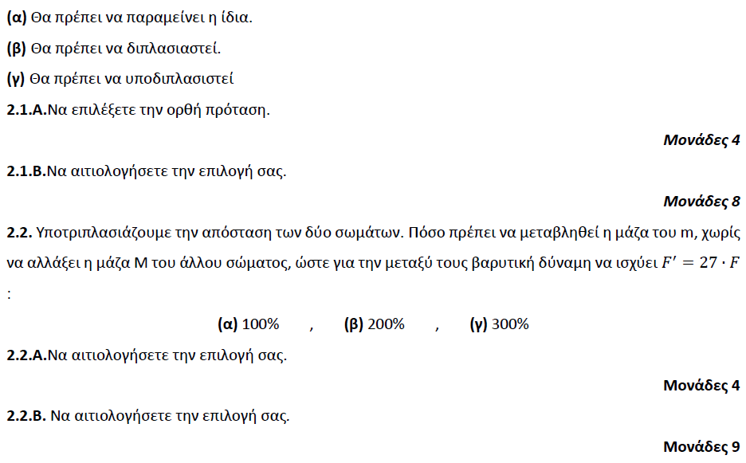

**➤ 16390 / B1** [****](https://drive.google.com/file/d/1zGdMWE5BcQC8PJZwNFYcaoj-DWY_CMvc/view?usp=sharing)

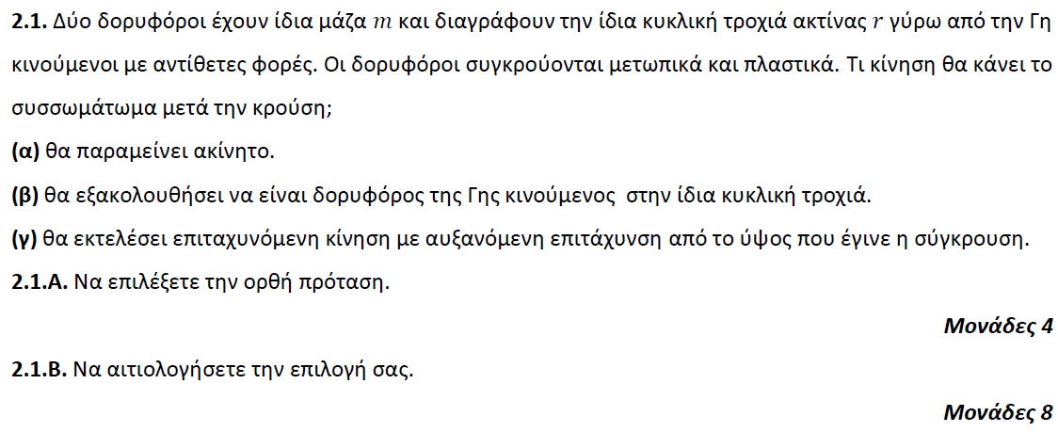

**➤ 16633 / B1** [****](https://drive.google.com/file/d/1-bQ5cTrSMlOONYtXeksYIaW4dBm4aJR8/view?usp=sharing)

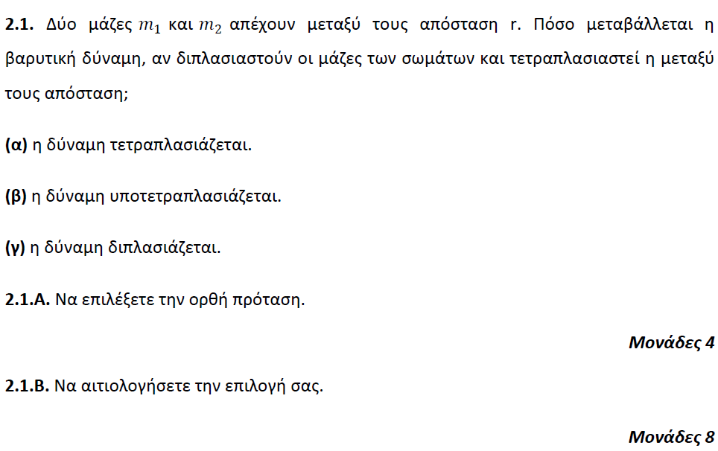

**➤ 16633 / B2** [****](https://drive.google.com/file/d/1-bQ5cTrSMlOONYtXeksYIaW4dBm4aJR8/view?usp=sharing)

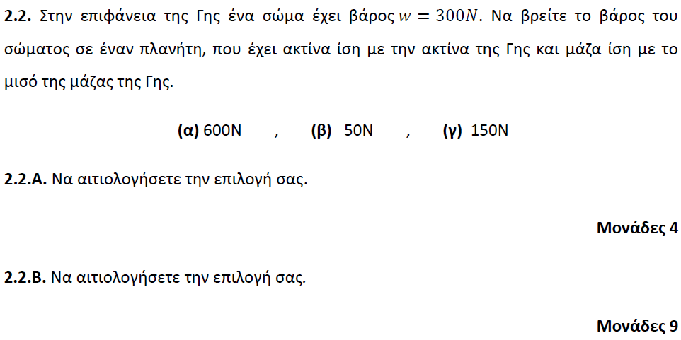

**➤ 16636 / B1** [****](https://drive.google.com/file/d/15d6erZFteoRjXHr4FnDB6XODnbGv2sp8/view?usp=sharing)

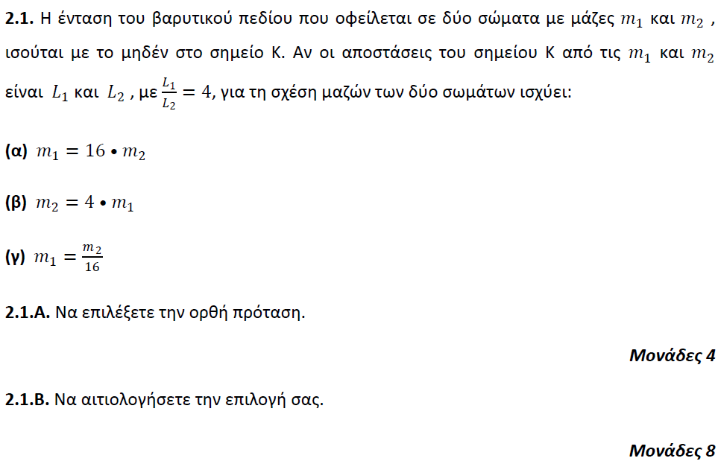

**➤ 16636 / B2** [****](https://drive.google.com/file/d/15d6erZFteoRjXHr4FnDB6XODnbGv2sp8/view?usp=sharing)

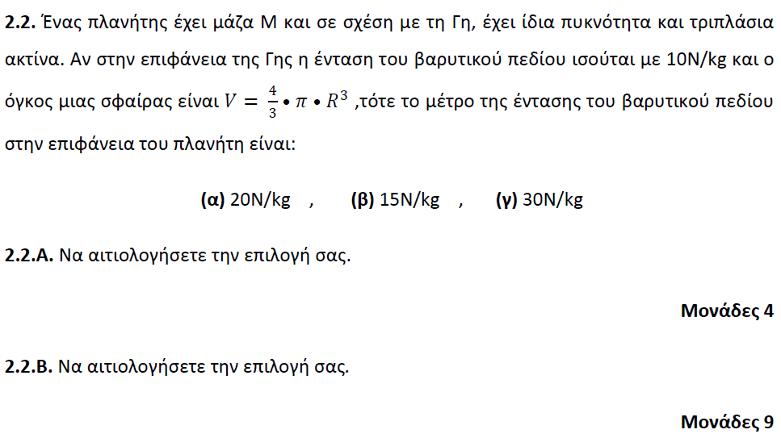

**➤ 16637 / B1** [****](https://drive.google.com/file/d/1SRrJskESGtv29qbgLDD8OR0AoPUKXvNr/view?usp=sharing)

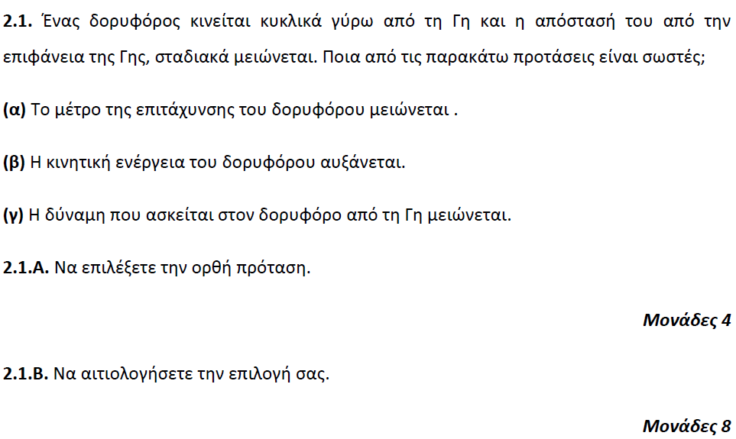

**➤ 16637 / B2** [****](https://drive.google.com/file/d/1SRrJskESGtv29qbgLDD8OR0AoPUKXvNr/view?usp=sharing)

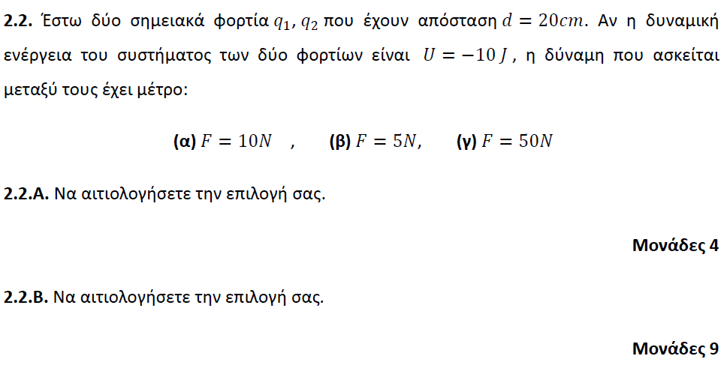

**➤ 16638 / B1** [****](https://drive.google.com/file/d/1DA9sQ0NRMkP5LhuyRzCUHYXS6Ki5_8wl/view?usp=sharing)

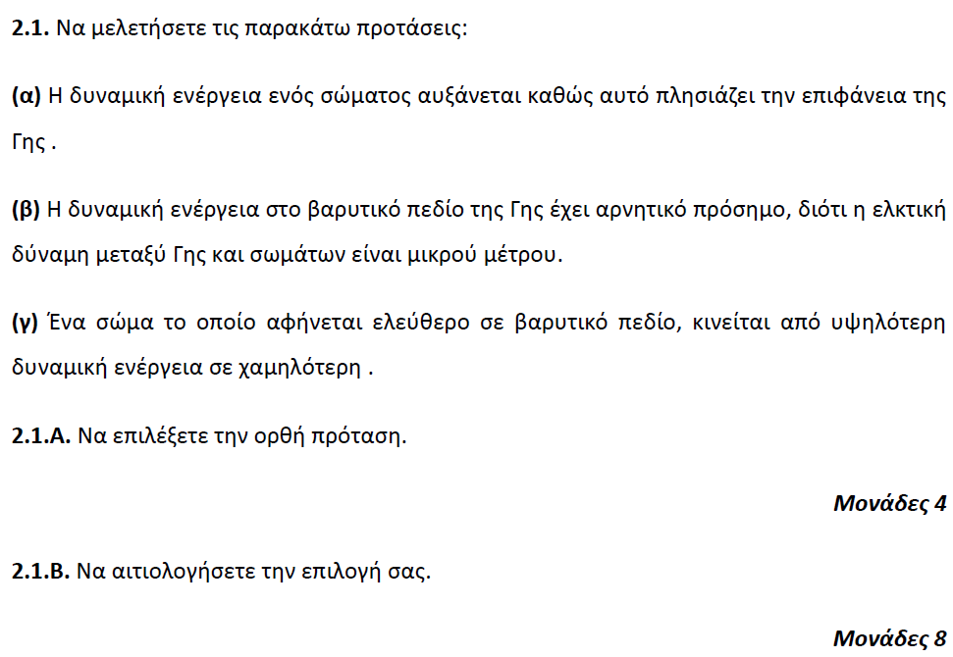

**➤ 16638 / B2** [****](https://drive.google.com/file/d/1DA9sQ0NRMkP5LhuyRzCUHYXS6Ki5_8wl/view?usp=sharing)

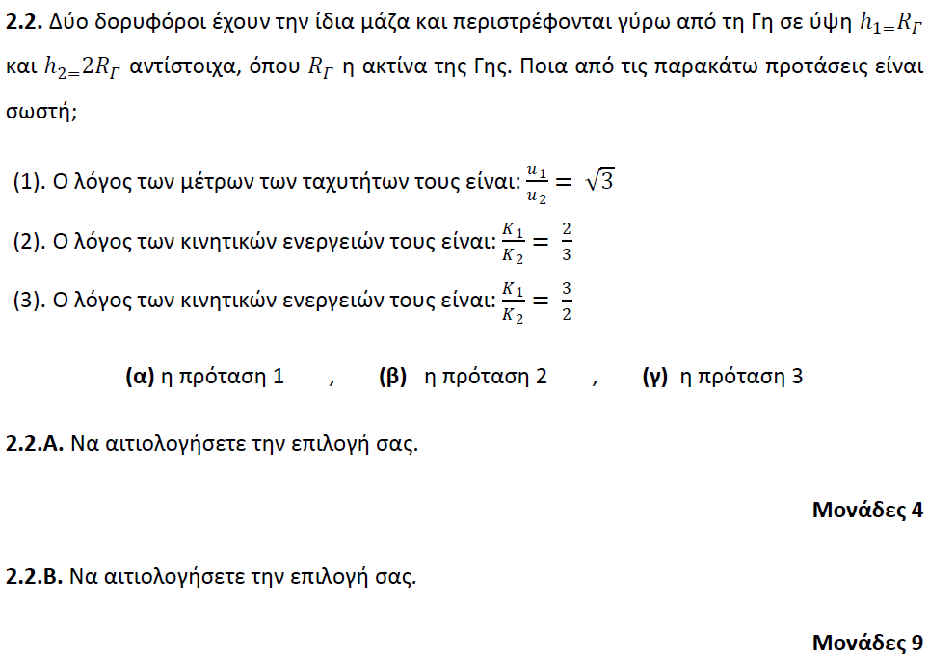

**➤ 16734 / B1** [****](https://drive.google.com/file/d/1LOz47BSENh1ZqxSLKwYc3KHcrCvZUnln/view?usp=sharing)

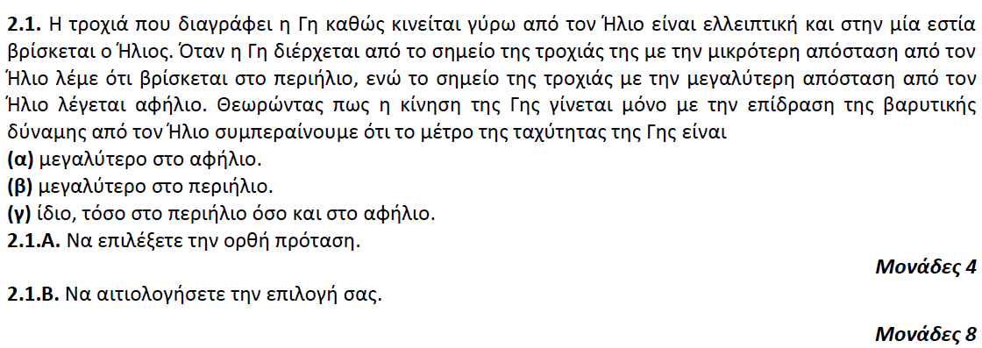

**➤ 16735 / B2** [****](https://drive.google.com/file/d/1QsH94x5I4DZqPjxR9D9ICmJBS5Oeu4i6/view?usp=sharing)

