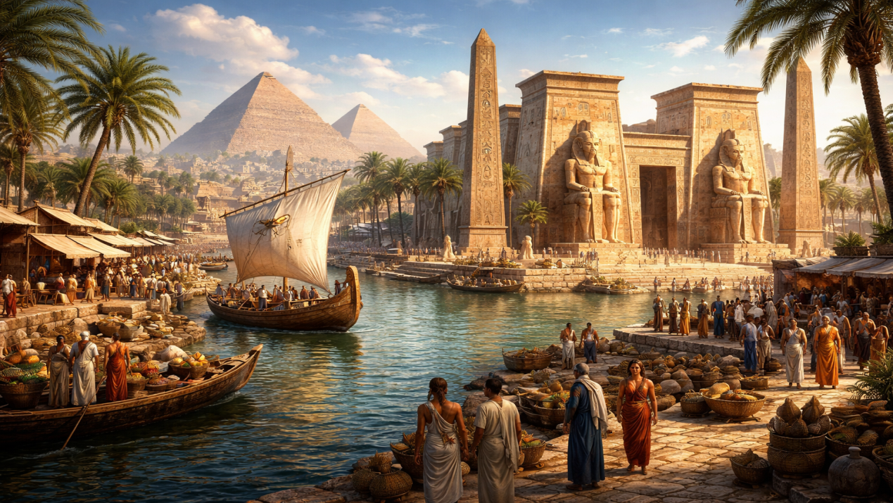
Ancient Egyptians – Gap-Fill Quiz
1. The ancient Egyptian civilisation lasted for nearly ______ years.
a) 1,500
b) 2,000
c) 3,500
2. The Egyptians used a system of writing called ______.
a) cuneiform
b) hieroglyphics
c) alphabet
3. They were skilled engineers, mathematicians, and also excellent ______.
a) sailors
b) surgeons
c) artists
4. One of the most famous statues built by the Egyptians is the ______.
a) Colossus
b) Pyramid
c) Sphinx
5. The pyramids were built mainly as ______ for pharaohs.
a) palaces
b) tombs
c) temples
6. Egyptians believed that after death, the spirit would need the ______ in the afterlife.
a) jewellery
b) food
c) body
7. To preserve bodies, the Egyptians used salt and wrapped them in ______ bandages.
a) cotton
b) wool
c) linen
8. Many items were buried with pharaohs, especially food and ______.
a) weapons
b) jewellery
c) tools
9. Each year the Nile flooded and left behind fertile ______.
a) sand
b) water
c) mud
10. The huge stone blocks for pyramids were probably moved using ______.
a) cranes
b) wheels
c) ramps

