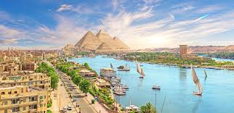

‘’Video – Egypt’’
Questions
1. What is the weather like in Egypt;
2. What are you advised to wear while visiting Egypt;
3. Where are most of the Great Sights in Egypt;
4. What do you Know about ‘’Baksheeh’’;
5. What would you say about the main streets in Cairo;
6. What is the market like in Egypt;
7. Can you use your mobile phone in Egypt;
8. What do you know about alcohol in Egypt;
9. Would you like to add any other comments about Egypt;

