Halloween

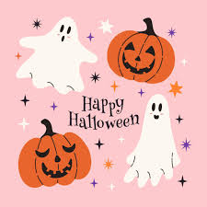
Comprehension Questions
**1. When does Halloween take place?**
A) 30th October
B) 31st October
C) 1st November
D) 25th October
**2. What does the word “Hallow” mean?**
A) Ghost
B) Pumpkin
C) Saint
D) Fire
**3. What did the Celts believe dead friends could return as?**
A) Wolves
B) Witches
C) Black cats
D) Bats
**4. Why did villagers put out the fires in their homes?**
A) To save wood
B) To make their homes cold and undesirable to spirits
C) To prepare for a bonfire
D) To celebrate with candles
**5. What do children usually receive when they say “trick or treat”?**
A) Money
B) Toys
C) Costumes
D) Chocolates or biscuits

Fill in the Gaps
**1. Halloween is celebrated on the ______ of October every year.**
**2. “All Hallows Eve” means the evening before ______ Day.**
**3. The Celts believed that spirits could return in the body of a ______ cat.**
**4. Villagers carved faces in candle holders made from large orange ______.**
**5. Children visit houses and call out “______ or treat”.**

