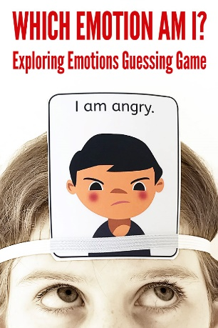

Which emotion am I?

- Shuffle the emotions cards and place them on a stack face down in the middle of the table.
- Each player selects a card from the stack and tucks it into their elastic headband (facing out) without looking at it. Now everyone can see which emotion each player has, except their own
- Starting with the youngest player and proceeding clockwise around the table, take turns to ask one question about the card on your head as you try to figure out which emotion you have, you must not however use the actual emotion word. For example you might ask, “Would I feel like this if I won a game of soccer?” “Would I have tears if I felt this way? “Did I feel like this when I fell out of bed?” The other players answer yes or no.
- When a player feels confident that they can identify their emotion, they may take a guess on their turn. The first person to identify their emotion is the winner of that round. The other players can then keep taking turns to ask questions about their emotions card until all emotions have been identified.
