ΔΙΑΓΩΝΙΣΜΑ-ΕΡΓΑΣΙΑ Β΄ΤΕΤΡΑΜΗΝΟΥ
Exercise 1 (12 points)
Read the text and circle the correct answer.
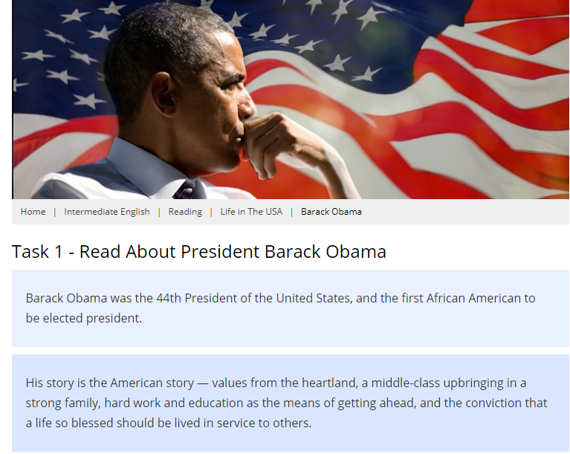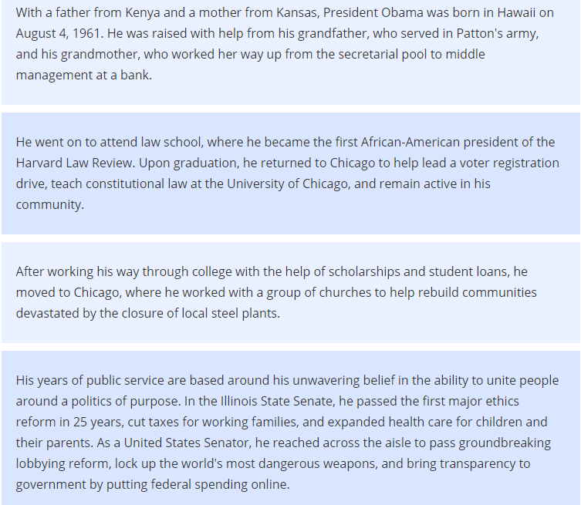
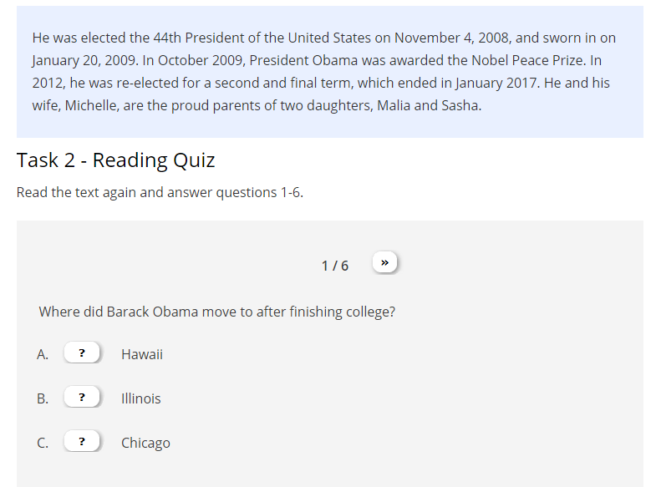
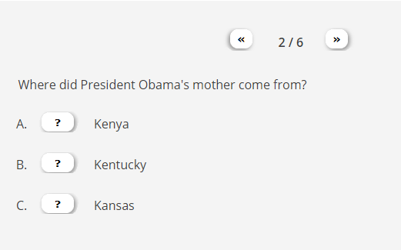

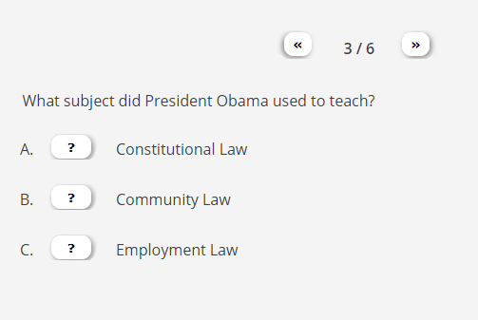
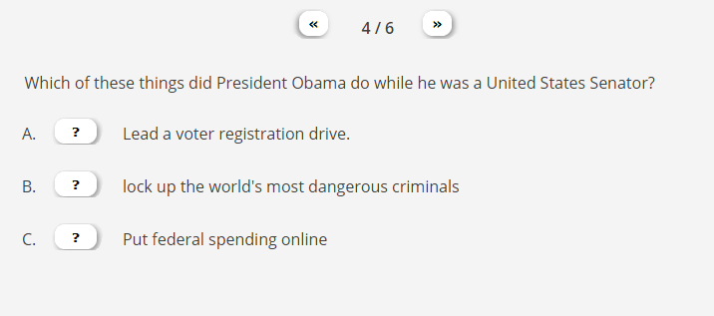
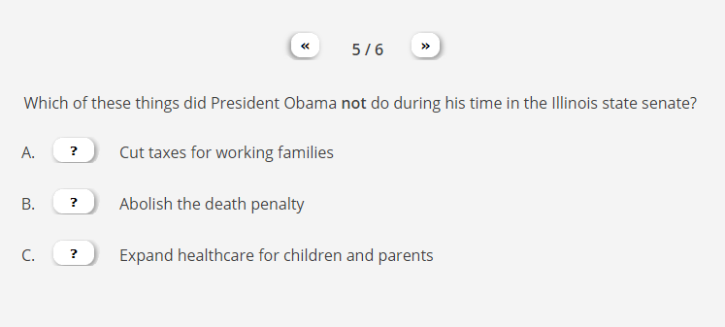

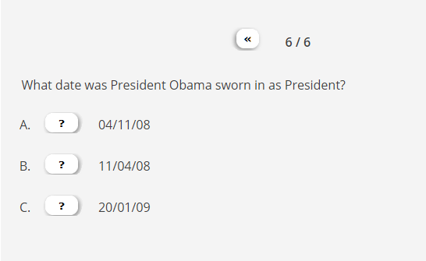

Exercise 2 (18 points)
Match the words to their definitions by writing the corresponding NUMBER next to them.
Celebrated | 1. Quarrelling and blaming one another
Discord | 2. Willingness to accept behaviour and beliefs that are different from you own
Era | 3. Well-known, famous
Tolerance | 4. the importance and value that a person has
Seize | 5. freedom
discrimination | 6. treating a person or group of people differently, especially in a worse way, because of their race, religion, gender, sexuality, etc
institution | 7. To take something quickly and keep or hold it
liberty | 8. a large and important organization, such as a university or bank
dignity | 9. Period of historical time

Exercise 3 (10 points)
Complete the UN Declaration of Human Rights by selecting the appropriate words.
Article 1.
All human beings are born free and equal in dignity and rights. They are endowed with reason and conscience and should act towards one another in a spirit of 1. ______________.

Article 2.
Everyone is entitled to all the rights and freedoms set forth in this Declaration, without distinction of any kind, such as race, colour, sex, language, religion, political or other opinion, national or social origin, property, birth or other status. Furthermore, no 2. ______________ shall be made on the basis of the political, jurisdictional or international status of the country or territory to which a person belongs. …

Article 18.
Everyone has the right to freedom of 3. ______________, conscience and religion; this right includes freedom to change his religion or belief, and freedom, either alone or in community with others and in public or private, to manifest his religion or belief in teaching, practice, worship and observance.

Article 19
Everyone has the right to freedom of 4. ______________ and expression; this right
includes freedom to hold opinions without interference and to seek, receive and impart information and ideas through any media and regardless of frontiers.

Article 26.
(1) Everyone has the right to education. Education shall be free, at least in the elementary and fundamental stages. Elementary education shall be 5. ______________. Technical and professional education shall be made generally available and higher education shall be equally accessible to all on the basis of 6. ______________.
(2) Education shall be directed to the full development of the human personality and to the strengthening of 7. ______________ for human rights and fundamental freedoms. It shall
promote understanding, 8. ______________ and friendship among all nations, 9. ______________ or religious groups, and shall further the activities of the United Nations for the maintenance of 10. ______________.

Article 29.
(1) Everyone has duties to the community in which alone the free and full development of
his personality is possible.
(2) In the exercise of his rights and freedoms, everyone shall be subject only to such limitations as are determined by law solely for the purpose of securing due recognition and respect for the rights and
freedoms of others and of meeting the just requirements of morality, public order and the general welfare in a democratic society.
(3) These rights and freedoms may in no case be exercised contrary to the purposes and principles of the United Nations.

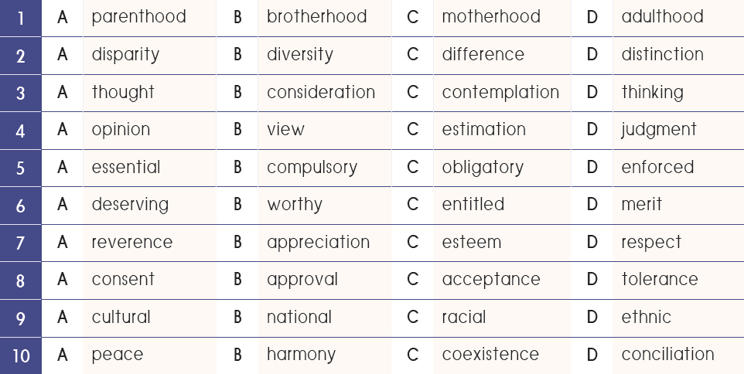

Exercise 4 (10 points)
Read the rest of the articles of the UN Declaration of Human Rights and find which right is violated in each of the following scenarios. Then suggest ways of dealing with the problem.

1. Discrimination in a School Club (Violation of Article 2 – Freedom from Discrimination)
Case: A student wants to join the school drama club, but the club president says “To join this club, you have to pay for your costumes as well for the settings.”

2. Unfair Punishment (Violation of Article 5 – Freedom from Torture or Cruel, Inhuman, or Degrading Treatment)
Case: A teacher punishes a student for talking in class by making them stand outside in the cold for hours, refusing to let them back inside.

3. Denial of Education (Violation of Article 26 – Right to Education)
Case: A refugee student who recently arrived in the country is denied enrollment at a local school because they do not yet have official identification documents.

4. Privacy Violation (Violation of Article 12 – Right to Privacy)
Case: Photographs of a student or a teacher are circulating on their classmates’ mobile phones without their consent.

5. Forced Labor (Violation of Article 23 – Right to Fair and Free Choice of Employment)
Case: A teenager coming from a low socio-economic background works for a local factory owner to support his family. The factory owner delays the payment, eventually ending up giving him half the amount of money they had agreed upon.

6. Censorship of a Student Newspaper (Violation of Article 19 – Freedom of Expression and Opinion)
Case: A group of students writes an article for the school newspaper criticizing the school’s decision to cut funding for arts programs. The principal refuses to publish it and threatens the students with suspension if they continue.

7. Unequal Punishment (Violation of Article 7 – Equality Before the Law)
Case: Two students are caught cheating on a test. One of them receives a week-long suspension, while the other, whose parent is an important school donor, gets away with just a warning.

8. Discrimination in a School setting (Violation of Article 2 – Freedom from Discrimination
Case: A teenager is being bullied by his classmates due to their not being “masculine” enough.

9. Denied Permission to Travel (Violation of Article 13 – Freedom to Leave One’s Country)
Case: An 18-year-old male student has been selected to study at a prestigious British university, but a civil war breaks out in his country. The authorities refuse to issue him a passport, saying that young men aged 18-35 must mandatorily join the army and go to war.

10. Denied Permission to Assemble (Violation of Article 20- Freedom of peaceful assembly)
Case: The school principal refuses to let the students join a peaceful demonstration that takes place in their town about the loss of human lives in an accident due to the government’s negligence.

Exercise 4 (10 points)
Read the rest of the articles of the UN Declaration of Human Rights and find which right is violated in each of the following scenarios. Then suggest ways of dealing with the problem.

Case 1: A student wants to join the school drama club, but the club president says “To join this club, you must pay for the expensive costumes as well for the play settings. Also, if the show is to be presented in various cities, you have to pay the fare for your transportation too.”

Violation of Article_____
Right violation: ______________________________________________

Your suggestion:

Case 6: A group of students writes an article for the school newspaper criticizing the school’s decision to cut funding for arts programs. The principal refuses to publish it and threatens the students with suspension if they continue.

Violation of Article_____
Right violation: ______________________________________________

Your suggestion:

Exercise 4 (10 points)
Read the rest of the articles of the UN Declaration of Human Rights and find which right is violated in each of the following scenarios. Then suggest ways of dealing with the problem.

Case 2: A teacher punishes a student for talking in class by making them stand outside in the cold for hours, refusing to let them back inside.

Violation of Article_____
Right violation: ______________________________________________

Your suggestion:

Case 8: A teenager is being bullied by his classmates for not being “masculine” enough.

Violation of Article_____
Right violation: ______________________________________________

Your suggestion:

Exercise 4 (10 points)
Read the rest of the articles of the UN Declaration of Human Rights and find which right is violated in each of the following scenarios. Then suggest ways of dealing with the problem.

Case 3: A Palestinian refugee student who recently arrived in the country is denied enrollment at a local school because they do not yet have official identification documents.

Violation of Article_____
Right violation: ______________________________________________

Your suggestion:

Case 7: Two students are caught cheating on a test. One of them receives a week-long suspension, while the other, whose parent is an important school donor, gets away with just a warning.

Violation of Article_____
Right violation: ______________________________________________

Your suggestion:

Exercise 4 (10 points)
Read the rest of the articles of the UN Declaration of Human Rights and find which right is violated in each of the following scenarios. Then suggest ways of dealing with the problem.

Case 4: Photographs of a student are circulating on their classmates’ mobile phones without their consent.

Violation of Article_____
Right violation: ______________________________________________

Your suggestion:

Case 9: An 18-year-old male student has been selected to study at a prestigious British university, but a civil war breaks out in his country. The authorities refuse to issue him a passport, saying that young men aged 18-35 must mandatorily join the army and go to war.

Violation of Article_____
Right violation: ______________________________________________

Your suggestion:

Exercise 4 (10 points)
Read the rest of the articles of the UN Declaration of Human Rights and find which right is violated in each of the following scenarios. Then suggest ways of dealing with the problem.

Case 5: A teenager coming from a low socio-economic background works for a local factory owner to support his family. The factory owner delays the payment, eventually ending up giving him half the amount of money they had agreed upon.

Violation of Article_____
Right violation: ______________________________________________

Your suggestion:

Case 10: The school principal refuses to let the students join a peaceful demonstration that takes place in their town about the loss of human lives in an accident due to the government’s negligence.

Violation of Article_____
Right violation: ______________________________________________

Your suggestion:

