**Social Media**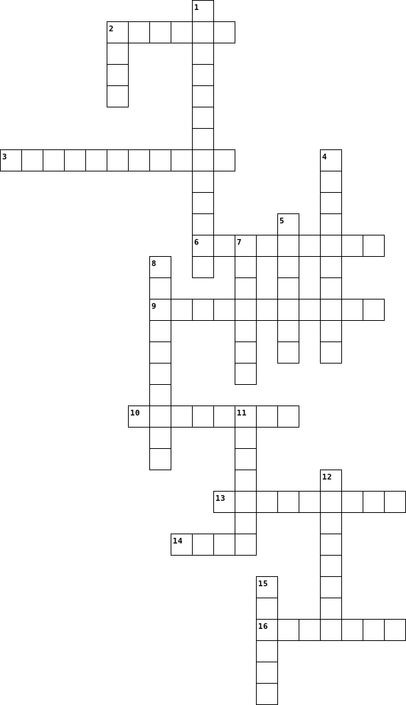

|  |  |  |  |  |  |  |  |  |  |  |  |  |  |  |  |  |  |  |  |  |  |  |  |  |  |  |  |  |  |  |  |  |  |  |  |  |  |  |  |  |
| --- | --- | --- | --- | --- | --- | --- | --- | --- | --- | --- | --- | --- | --- | --- | --- | --- | --- | --- | --- | --- | --- | --- | --- | --- | --- | --- | --- | --- | --- | --- | --- | --- | --- | --- | --- | --- | --- | --- | --- | --- |
| |  |  | | --- | --- | | **Across** | | | **2.** | Everyone looked at the ...as the movie started. | | **3.** | Contact or relationship among people is called social... | | **6.** | Negatively | | **9.** | The state of been without something | | **10.** | Familiarity with computers is called computer ... | | **13.** | The chemical that tells us that it's time to go to sleep | | **14.** | Give out ,expel. | | **16.** | Another word for adolescence | |  | |  |  | | --- | --- | | **Down** | | | **1.** | These advances of the 20th century were really remarkable. | | **2.** | Nausea could be a ... effect of this drug. | | **4.** | The 1930's economic crisis was called The Great D.... | | **5.** | The actor asked the press to respect his family's ... . | | **7.** | A cycle of cause and effect is called a ...circle. | | **8.** | M...... is the key to healthy eating. | | **11.** | Enlarge / increase | | **12.** | Disadvantage | | **15.** | His complaining has no ... on me.I really don't care. | |