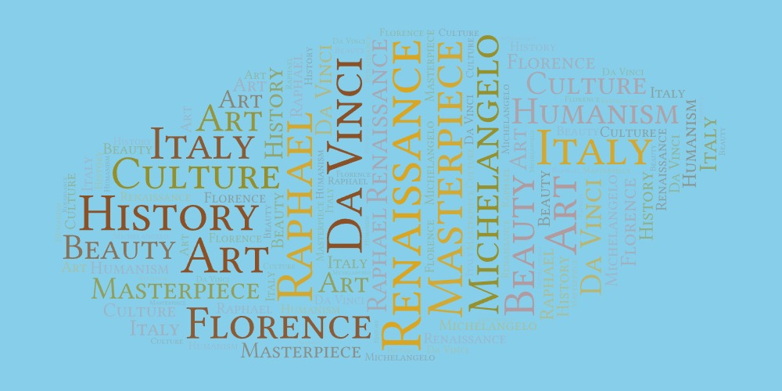
Worksheet 1
Welcome to the Renaissance!

You are going to watch the following video about the Renaissance period twice. Try to answer the questions https://youtu.be/GOjBbkGiwq0

- The word Renaissance is a(n) Italian / French word that means rebirth.
- During this period lots of creative things happened in Europe in the fields of _________________ , ___________________ , ____________________ and architecture.
- The Bubonic Plague was a disease that killed a large part of the European population. T/ F
- The geographical location of Italy was advantageous for trade. T/ F
- The Medici was a wealthy family of _____________________ who used their wealth to sponsor the __________________ and ______________________ .
- Egg tempera is a type of a. food
b. paint
c. colour
- The printing press was an invention of Fra Angelico/ Johannes Gutemberg.
- The architecture of the time was inspired by ancient _________________ and ____________________ .
- Popular pastimes of the period included _____________________ , ___________________________ and jousting (κονταρομαχία).
- All music composed at the time was composed solely for the church. T / F

Write down a question you have about this period that was not answered in the video.

____________________________________________________________________________________________________________________________

