Worksheet 2 Renaissance
(Group work)
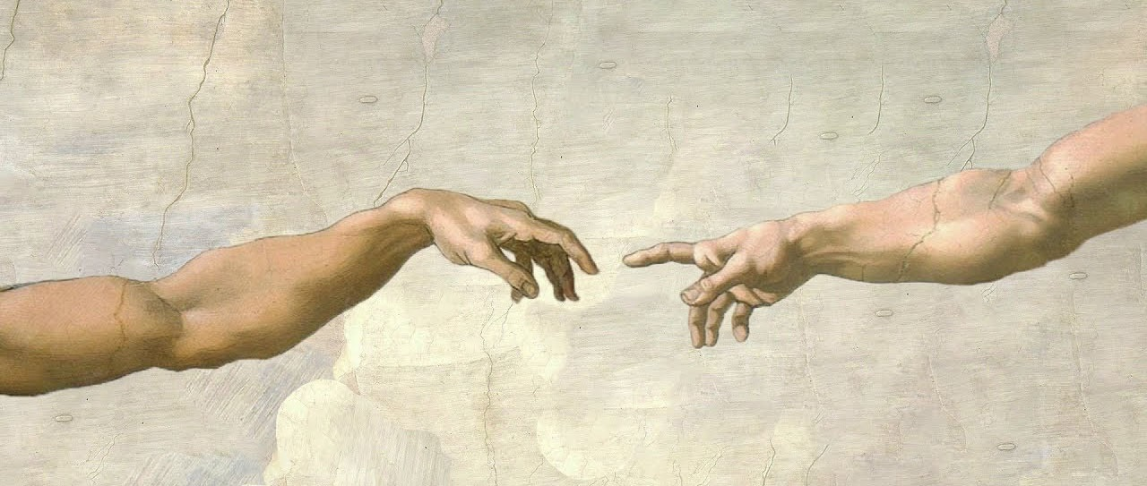
You have already read the information about the Renaissance master that was assigned to your group. Write a short text (100-120 words) with the main points of the life and work of this master. When you finish, one member of the group will read it aloud to the class so that your fellow students get some information about him.
______________________________________________________________________________________________________________________________________________________________________________________________________________________________________________________________________________________________________________________________________________________________________________________________________________________________________________________________________________________________________________________________________________________________________________________________________________________________________________________________________________________________________________________________________________________________________________________________________________________________________________________________________________________________________________________________________________________________________________________________________________________________________________________________________________________________________________________________________________________________________________

