ΕΝΟΤΗΤΑ 5^{Η} : ΕΡΓΑΣΙΑ – ΕΠΑΓΓΕΛΜΑ

ΟΜΑΔΑ 2^{Η}
Δραστηριότητα: Παρατηρήστε προσεκτικά τις παρακάτω εικόνες που αφορούν διάφορες πτυχές του θέματος. Συζητήστε τις με την ομάδας σας και, στη συνέχεια, καταγράψτε σύντομα ποιον προβληματισμό του σκιτσογράφου θεωρείτε ότι απεικονίζει η καθεμιά.
Εικόνα 1 | 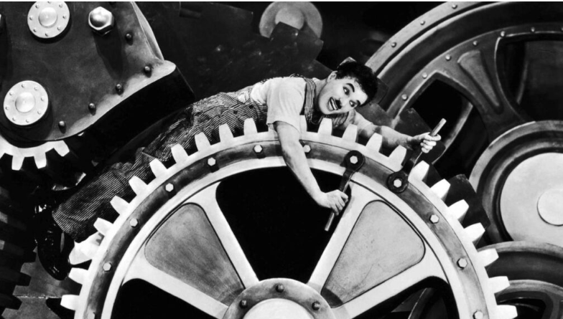

___________________________________________________________________________________________________________________________________________________________________________________________________________________________________________________________________________________________________________________________________________________________________________________________________________________________________________________________________________________________________________________________________________________________________________________________________________________
Εικόνα 2 | 

___________________________________________________________________________________________________________________________________________________________________________________________________________________________________________________________________________________________________________________________________________________________________________________________________________________________________________________________________________________________________________________________________________________________________________________________________________________

Εικόνα 3 | 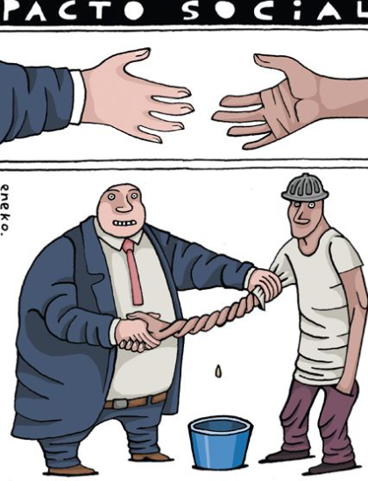

___________________________________________________________________________________________________________________________________________________________________________________________________________________________________________________________________________________________________________________________________________________________________________________________________________________________________________________________________________________________________________________________________________________________________________________________________________________
Εικόνα 4 | 

___________________________________________________________________________________________________________________________________________________________________________________________________________________________________________________________________________________________________________________________________________________________________________________________________________________________________________________________________________________________________________________________________________________________________________________________________________________

Εικόνα 5 | 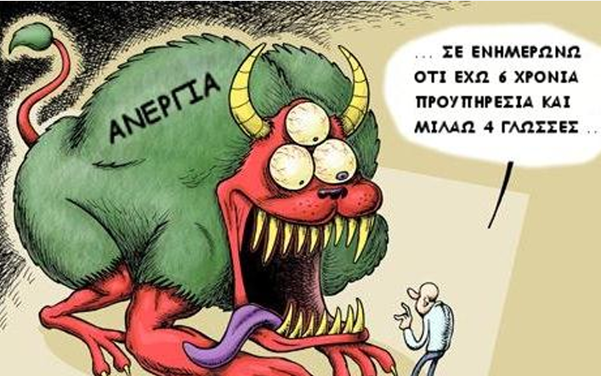

___________________________________________________________________________________________________________________________________________________________________________________________________________________________________________________________________________________________________________________________________________________________________________________________________________________________________________________________________________________________________________________________________________________________________________________________________________________

Εικόνα 6 | 



