**Γ' ΓΥΜΝΑΣΙΟΥ**

***Read Charlie Chaplin's biography to get an idea of famous people's biographies and data.***

**A Short Biography of Charlie Chaplin**

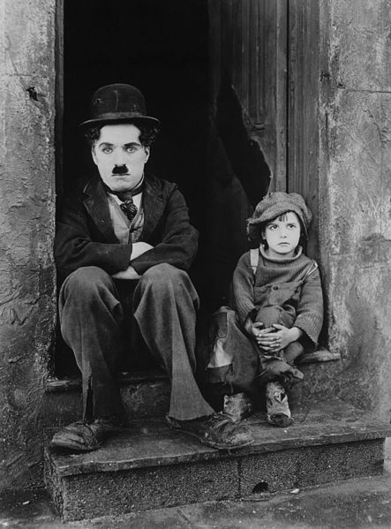**Charlie Chaplin** was an English comic actor, filmmaker, and composer who rose to fame in the silent era. He is mostly famous for his screen persona ***"the tramp"***. Born on April 16, 1889 in London, Chaplin is considered one of the most important figures in the history of the film industry. He had been a productive and creative film maker for about 75 years before he died in 1977.

**Early life**

Chaplin suffered from poverty and hardship in his childhood. He was sent to a workhouse twice before the age of nine. His mother struggled financially when his father was absent. When he was 14, his mother was sent to a mental asylum.

**Career**

Chaplin's first performances were at music halls as a stage actor and comedian at the age of 19. He went to the USA where he was scouted for the film industry, and began appearing in 1914 for *Keystone Studios*. He soon developed ***the Tramp*** persona and formed a large fan base. Chaplin directed his own films from an early stage, and continued to hone his craft. By 1918, he was one of the best known figures in the film industry.

Chaplin wrote, directed, produced, edited, starred in, and composed the music for most of his films. He was a perfectionist, and his financial independence enabled him to spend years on the development and production of a picture.

In 1919, Chaplin co-founded the distribution company *United Artists*, which gave him complete control over his films.

#### His latest films

Charlie Chaplin abandoned ***the Tramp*** in his later films, which include ***Monsieur Verdoux*** (1947), ***Limelight*** (1952), ***A King in New York*** (1957), and ***A Countess from Hong Kon***g (1967).

#### Award

In 1972, as part of a renewed appreciation for his work, Chaplin received an Honorary Academy Award for:

***"the incalculable effect he has had in making motion pictures the art form of this century"****.*

*(*[*https://www.myenglishpages.com/site_php_files/reading-charlie-chaplin.php*](https://www.myenglishpages.com/site_php_files/reading-charlie-chaplin.php)*,*

***source****:* [*https://en.wikipedia.org/wiki/Charlie_Chaplin*](https://en.wikipedia.org/wiki/Charlie_Chaplin)*, retrieved on 14/11/2020)*

***Now answer these questions about Charlie Chaplin based on what you have read.***

#### Comprehension:

1. Charlie Chaplin had a happy childhood.  
   a.  True  
   b.  False
2. Chaplin started his career in England.  
   a.  True  
   b.  False
3. Chaplin died at the age of 88.  
   a.  True  
   b.  False

**H/W: answer this activity by a MESSAGE in e-class.**

**"Imagine you are a famous person, an idol to people. Write a short biography of one paragraph (60-80 words) to publish on the net for your funs". Look at the biography in our book, p:21 to help you or Charlie Chaplin's. Speak in the FIRST PERSON SINGULAR! YOU ARE THE FAMOUS PERSON!**

**- Use everyday language that your fans will understand.**

**- Say where and when you were born**

**- Say how you started**

**- Say what made you famous/ how you became famous**

**- Say if it was easy becoming famous**

**- Talk about these days.... Are you still famous or not? What happened?**