WORKSHEET 2
THE TRAVEL BUG: Live out of a suitcase
Names:
Class: Date:
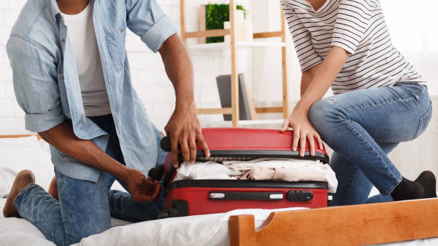
Activity 1: Hit the road
With your partner drag the words in the correct boxes in this assignment in eclass to practise travel collocations.
Activity 2: Make yourself comfortable!
Read an article about how to choose the right holiday accommodation and do task 1 if you belong to group (a) and task 2 if you belong to group (b). Complete the table according to the instructions of the assignment.
Activity 3: Mr. Bean’s suitcase
Watch the video with Mr. Bean packing up and do the tasks. Discuss your answers with your teacher and classmates. You can find the assignment here.
Activity 4: Travel light
You have decided to fly light. What would you pack in your 8 kg hand luggage? You have five minutes to make your list and share it in class!
Activity 5: Couchsurfing
Homework: You and your cousins from New York are planning to meet somewhere in Europe for a short summer trip. You 've come across an article about "couchsurfing". Write an email to them (120 words) proposing the idea of couchsurfing based on the information from the article that you’ve read, using an online dictionary whenever necessary and taking into consideration the assessment criteria described in the assignment.

