- You are at Holborn Station. How can you get to the British Museum?
- You decide to buy some books after visiting the British Museum. You ask a passer-by about the nearest bookshop. Write a dialogue.
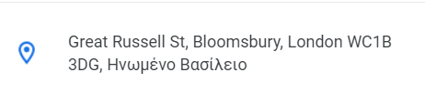
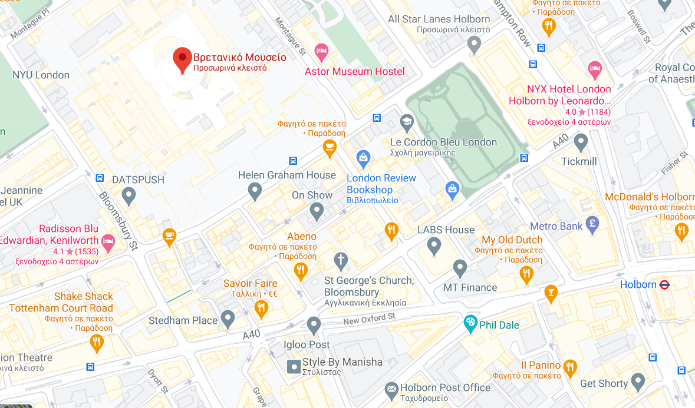
2
1

