Tι έκανες παλιά και όχι τώρα; Τι κάνεις τώρα που δεν έκανες παλιά; Γράψε προτάσεις με το used to και didn’t use to.

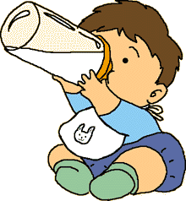
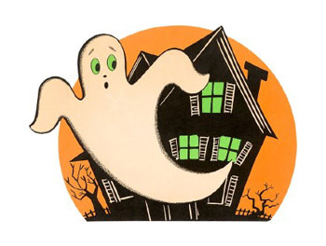
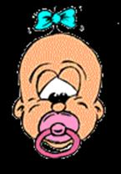

Drink from a baby bottle Sleep with a pacifier(πιπίλα) Be afraid of ghosts

π.χ. __________________ _________________
Ι used to drink from a
baby bottle. ______________ __________________

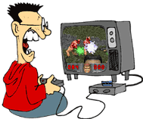
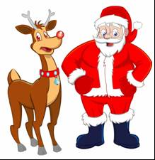
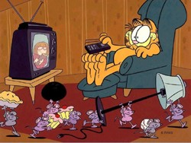

Watch cartoons Play computer games believe in Santa Claus

__________________ __________________ _________________
__________________ __________________ _________________
__________________ __________________ _________________

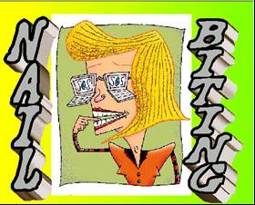
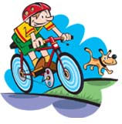
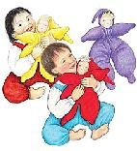

Play with dolls Ride a bike Bite your nails

__________________ __________________ _________________
__________________ __________________ _________________
__________________ _________________ _________________

