**ΦΥΛΛΟ ΕΡΓΑΣΙΑΣ**

***What about COVID-19?***

**EXERCISE 1**

Use the KWL (Know/ Want to know/ Learnt) table and fill in the columns. In the first column write down what you already know about COVID-19. In the second one, write whatever you would like to learn about it. Then, listen and add any extra information that you have learnt from the YOUTUBE video. (<https://www.youtube.com/watch?v=Xj1nUFFVK1E>)

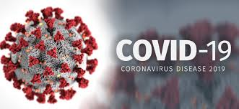 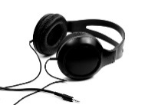

***KWL***

|  |  |  |
| --- | --- | --- |
| Know | Want to know | Learnt |
|  |  |  |

**EXERCISE 2**

1. Read the article about the COVID-19 pandemic and the environment on <https://www.newsweek.com/coronavirus-major-impact-environment-co2-air-quality-animals-1493812>.
2. Then, answer the comprehension questions and get a score on eclass.
3. Go to ***EXERCISES***: <https://eclass03.sch.gr/modules/exercise/exercise_submit.php?course=EL261153&exerciseId=3012688>).
4. Answer the ten comprehension questions.
5. Get your score!

**EXERCISE 3**

Create the mindmup with key words from the above text on:

<https://app.mindmup.com/map/_free/2020/05/d3072f60902311ea991ea12c63444d9c>

**EXERCISE 4**

Log on eclass and take part in the blog :

