Rewrite the following passages in the passive.

1.Someone broke into the National Gallery late last night. The thieves had broken the alarm system before they climbed through a window.They stole some priceless work of art.They used a getaway car to escape. The police have questioned some suspects. They have not caught the thieves yet.
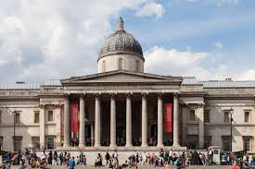
2.A few days ago, somebody stole Keith Dunn’s motorbike .Keith had left his motorbike outside his house. Keith reported the theft to the police. The police told him they would try to find his motorbike. This morning, the police called Keith and asked him to go to the police station. They had found his motorbike. The thieves had painted it and then sold it to someone else. The new owner had parked the motorbike outside the police station.The police arrested the thieves.

