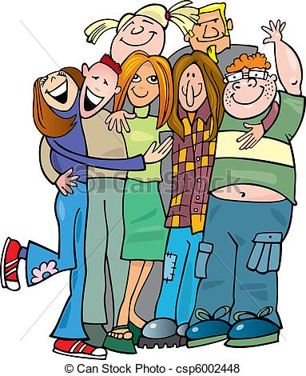
Getting to know each other…
Name:

- Do you have any siblings?
….……………………………………………………………………………………………………………………………………………………………….
- What’s your favourite series/film?
..........................................................................................................................................................................
- If you were a character from your favourite series, which one would you choose to be and why?
…………………………………………………………………………………………………………………………………………………….………………
- Who’s your favourite actor/actress?
……………………………………………………………………………………………………………………………………………………………………..
- What’s your favourite band? Name your favourite song by this band.
……………………………………………………………………………………………………………………………………………………………………….
- Do you enjoy reading novels? Who’s your favourite author?
……………………………………………………………………………………………………………………………………………………………………….
- What do you usually do when you get connected to the Internet?
…………………………………………………………………………………………………………………………………………………………………………
- What’s your favourite moment of the day?
…………………………………………………………………………………………………………………………………………………………………………
- What positive characteristics do you look for in a friend?
…………………………………………………………………………………………………………………………………………………………………………
- What is your best and worst characteristic?
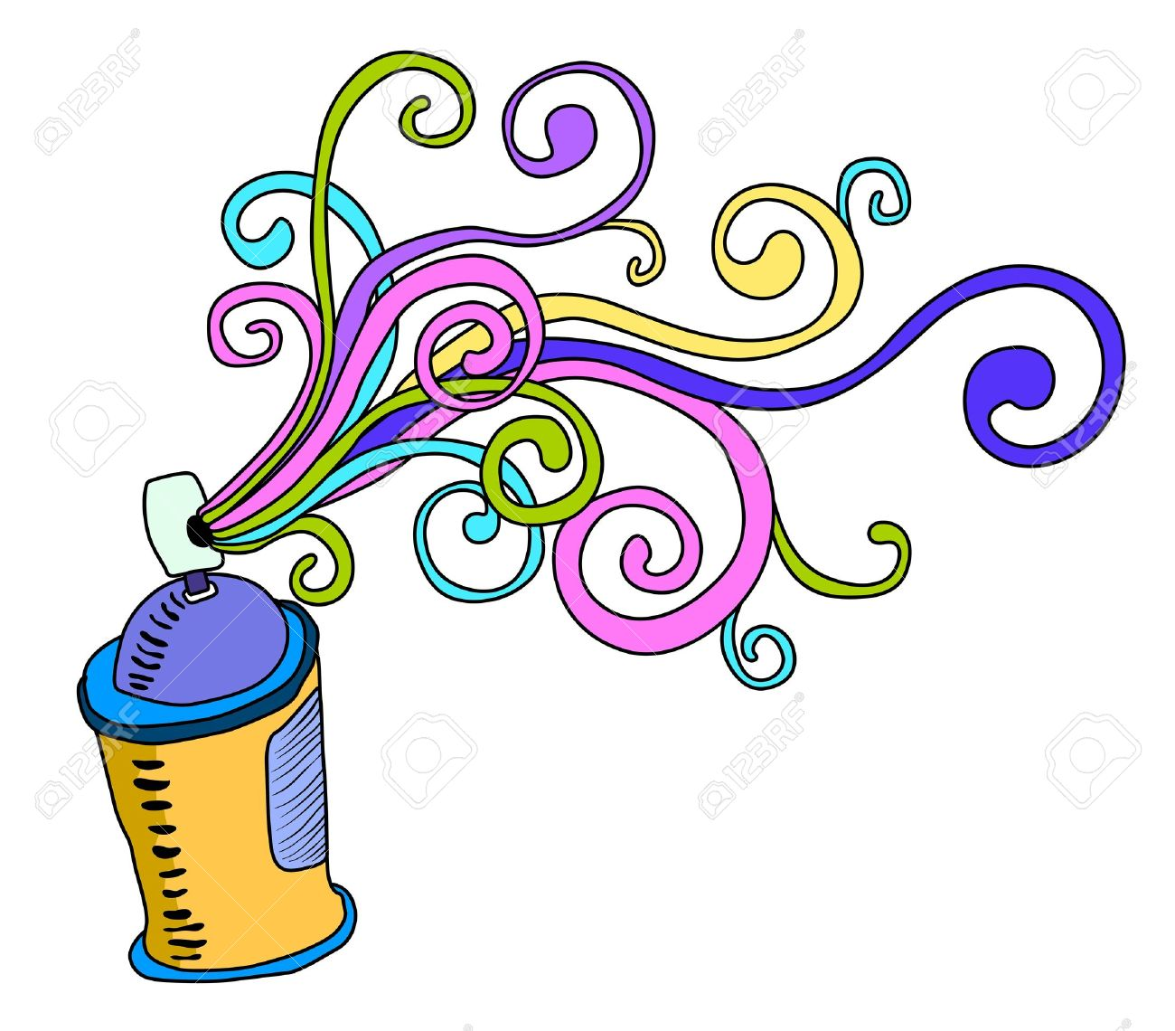
………………………………………………………………………………………………………………………………………………………………………...
- How do you imagine your life ten years from now?
…………………………………………………………………………………………………………………………………………………………………………
- Which activities do you find interesting/boring in your English classes?
…………………………………………………………………………………………………………………………………………………………………………

