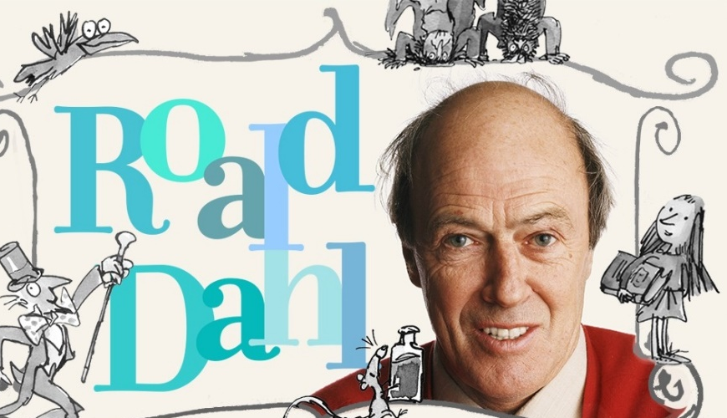
ROALD DAHL WORKSHEET

A. Follow the link to visit Roald Dahl’s Homepage:
https://www.roalddahl.com/home/kids

1. Browse all of Roald Dahl’s stories and write down the titles of three of your favourite books.
a. ___________________________________________
b. ___________________________________________
c. ____________________________________________

B. Follow this link: https://www.roalddahl.com/roald-dahl/timeline/1910s to study the timeline of Roald Dahl’s life events and fill in the missing information:
1. In 1916 Roald Dahl is born in ___________.
2. In 1923 Roald Dahl attends the local _________________________.
3. In 1939 after the outbreak of World War Two, Dahl joins the _____________________.
4. In 1946 Dahl’s first ____________ is published and he returns to the UK.
5. In 1957 Dahl’s ____________ is born and his stories appear in Alfred ____________ Presents.
6. In 1961 the publication of Dahl’s first famous book for children ______________________ takes place.
7. The first feature version of Willy Wonka and the Chocolate factory is released in _____________.
8. In 1988 his last long children’s book, _______________ is published.

C. Follow this link https://www.roalddahl.com/roald-dahl/stories/a-e/charlie-and-the-chocolate-factory and meet the characters from the novel “Charlie and the Chocolate Factory”. Press the arrows (left/right) and choose one of your favourite characters.
- Now read each character’s description and write down four things about them that you found interesting:
- …………………………………………………………………………………………………………………………………………………………….
…………………………………………………………………………………………………………………………………………………………….
- …………………………………………………………………………………………………………………………………………………………….
………………………………………………………………………………………………………………………………………………………………
- ………………………………………………………………………………………………………………………………………………………………
………………………………………………………………………………………………………………………………………………………………
- …………………………………………………………………………………………………………………………………………………………….
…………………………………………………………………………………………………………………………………………………………….
- Each character has a quote (that is a phrase very characteristic of him/her). Write down your favourite character’s quote:
…………………………………………………………………………………………………………………………………………………………………………………………………………………………………………………………………………………………………………………………………………………………………………………………………………………………………………………………………………………………………………………………………………………………………………………………………………………………………………………………………………………………………………………………………………………………………………………………………………………………….
- Browse the stories’ timeline and choose one you would like to read. Don’t forget that you can find all of Roald Dahl’s stories in an alphabetical order here: https://www.roalddahl.com/roald-dahl/stories/a-e
Explain why you chose this particular story and give a brief description of the plot!
………………………………………………………………………………………………………………………………………………………………………………………………………………………………………………………………………………………………………………………………………………………………………………………………………………………………………………………………………………………………………………………………………………………………………………………………………………………………………………………………………………………………………………………………………………………………………………………………………………………………………………………………………………………………………………………………………………………………………………………………………………………………………………………………………………………………………………………………………………………………………………………………………………………………………………………………………………………………………………………………………………………………………………………………………………………………………………………………………………………………
