YOU’VE GOT FOOD ON YOUR FACE (3)
NAMES: …………………………………………….…………………………..
DATE: ………………………………………….

Activity 1: Quizlet study set-Food idioms

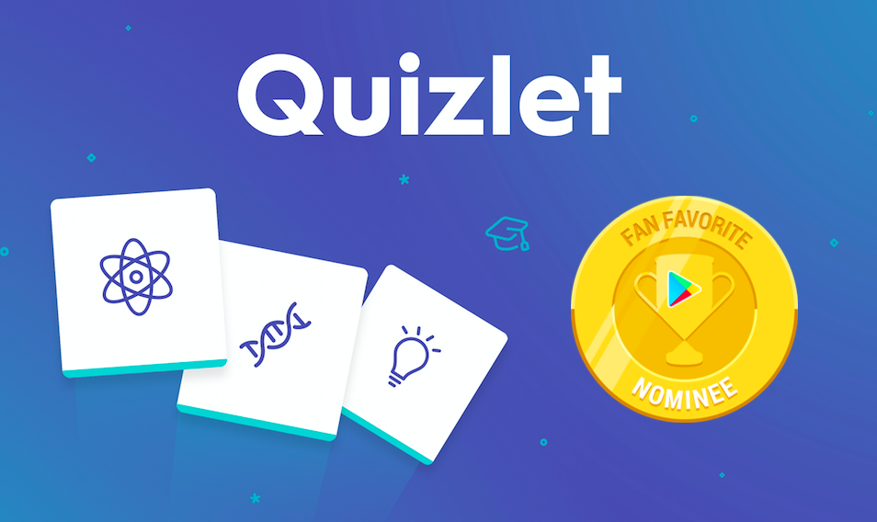
Go through ALL four self-study activities about food idioms with your partner and then get ready for a super enjoyable class game!!
All fun is HERE.

Activity 2: Interactive video tutorial


You are one step before creating an online mouthwatering menu with your partners with PosterMyWall app. Watch the interactive video tutorial and answer the questions to get an idea of how it works. It’s so easy! You’ll be experts in no time!

