The Comenius-students 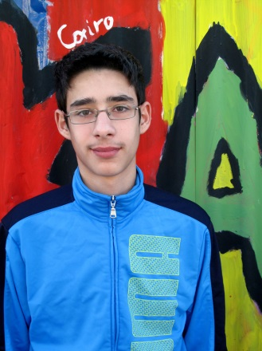 | Nikos Petrakis  Hello! I am Nikos Petrakis and I am thirteen years old. I come from Crete and I am in the second grade of junior high school. I have got many hobbies. I love football. I think, it is a brilliant way to have fun and make new friends. Furthermore, I like table tennis. In addition, I like reading books such as novels. My favourite author is Jules Verne. In my leisure time, I prefer listening to music or watching TV. Last but not least, I like playing computer games, because they offer entertainment and help you spend your free time creatively.

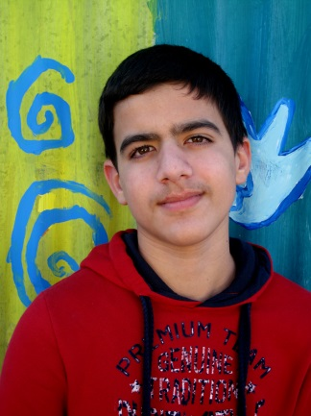 | Sekeris Tassos  Hello! My name is Tassos Sekeris. I am a Greek student and I am 14 years old. I am in the 3rd grade of junior high school. My school is called Kapetanakeio. In my leisure time I love playing volleyball and hanging out with my friends.

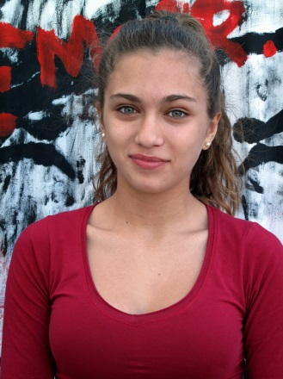 | Zenia Papachatzaki  Hello! I'm Zenia Papachatzaki and I'm 14 years old. I'm from Greece and I live in Heraklion, Crete, with my parents and my brother. My favourite subjects are Ancient Greek and Physical Education. In my free time I play volleyball and I spend time with my friends. When I grow up I want to be an actress or a volleyball player.
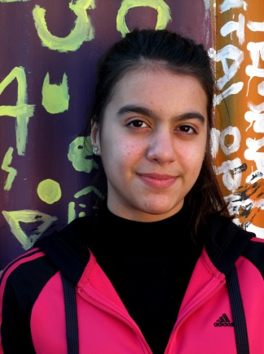 | Olga Sekeri Hi! My name is Olga! I am 14 years old and I am in the third grade of Junior High School. I have a twin brother whose name is Tassos. I do gymnastics five times a week and I enjoy playing volleyball. In my leisure time I love shopping and doing plenty of activities with Tassos in our garden. I am very sociable and I like meeting new people and making new friends. I AM GOING TO SPAIN THIS MARCH!!!!!!!

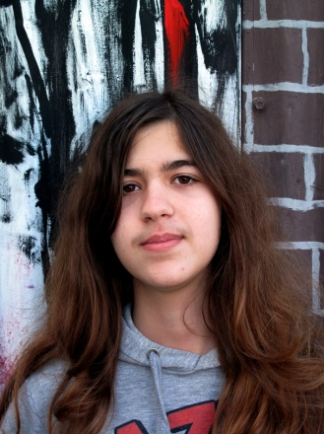 | Eleni Ktalagargiannaki  My name is Eleni Katalagarianaki and I am 15 years old. I live in Heraklion ,Greece, with my parents and I am in the third grade of Junior High School. In my free time, I like listening to music, reading books, spray-painting, surfing the net and playing the violin.

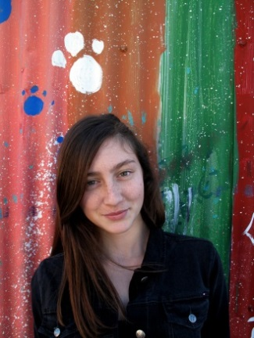 | Ioannou Anastasia  Hello! My name is Anastasia and I am 14 years old. My favourite subject is Maths. I'm a good student. I have a younger brother. He is very naughty but I love him anyway. I also have a dog called Max. I love spending my time with my best friend, who's in the same class as me. She's the most important person in my life besides my family. We always have a great time together. In my free time, I enjoy hanging out with friends, making new ones, and watching either football or basketball matches with my brother. In the future, I want to become a psychologist.
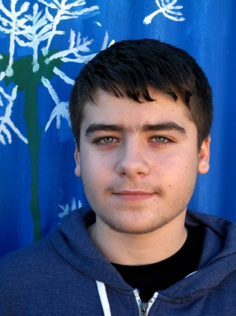 | Niotakis Manolis  My name is Manolis Niotakis. I am 15 years old and I am from Greece. My hobby is basketball but I sometimes play computer games in my free time. My favourite team is Olympiakos and my favourite subject is Maths. I am also going to Spain in March, 2014.
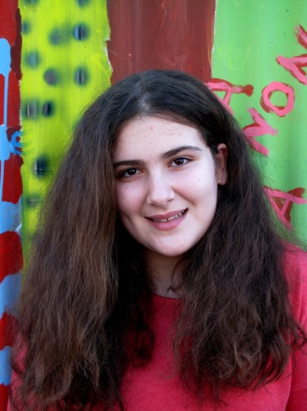 | Konstantina Mathioudaki  Hello!!! My name is Konstantina Mathioudaki and I am 13 and a half years old. I am Greek and I live in Heraklion, Crete. My hobbies are volleyball, swimming, traditional dancing and of course English!!! I like school very much!!!!! My favourite subjects are Ancient Greek and Maths.

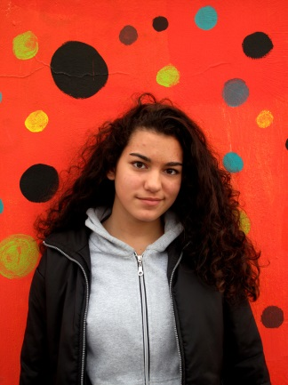 | Messaritaki Ria  My name is Ria and I am from Greece. I am 14 years old and I am in the 3rd grade of Junior High school. There are four members in my family and I also have a pet dog. I play volleyball in a team, since I love playing volleyball. I like reading books and taking photos. I think I am honest, but I am a bit selfish!

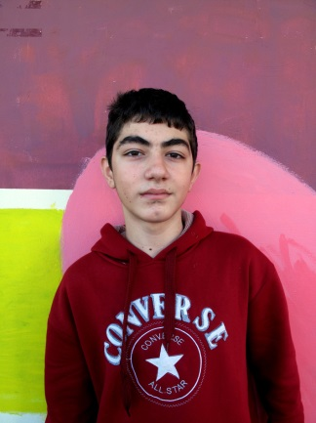 | Constantinos Kotzampasakis  I am Constantinos Kotzampasakis and I am 13 years old. I live in Iraklion, Crete. I live with my mother and my brother. I like fishing and swimming in the summer, surfing the net, playing computer games, reading novels and playing with my dog, Victor. I am going to travel to Annecy, France. I have seen some photos of this place and I believe it is wonderful. I have travelled a lot around Europe with my mother and brother. I hope to hear from you soon.

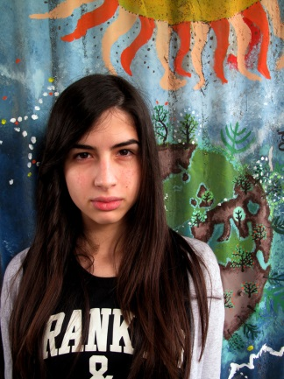 | Danelli Smaragda  My name is Smaragda, I'm 14 years old. In my free time I enjoy dancing and I love playing with my cats. I also spend a lot of time with my best friend. I find travelling very interesting because I make new friends and have unforgettable experiences.

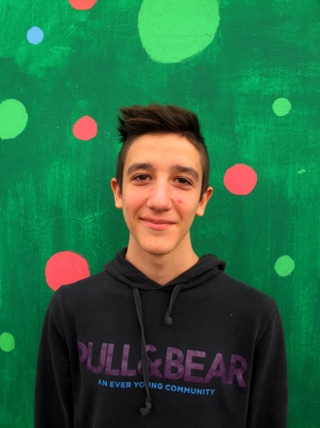 | Michalis Mathioudakis  Hello,my name is Michalis Mathioudakis. I am 14 years old and I live in Iraklion, which is a beautiful town. I have a brother whose name is Manos and a dog whose name is Roubis. My father is a teacher and my mother is a pharmacist. They are very cool. I have many friends and I hang out with them. I am very good at athletics. I am a student at Kapetanakeio High School, which is the best school in the city. I am tall and sporty. This is me!!!!!!

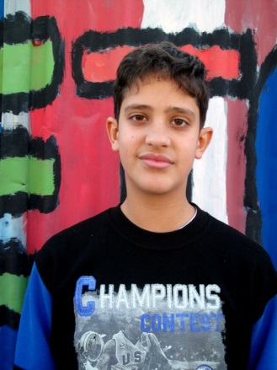 | Grigoris Fragiadakis  Hello! My name is Grigoris Fragiadakis and I am 13 years old. I live in Iraklion, Crete. I live with my parents and my two brothers. Their names are George and Marios. I am a student at Kapetanakeio. I like travelling and I often go to the seaside, because I love swimming. My favourite hobbies are table tennis, tennis and basketball. I’m also learning karate. I love living in Crete and I have a great time here.

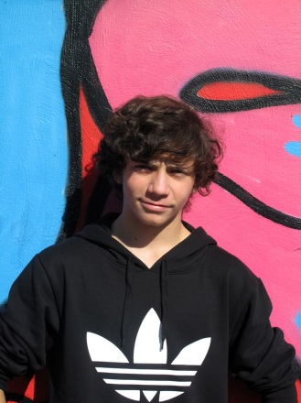 | Lefteris Kargiantoulakis  Hello, Comenius members! As you can see from my profile, I'm Lefteris Kargiantoulakis and I'm turning 15 in March 27th (2014). Concerning my hobbies, I love spending my free time playing my guitars or hanging out with my friends and playing our favorite sport, which is basketball. Well, besides the hobbies I have mentioned there are also quite a few obligations that have really put me under pressure this year but I'm trying to cope with them. Secondly, I must tell you that I like being part of this team and the team's purpose of bringing people from different countries with a vast variety of habits and traditions together in order to cooperate as one. And of course, lastly I also MUST tell you I am bursting with excitement about our visit in Spain, in March 2014 and I can't wait to finally be there! Honestly, it's a dream come true! Lots of greetings from Greece!
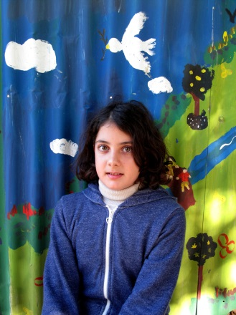 | Emmanouela Aggouridaki Hello! My name is Emmanouela and my surname is Aggouridaki. I am 12 years old. My hobbies are playing computer games, reading fantasy books and playing the piano. I have lots of friends and in our free time we usually go shopping. My favourite colour is red. I love the Harry Potter film series! Specifically, my favourite is Harry Potter and the deathly hallows.
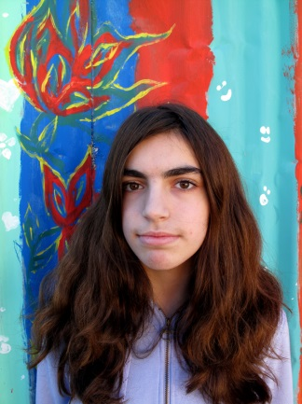 | Efi Mavromanolaki  Hello!! My name is Efi Mavromanolaki and I am 13 years old!! I live in Iraklion, Crete. In my spare time I listen to music, play volleyball in my backyard, surf the internet and read magazines! I have a dog! He used to live on the streets, but I adopted him!! I named him Beethoven!! My dream is
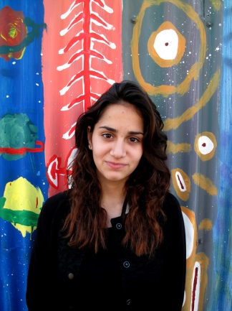 | Chryssa Garefalaki  My name is Chryssa Garefalaki and I am from Greece. I was born in Heraklion, Crete. I am 13 years old and I am a high school student. I have a younger sister who is 10 years old. Her name is Joanna. My father is a physiotherapist and my mother works as a secretary in the Department of Mathematics at the University of Crete. Basketball is my favorite sport because it is a great way to exercise and to have fun with friends. I play with a basketball team called OFI and I train four times a week. In my free time I like to listen to music, watch movies and hang out with my friends. When I grow up I want to be a teacher. I am very happy that I am going to visit France with the Comenius Programme.
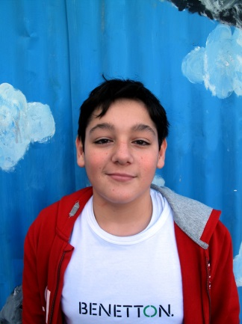 | Meramveliotakis Giagkos  Hi my name is Giagkos and I am 13 years old. I live in Greece. My hobbies are judo and jiu-jitsu. I have fun when I do these hobbies. I will probably go to Norway.

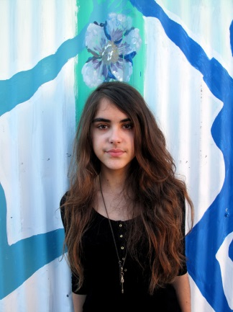 | Irene Katzagiannaki  Hi everybody! My name is Irene and I am 13 years old. There are four of us in my family. I have a little brother whose name is John. In my free time I love listening to music and reading books. I love the Harry Potter book series. My favourite singer is Justin Bieber! I look forward to visiting your country! I can't wait! I hope we will become good friends.

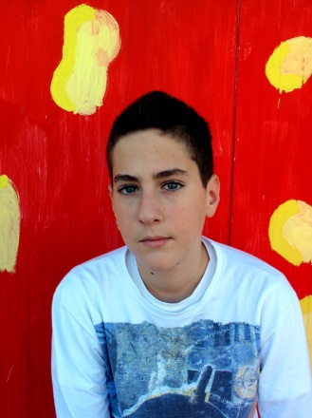 | Christopher Fountoulakis  My name is Christopher Fountoulakis. I am 13 years old. I really like basketball and football. I read lots of comics and adventure books and I play paintball, too. I watch many movies (especially comedies and fantasy films) and I listen to music (mostly rock and rap).

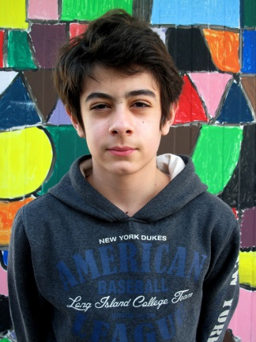 | Myron Peristeris  My name is Myron Peristeris. I’m 13 years old and I’m in the first year of Junior High School. I like reading books and listening to music. I also like sketching. I have English lessons twice a week and music lessons once a week.

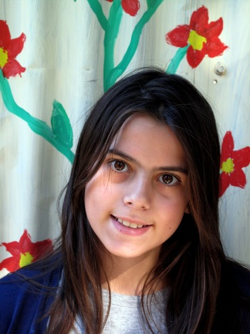 | Mary Metaxaki  Hallo, my name is Mary Metaxaki.I am from Greece (Heraklion).I am 12 years old  And in 2015 I will go to the Norway. And you?

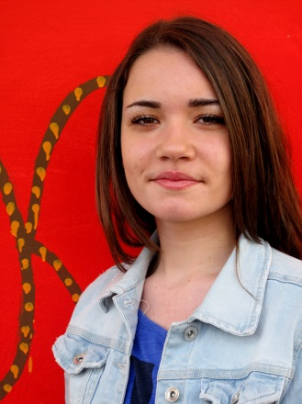 | Mariarena Filippaki  My name is Mariarena and I am fifteen years old. I have one brother and one sister. I live in Heraklion with my family and I am in the third grade of Junior High School, called Kapetanakeio.  My favourite hobby is volleyball. In my free time I like going for shopping with my friends or staying to my house to see a film. My favourite food is spaghetti and I hate beans.  My friends say that I am a little bit dopey but I don't care. I always laugh and I enjoy it. I hate liars and I try to be reliable with all my friends!

