History of Cartoons: The Evolution of Animation Through Time

Cartoons have always had a special way of connecting with people, blending art and storytelling to create something timeless. I’ve always loved how they’ve evolved—from satirical sketches in newspapers to the animated classics we all grew up with. Part of what makes them so powerful is how they tap into our emotions and reflect the world around us, something I’ve thought about a lot while learning about the [psychology of cartoons](https://nalena.com/psychology-of-cartoons/). Looking at their history, it’s amazing to see how much they’ve shaped—and been shaped by—our culture.

**On this page**

* [Key Highlights in the History of Cartoons](https://nalena.com/history-of-cartoons/" \l "Key_Highlights_in_the_History_of_Cartoons" \o "Key Highlights in the History of Cartoons)
* [The Origins: Sketches and Social Commentary](https://nalena.com/history-of-cartoons/" \l "The_Origins_Sketches_and_Social_Commentary" \o "The Origins: Sketches and Social Commentary)
* [The Birth of Animation: Movement and Innovation](https://nalena.com/history-of-cartoons/" \l "The_Birth_of_Animation_Movement_and_Innovation" \o "The Birth of Animation: Movement and Innovation)
* [The Golden Age of Cartoons: Beloved Characters and Stories](https://nalena.com/history-of-cartoons/" \l "The_Golden_Age_of_Cartoons_Beloved_Characters_and_Stories" \o "The Golden Age of Cartoons: Beloved Characters and Stories)
* [The Television Revolution: Cartoons at Home](https://nalena.com/history-of-cartoons/" \l "The_Television_Revolution_Cartoons_at_Home" \o "The Television Revolution: Cartoons at Home)
* [The Digital Age: Endless Possibilities](https://nalena.com/history-of-cartoons/" \l "The_Digital_Age_Endless_Possibilities" \o "The Digital Age: Endless Possibilities)
* [Cultural Impact: Cartoons as Storytelling Tools](https://nalena.com/history-of-cartoons/" \l "Cultural_Impact_Cartoons_as_Storytelling_Tools" \o "Cultural Impact: Cartoons as Storytelling Tools)
* [Why the History of Cartoons Matters](https://nalena.com/history-of-cartoons/" \l "Why_the_History_of_Cartoons_Matters" \o "Why the History of Cartoons Matters)

Key Highlights in the History of Cartoons

* **16th Century**: Cartoons originated as preparatory sketches used by artists to plan large-scale works like frescoes and tapestries.
* **19th Century**: The term “cartoon” shifted to mean humorous illustrations in newspapers and magazines, often used for political satire and social commentary.
* **Late 1800s**: Devices like the zoetrope and flipbook introduced the concept of sequential images creating the illusion of movement.
* **1914**: Winsor McCay’s *Gertie the Dinosaur* became one of the first animated films, showcasing how drawings could come to life and tell a story.
* **1928**: Disney’s *Steamboat Willie* marked the debut of Mickey Mouse and introduced synchronized sound to animation, revolutionizing the medium.
* **1930s-1940s**: The Golden Age of Cartoons produced iconic characters like Bugs Bunny, Betty Boop, and Popeye, and introduced feature-length animated films like *Snow White and the Seven Dwarfs*.
* **1950s-1960s**: Television brought cartoons into homes, popularizing episodic shows like *The Flintstones* and *Scooby-Doo* and making animation a regular part of daily entertainment.
* **1980s-1990s**: Cartoons expanded into adult-oriented programming with shows like *The Simpsons* and influenced global pop culture through franchises like *Transformers* and *Teenage Mutant Ninja Turtles*.
* **2000s-Present**: The rise of digital tools and platforms like YouTube and TikTok democratized animation, enabling creators to produce diverse styles and reach global audiences directly.

The Origins: Sketches and Social Commentary

In the 16th century, the word “cartoon” referred to preparatory sketches used by artists to plan larger works, such as frescoes or tapestries.

These sketches were functional, meant to guide the final creation. Over time, the term evolved, and by the 19th century, “cartoon” came to describe humorous illustrations published in newspapers and magazines.

These early cartoons often featured sharp social and political commentary, using simple drawings to convey complex messages with humor. They became a widely popular form of communication, laying the groundwork for what cartoons could achieve. This ability to engage and entertain through simplicity is something that still resonates in many visual arts, including modern-day [illustration projects](https://nalena.com/illustration/).

The Birth of Animation: Movement and Innovation

The late 19th century saw the invention of devices like the zoetrope and flipbook, which brought sequential images to life through movement. These innovations paved the way for animated films. By 1914, Winsor McCay’s *Gertie the Dinosaur* introduced audiences to the idea of characters moving and expressing emotion on screen.

This early experimentation marked the birth of animation as we know it. The medium quickly gained momentum, with artists discovering that movement could make their characters and stories even more engaging. Today, animation continues to push boundaries, from traditional frame-by-frame techniques to modern [motion design](https://nalena.com/motion-design/) that integrates creativity with technology.

The Golden Age of Cartoons: Beloved Characters and Stories

The 1930s and 1940s, often referred to as the Golden Age of Cartoons, gave rise to iconic characters like Mickey Mouse, Bugs Bunny, and Betty Boop.

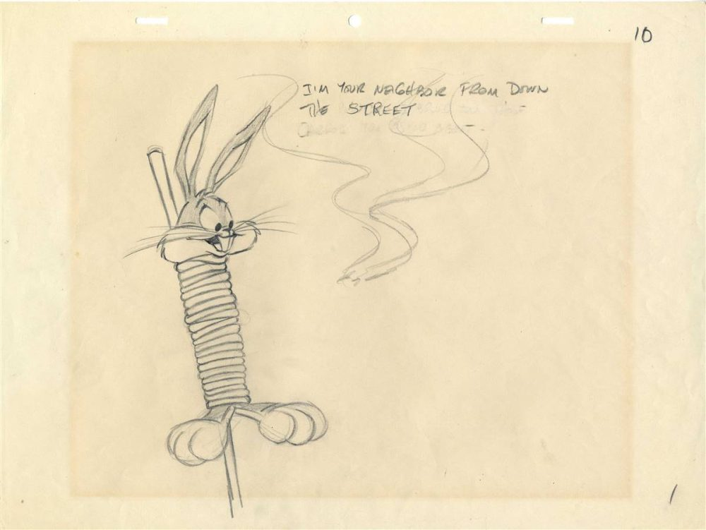Original Bugs Bunny animation drawing.

Studios like [Disney](https://disneyanimation.com/" \t "_blank) and Warner Bros. became powerhouses of animation, creating films and shorts that are still loved today. These characters weren’t just entertaining—they embodied personality, humor, and charm that connected with audiences of all ages.

This period also saw significant advancements in animation technology. Disney’s *Snow White and the Seven Dwarfs* (1937) was the first full-length animated feature film, showcasing synchronized sound, vibrant color, and complex storytelling. This dedication to quality and creativity set a standard that animators still strive for, whether producing feature films or shorter formats like [video series](https://nalena.com/video-series/).

The Television Revolution: Cartoons at Home

The 1950s brought a major shift as cartoons transitioned to television. Shows like *The Flintstones* and *Scooby-Doo* became weekly staples, introducing episodic storytelling to animation. This new format allowed creators to develop characters and plots over time, keeping audiences engaged and coming back for more.

Television also expanded the reach of cartoons, making them accessible to wider audiences, from children to adults. It opened the door to experimentation, with animators creating content that ranged from slapstick humor to more sophisticated themes. Today, this adaptability influences how cartoons are used across platforms, from serialized TV shows to bite-sized [social media shorts](https://nalena.com/motion-design/).

The Digital Age: Endless Possibilities

With the rise of digital tools, the animation industry has seen incredible growth. Software like Blender and After Effects has made it possible to create stunning animations with fewer resources, allowing independent creators to compete with large studios. This shift has democratized animation, giving rise to a more diverse range of styles and stories.

The digital era also brought new ways to share and consume cartoons. Platforms like YouTube and TikTok have made short-form animation a popular format, while streaming services allow creators to explore longer, more complex narratives. Digital tools have also made it easier for artists to experiment, whether creating personal projects for a [sketchbook](https://nalena.com/sketchbook/) or designing polished professional reels.

Cultural Impact: Cartoons as Storytelling Tools

Throughout history, cartoons have reflected the culture and issues of their time.

Early political cartoons commented on societal problems, while animated shows like *The Simpsons* and *BoJack Horseman* explore deeper themes, often blending humor with thought-provoking ideas.

This versatility is one reason cartoons remain so powerful. They can be lighthearted or profound, simple or complex. Artists like [Maria Primachenko](https://nalena.com/maria-primachenko/) demonstrated how even surreal, whimsical cartoons can carry deeper cultural significance, inspiring creators worldwide.

Why the History of Cartoons Matters

The history of cartoons is more than just an evolution of a medium—it’s a story of creativity, resilience, and adaptation. From the earliest sketches to today’s digital masterpieces, cartoons have continued to entertain, inform, and inspire. If you’re curious about how cartoons connect storytelling with visuals, check out my [animation reel](https://nalena.com/reel/) to see how these timeless principles shape modern projects.